Using Paths for Simple Illustration
Aim
To Illustrate using the pencil and pen in Adobe Illustrator and to use the Direct, Indirect and Covert Anchor point tool to transform shapes to make a simple illustrations using templates and this tutorial as reference
Objectives
To be aware of the following tools and panels
- Making a new document
- The Direct Selection Tool
- The Indirect Selection Tool
- The Convert Anchor Point Tool
- To apply colour using the swatch panel
- Basic use of the Pencil Tool
- Basic use of the Pen Tool
- To place documents for tracing
- Saving a document correctly

The Finished Illustrations you are working towards
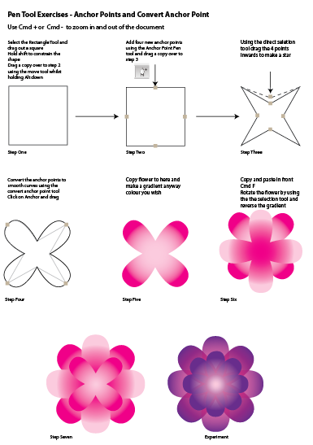
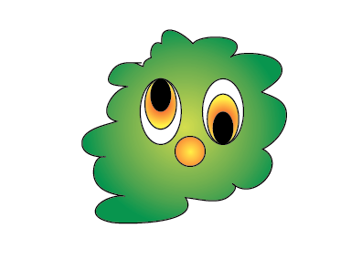
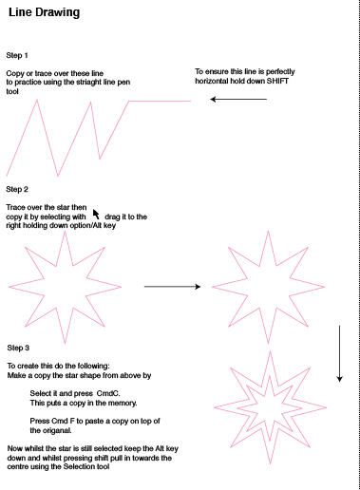
Section A
Drawing a Line
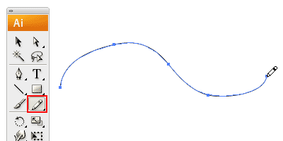
Select the pencil tool and click and drag to draw a free hand line drawing.

Closing Paths with Pencil Tool

To close a path, hold Alt/Option as your Pencil Tool reaches the start point. A circle icon will appear next to the Pencil Tool to indicate path closure.
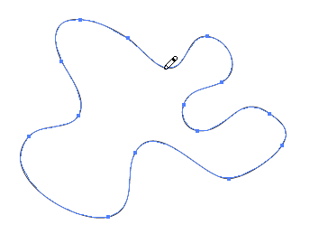
Smoothing Jaggy Lines

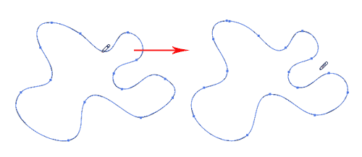
Normally when you draw with the Pencil Tool, the path looks jaggy. To smoothen the parts that are jaggy, simply hold Alt/Option to turn the Pencil Tool to Smooth Tool. Or select the smooth tool. Then draw over the area of the lines which you would like to smoothen.

Reshaping Path

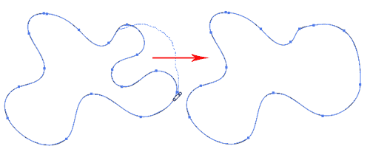
To reshape a path, make sure your path is selected and use the Pencil Tool to redraw the parts you would like to reshape. Note that the start and end path must be close to the original path to make it work.

Pencil Tool Preferences

You can turn on the Pencil Tool Preferences by double clicking on the Pencil Tool. You can change the fidelity and smoothness to find a combination that works for you.
Fidelity: Determines how close the path is drawn to your mouse movement. Set it at a higher fidelity if your not good at drawing with your mouse.
Smoothness: The higher you set for smoothness, the less anchor point it produces. Thus, producing a smoother line.
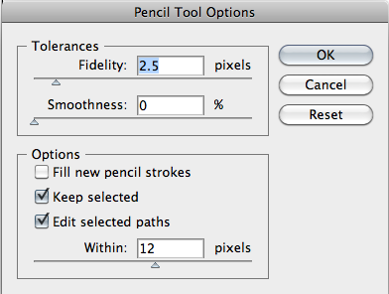

Activity 1 Make a Monster

Make a new document
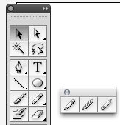
Select the pencil tool

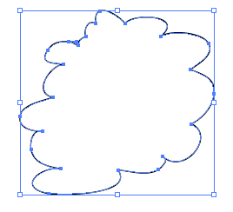
Draw the shape as shown if you have to many curves use the smooth tool to smooth them out

Make a gradient (refer to using colour and gradients tutorial if your stuck)

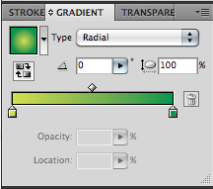
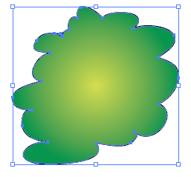

Make some eyes

- Using the Ellipse shape draw out a shape

- Copy the shape by power duplication
Select, drag out a copy whilst holding Alt

- Colour it with a gradient as shown

- Copy the shape and colour black

- Highlight all the shapes and align them to the top

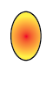

Arrange the shapes as shown

If you Finnish your illustration try experimenting with other drawn shapes

Section B
Introduction to the Pen Tool

The pen tool is perhaps the most powerful tool in Illustrator. It can be used to create countless lines, curves and shapes, and serves as the building block for illustration and design. The tool is used by creating “anchor points,” and then by connecting those points with lines, which can be connected further to create shapes. Use of the pen tool is perfected through practice. Unlike many graphics software tools that have clear use and limitations, the pen tool is extremely flexible and encourages creativity.

Create a New File and Select the Pen Tool
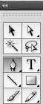
To practice using the pen tool, create a new Illustrator file. To create a new document, select File > New in the Illustrator menus or hit Apple-n (Mac) or Control-n (PC). In the “New Document” dialog box that will pop up, click ok. Any size and document type will do. Select the pen tool in the toolbar, which resembles the tip of an ink pen. You can also use the keyboard shortcut “p” to select the tool quickly.

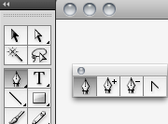
Create Anchor Points and Lines

Lets start by creating lines, and a shape with no curves. Start by selecting a stroke and fill color, which will be the outline and color of the shape created. To do this, select the fill box at the bottom of the toolbar, and choose a color from the color palette.

Pen Tool Add an Anchor Delete an Anchor Covert an Anchor

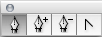

Drawing Straight Lines

Select the Pen Tool and click once to add the first anchor point. Move your mouse to the next position and click again to create the second point. The two anchor points will be connected together. Continue doing this to create a W shape as shown. To draw a new line, click the Selection Tool (The Black Arrow Icon) and click back the Pen Tool again.

Activity 2
Open Path
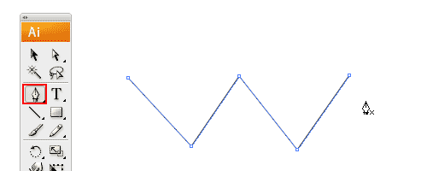
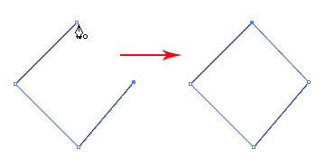
Closing a Path

To close a path, click back the starting point to close the shape.

Activity 3

Open the file called Line Drawing, this is a template that you will trace over using Illustrator

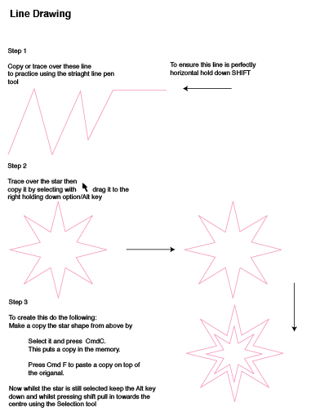

Activity 4

Converting Anchor Points

The convert anchor point tool allows you to change a tight corner to a smooth curve
Open the file called Pentool Flower; this is a template that you will trace over using Illustrator

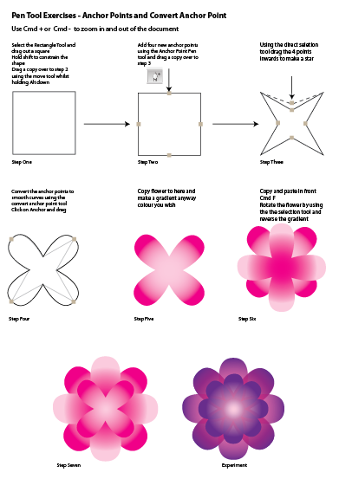
Activity 5

Drawing Curves Introduction

Open the file called curved paths; this is a template that you will trace over using Illustrator

To draw a curved path

Step 2 Click in the middle of the shape
And drag out Bezier Handles HOLDING SHIFT to constrain

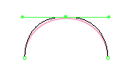

Step 3 Click to end the path
Step 1
Click once with the pen tool

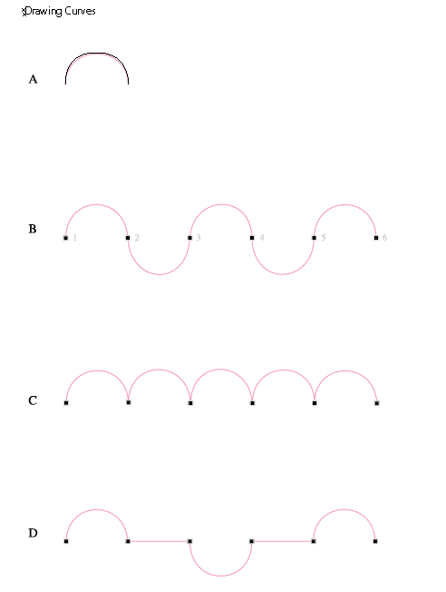
Using the template try tracing the curve

Remember

Click at point A
Click and drag point B
Click and end point C

Drawing Curves Intermediate

Open the file called Shapes; this is a template that you will trace over using Illustrator

Try tracing around each shape take your time and try and draw less anchors

Drawing Curves Advanced

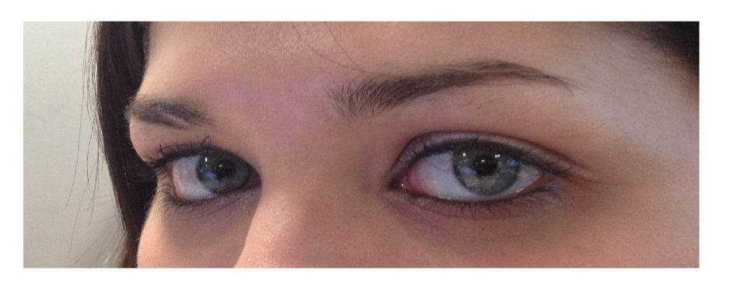
- Placing the jpg file
First we have to import our source image. Take it into illustrator (File > Place). Rescale it to fit your workspace.

- Select the pen tool

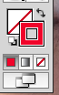
Make sure your stroke is set to a bright colour you can see and switch of the fill so there is no colour in it

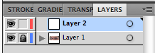
Make a new layer call it eyes

- This is the layer you will be working on

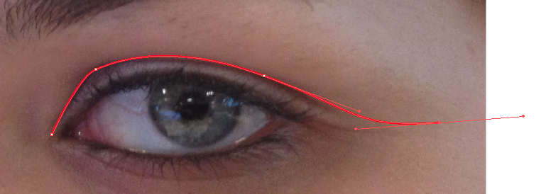
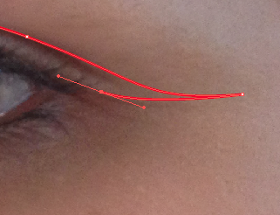
Click at the fist point in the corner of the eye and then click and drag out a Bezier handle to create the curve repeat this process until you have reached the outside of the eye

Click right on the corner anchor point you have just created and continue to click and drag out curves

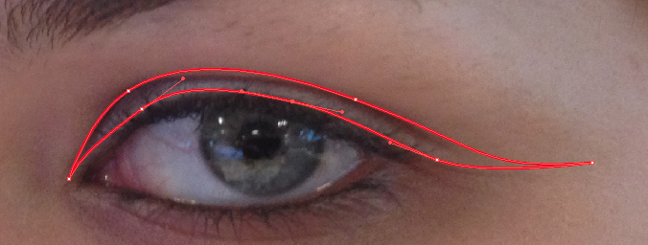

Follow the same process as above to draw round the eyebrow
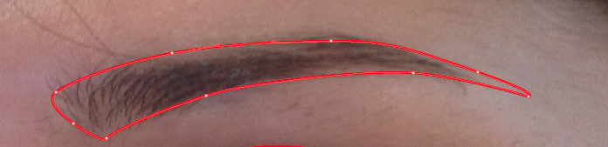

You must complete the path by clicking on the first anchor point you created

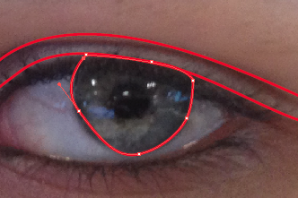
Next draw the eye
If you make a mistake you can easily rectify this by clicking on the
Direct selection tool

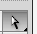

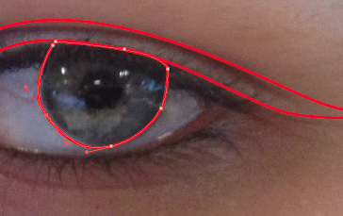

Pull the anchor point out until you have a smoother curve

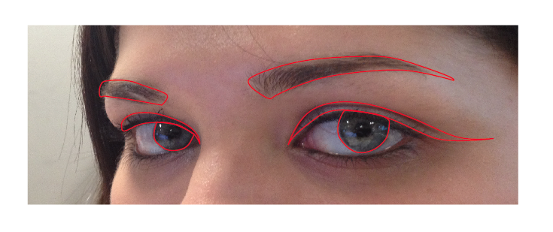
Now you need to trace over everything else you want in the same way. I traced over the aforementioned eyelid/eyelashes, the actual eye itself, the crease where the eyelid meads the face and the eyebrows. You can add more or less detail as you like. Remember (especially around the eyes) to use as few as points as possible to keep everything smooth. Remember that because you are making a stencil you just want the highest contrast areas... you just want to capture the essence of the picture without getting too much unneccesary detail.

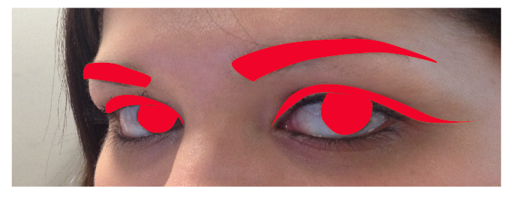
Now change the fill to a solid and make red
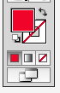

Once they are all done, hide (the little eye icon to the left of each layer) the layer with the source image so you can just see the shapes you’ve made.
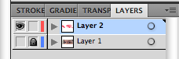

Jfkdlsfjkl;jfkld;s

Now you have drawn the eyes zoom in close and look to see if you can see any jaggy lines

Here is one in the corner

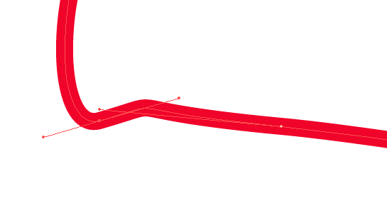
Select the direct selection tool
And pull the anchor and or adjust the Bezier handle by pulling in the direction you want the path to follow

Experiment with different colours and maybe different images

Section C
Drawing a Curved Line (Advanced Extension Activity Revision)

Click and drag to put out the handles to create a smooth anchor point.

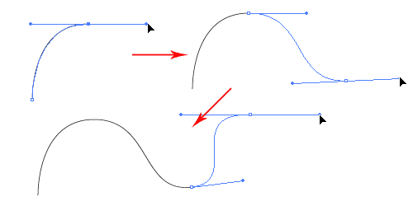

Changing Path Directions

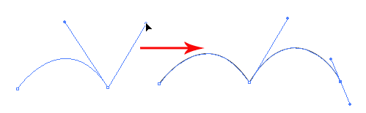
Click and drag to create a smooth anchor point. Without releasing your mouse, hold Alt/Option and drag the handle up to change the path direction.

Drawing a Circular Path

Click and drag to create a smooth anchor point. Continue adding points and click back the starting point to close the path.

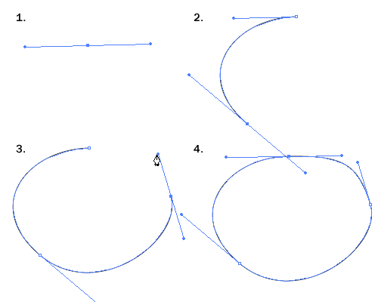
Please note there are easier ways to do this, think circular shapes.

Adding Anchor Points

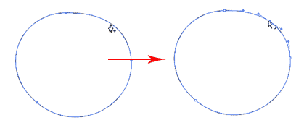
With the Pen Tool selected, go near the path where you want to add a new anchor point. A plus sign will appear next to the pen, click on the path to create a new anchor point.

Removing Anchor Points

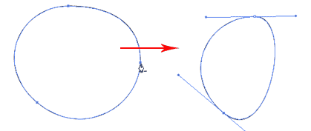
To remove point, move your Pen Tool close to an anchor. A minus sign will appear next to the pen. Click on the anchor point to delete it.

Converting Anchor Points

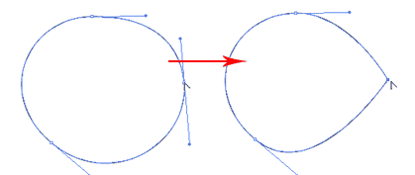
To convert a smooth anchor point to a sharp anchor point, move your Pen Tool near the anchor and hold Alt/Option and your Pen Tool will change to an arrow shape. Click on the smooth anchor to convert it to an anchor point. Click and drag on the anchor point again to change it back to a smooth anchor point.

Moving Anchor Points

Select the Direct Selection Tool and click and on anchor you want to move. Click and drag to change positions.

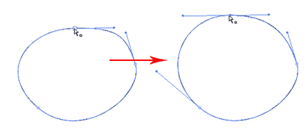

Changing Anchor Directions

With the Pen Tool, you can quickly change the anchor directions. Hold Ctrl/Command to quickly change the Pen Tool to Direction Selection Tool. Select the anchor point you want to edit. The anchor handle will appear. Now release Ctrl/Command and hold Alt/Option to change it to Convert Anchor Tool. Click and drag the handles to change the direction.

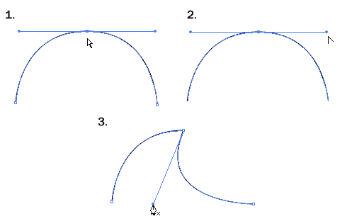

Drawing an Old Key
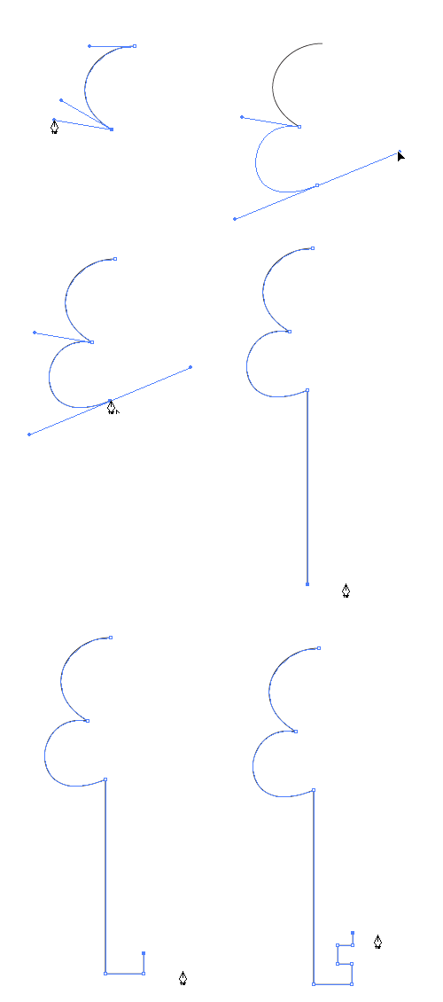
After learning the concepts of how the Pen Tool works, we will apply what you have learnt to create this ancient old key shape. For the right angles, hold Shift before adding anchor point to constrain it to 90-degree.

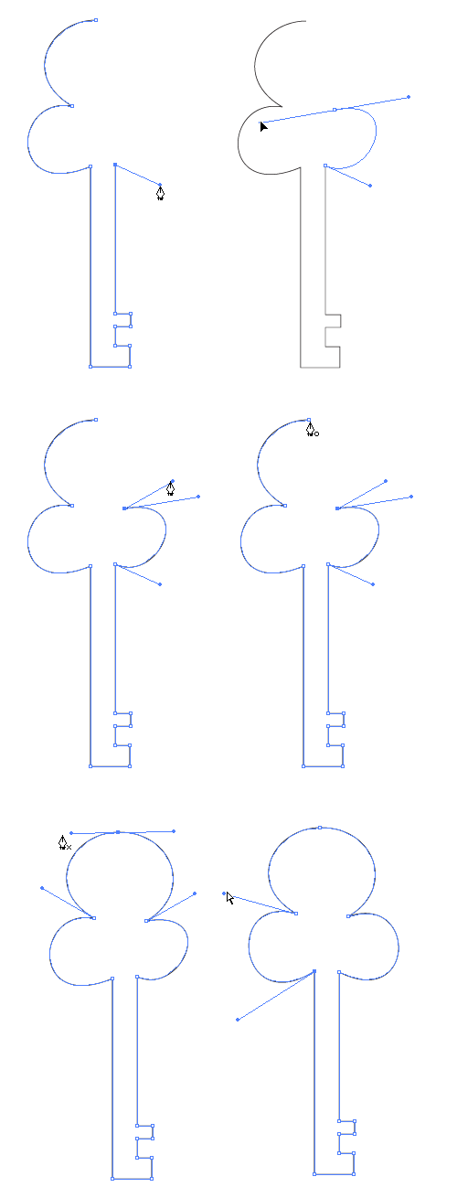

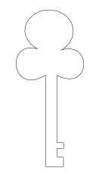
Final Illustration
This is the final illustration.

Tips for Using Pen Tool
Use as little anchor points your need to create your shape

Add anchor points where there is a change in direction of the line/curve

Use shortcuts like Alt/Option or Ctrl/Command to quickly swap to other tools to edit your path

Hold shift to lock your path while adding new anchor point for 45-degree increments.

We will so learn how to draw this key using shapes, it is a far more efficient and professional way to build images, for now, can you count how many shapes are in this drawing.

