Using Shapes for Simple Illustration
Aim
To Illustrate using pre-set shapes in Adobe Illustrator and to use the Direct, Indirect and Covert Anchor point tool to transform shapes to make a simple illustration of a ‘Vampire Cat’
Objectives
To be aware of the following tools and panels
- Making a new document
- The Direct Selection Tool
- The Indirect Selection Tool
- The Convert Anchor Point Tool
- To make and save a gradient
- To apply colour using the swatch panel
- Basic use of the Type Tool
- Saving a document correctly

The Finished Illustration you are working to
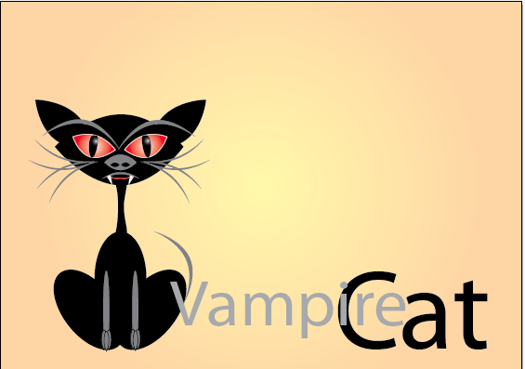

Making the Eye

- File New Document

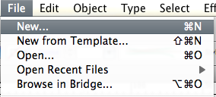

- Make sure you gradient panel is open and select BLACK
Ellipse Tool
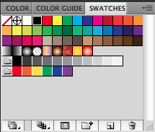

Fill Colour Black

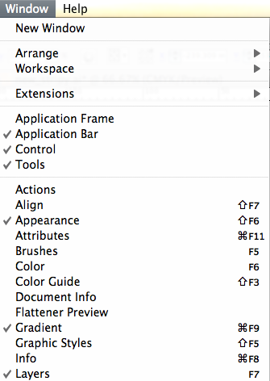
- Select the Ellipse Tool and draw the shape as shown
You will now apply a gradient colour to the shape

- Make sure you gradient panel is open

Stage Two Making Gradients

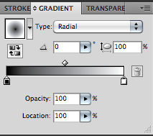
- You will now see the gradient panel to the left of your screen

Select your shape
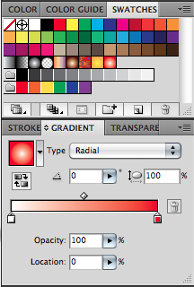

- You will now drag a colour swatch down from the swatches panel and place on each of the little paint pots
Making sure that type is selected to Radial

PLEASE SEE TUTORIAL MAKING A GRADIENT SWATCH

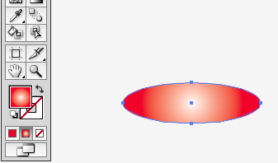
The ellipse should now look like this
Stage Three directly editing a shape using the convert anchor point tool

- Select the Convert Anchor Tool
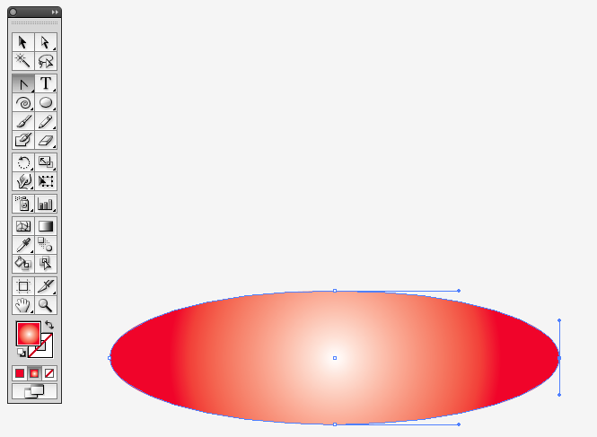
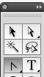

You will now see that there appears Bezier handles on the shape
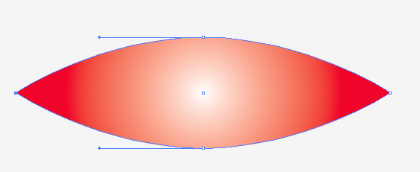
Select the little BLUE ANCHOR

You should now have a shape that looks similar to leaf
Making the inner black shape (inner eye)
Insert rulers
Cmd R

- Draw an Ellipse the same size as outer eye
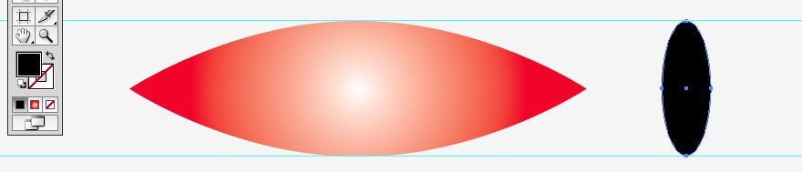

- Using the Convert Anchor point tool click on the bottom anchor

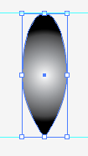
Make a Black and White Gradient

Use the same technique as you used for the red outer eye remembering to Select the black shape first
- Select the Gradient Tool
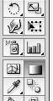
You will now be able to alter the angle of the gradient please experiment
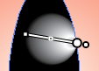

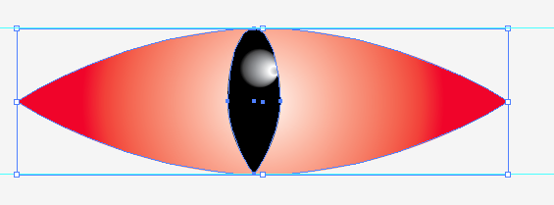
- Select all the shapes by scrolling over them with your Black Selection Tool

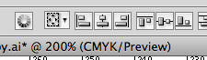
Selecting both shapes now select the
Horizontal align tool and notice now that both shapes jump to the centre

- Group the shapes
By Selecting the shapes and pressing the short cut cmd G or Object Group

Transforming the Eye Shape
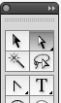
Select the Direct Selection Tool (white arrow)

- Select the solid blue anchor at the bottom of the outer eye and keeping hold shift held down pull down the anchor until the eye looks as shown

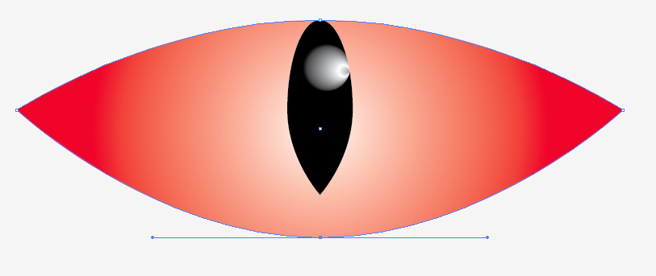

- Do the same step as above to pull down the anchor for the inner black eye
- Select the Move tool and hover the arrow around the transform handles and pull the shape round as shown

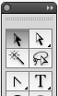
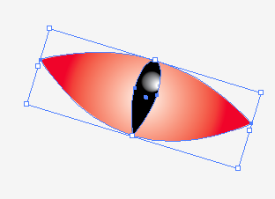

Copying and reflecting the eye

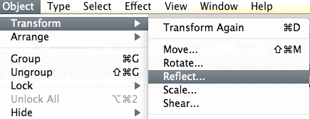
- Select the eye with the black selection tool

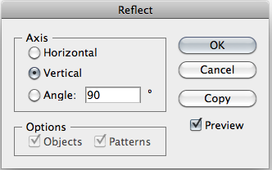
- You will see the following pop up box make sure the preview box is selected and input the values as shown

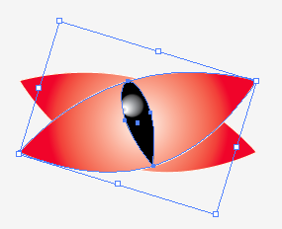
- You should now have two eyes, separate them by moving the top one with the black selection tool

Try and aim for a set of eyes as shown

Select both eyes and group the shapes this will group the shapes into one shape which will make selecting parts of the image a lot easier
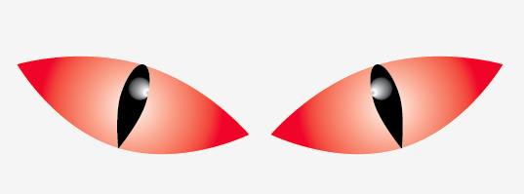

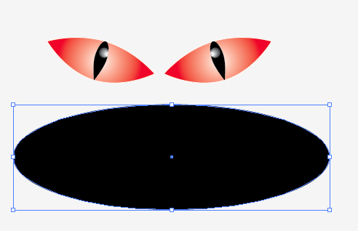
- Select the Ellipse tool and draw a shape as shown

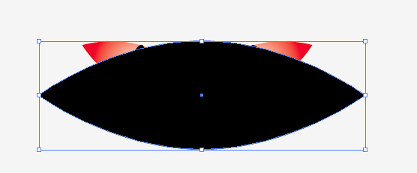
- Now select the shape and using the convert anchor tool to the shape as shown

Ordering of objects

Notice now how the head is on top of the eyes, we now need to move this to the back

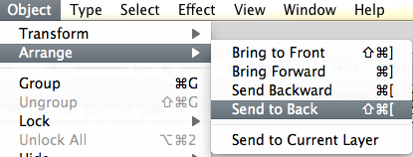

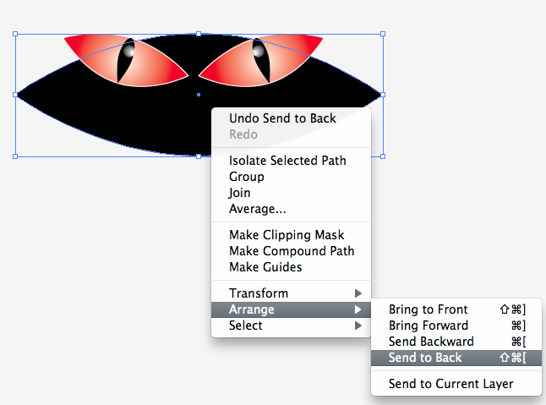
- Go object arrange and send to the back or alternatively ctrl click on the object and go arrange send to the back

Now move the head and the eyes into position as can be seen on the next page

Making the Shaping of the head

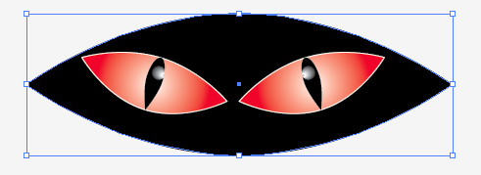
As can be seen the head is a little thin

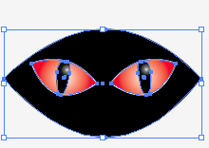
- In order to make the head a little wider, select the selection tool the black arrow and whilst pressing and holding down alt pull up the centre transform point so the shape becomes wider

Creating Ears

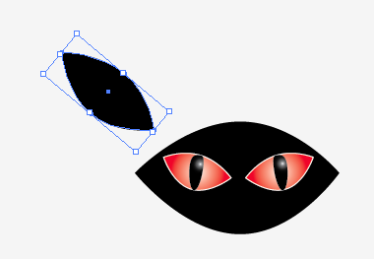
Is the exactly same process as creating the other shapes such as the head and the eyes

- Ellipse tool
- Direct selection tool on
The anchor
- Move into position

Continuation of making ears

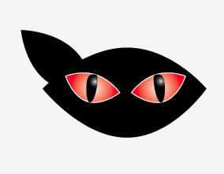
Using the steps as shown before now reflect and copy the ear you have made

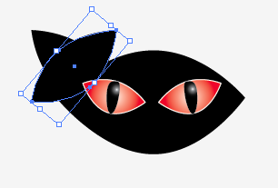
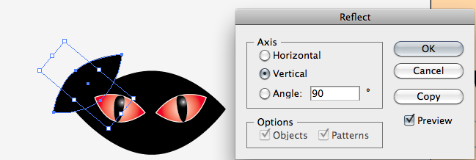
Using selection tool move ear

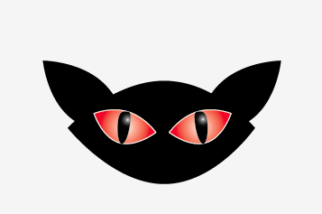
Making Whiskers and Eye Brows

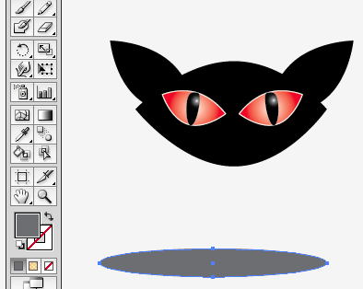

This is exactly the same as making the rest of the cats face

- Draw an ellipse

Pull in an anchor using the direct selection tool

Use the Convert anchor point to narrow edges

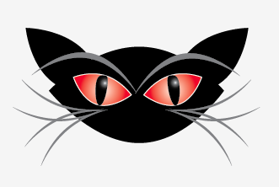
Copy SHAPE AND ROTATE using the selection tool AS SHOWN

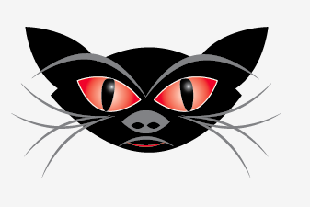

Can you guess how to make the nose and mouth?
Have a go, if you get stuck ask

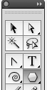
Making Fangs

- Select the polygon tool

And then click once on your art board the following pop up box will appear

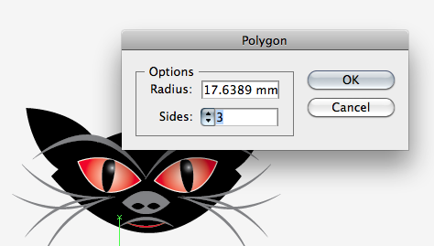
- In the polygon pop up box for the sides select 3

Making the neck and the body

Make an Ellipse

25. Select the direct selection tool and pull in an anchor
Do this on both sides until you have the shape as shown

Ellipse Move the right Anchor Move the Left Anchor

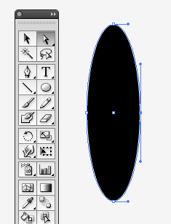

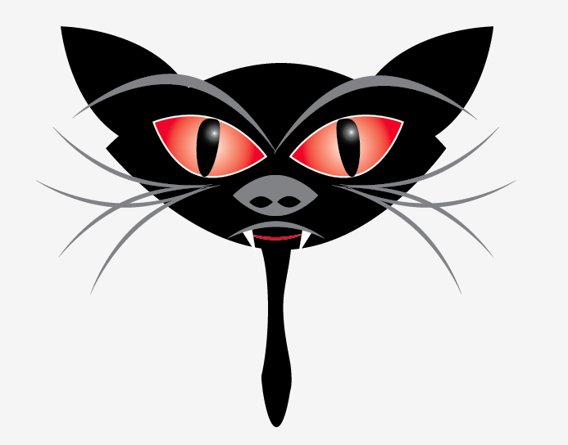
Move the neck into position

Make the body using the ellipse tool

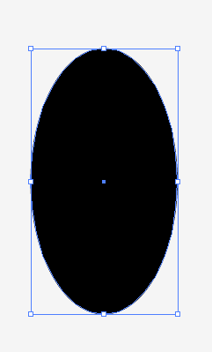
- Copy the shape by pressing and holding Alt and dragging another shape from it do this twice

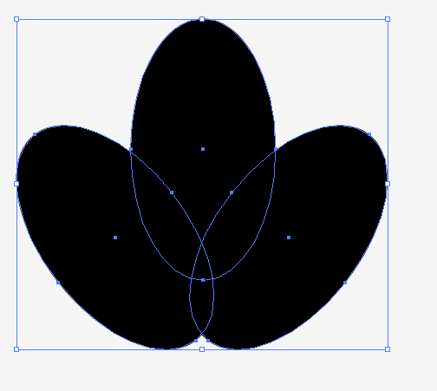

- Move and Rotate the shapes as shown

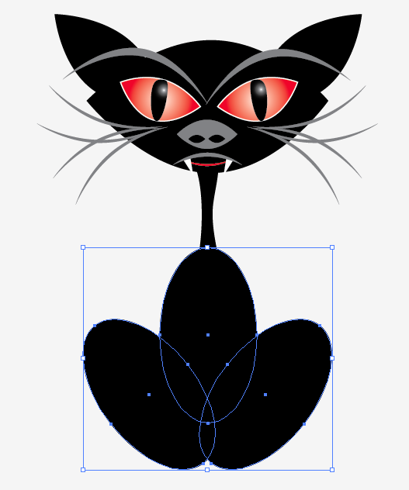

- Place as shown

Making the legs

29. Is the same process as the neck see if you can follow the screen shots

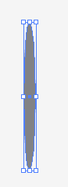

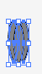

NOW HIGHLIGHT YOUR CAT AND GROUP IT

Making the background

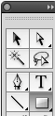
30. Select the Rectangular marquee

And draw a shape covering your whole document
NOTICE YOU CAT DISAPERS

31. Make a gradient and save it

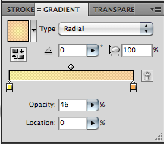
- Use yellow on the left pot
- Use orange on the right pot

Make sure the opacity on both selected pots is around 45% – 50%

Notice that the block you have drawn is above the cat and you can just see the cat poking through

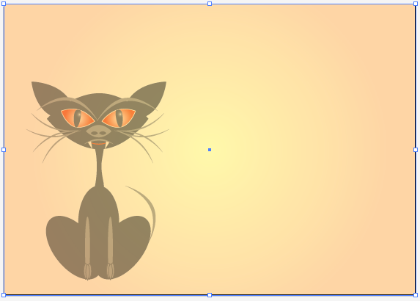
Lets get the cat back

- Ctrl click on the rectangle and go

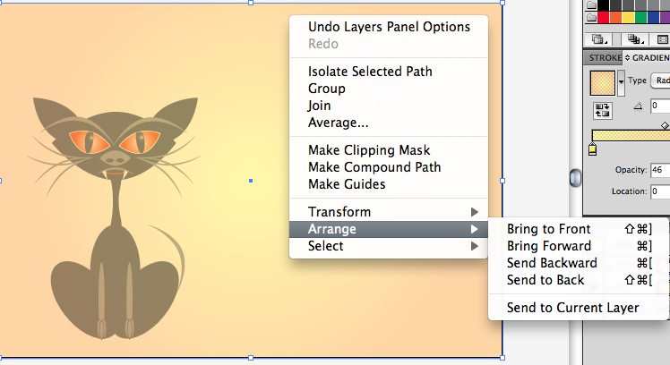
- Arrange Send to the back

Name the Cat
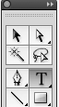
32. Select the text tool

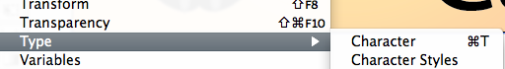
Go to window scroll to type and select the Character

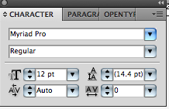

Select the drop down arrow and choose a font

Select font and choose a big font size try over 72

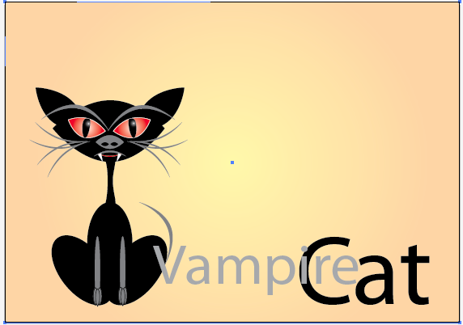
Finished Vampire Cat

