Making Shapes in illustrator

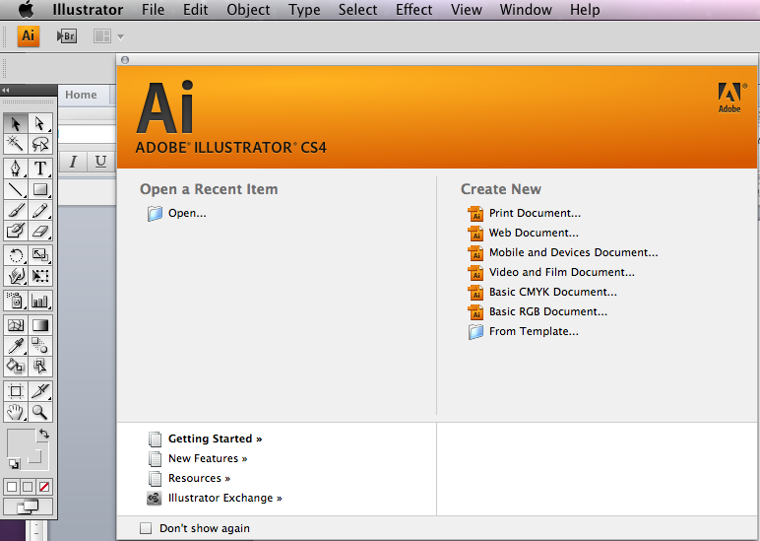
- 1 Open up adobe Illustrator and select new document

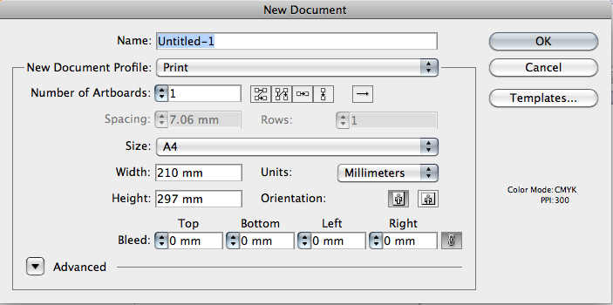
- 2 Select A4 and orientation portrait

The bleed options and margins we will discuss in a later tutorial

- 3 Press and hold down the rectangle tool as shown and you will see a fly out

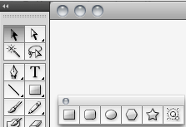

- 4 Select the rectangle and drag out the shape

BY HOLDING DOWN THE SHIFT KEY YOU WILL CONTRAIN THIS SHAPE TO A SQUARE IF NOT YOU WILL GET A RETANGLE

BY HOLDING DOWN THE SHIFT AND ALT KEY YOU WILL CONSTRAIN THE SHAPE FROM THE CENTRE

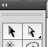
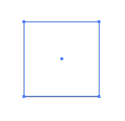

You can now move your shape around the page using the move tool

You can also resize the shape by dragging out the the corners of the shape, remember to hold down shift if you wish the shape to keep the same proportions.

Read Stage 1 tutorial then follow this with stage 2 filling colour using swatches.

In brief you can change the colour of a shape quickly by clicking on the fill block on your toolbox

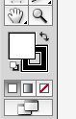
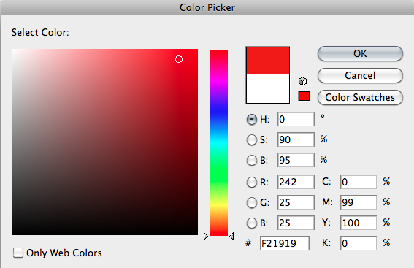
You will now be able to click and select a colour from the colour picker pop up box

Stoke Colour

This is the square hollow box you can see behind the fill box you will need to select this by clicking on it, and the stroke box comes to the front.

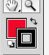

You can change the colour of the stroke by in the same way as the fill

BUT BOTH THE FILL AND STROKE MUST BE SELECTED (AT THE FRONT) TO MODIFY THE SHAPE

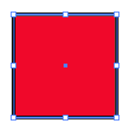
Notice now how the bounding stoke box has changed colour

For your stroke to be sized differently select the stoke panel

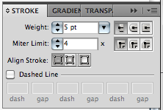
You can now change the WEIGHT or size of the stoke by selecting the weight

Power Duplicating

By selecting the rectangle with the move tool and holding down the alt key you can make a copy of the shape

Activity 1

Make the following pattern using shape colour stroke size and power duplicating

1 Draw a square

2 Hold down alt and shift and using the move tool drag out another square

Notice how holding down shift keeps the new copied square in alignment with the other

3 Repeat step 2, so you now have 3 squares

4 Make sure your Move Tool is selected an drag your mouse over all three shapes THEY are now all selected

This is called the bounding box

Drag down another copy of this pattern

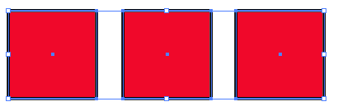

You should have something that resembles this.

5 Try to make this pattern

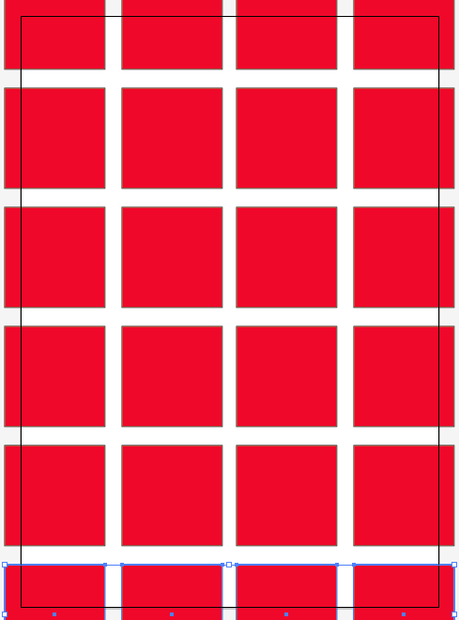

Industry Hint!

You can drag the first row down using alt and shift

Now hold down Cmd and press D

5 Try to make this pattern

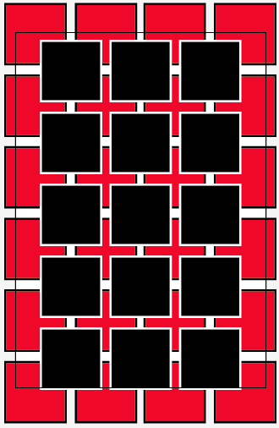
Hint!

Copy a square and change colour
POWER DUPLICATE

The Direction Selection Tool

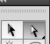
This tool allows you to directly edit any shape using the shapes anchor point

6 Copy your square and change the fill to white

Select the corner anchor using the direct selection tool on the squares corner anchor

NOTICE how that anchor has now gone dark blue

7 Try to recreate this shape

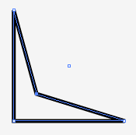

8 Now create this pattern

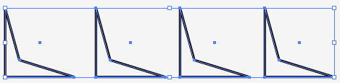
Hint! Use the same technique as on the previous page

4 Now create this pattern

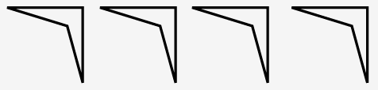
Stuck?

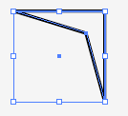
- Use the Move tool to select the shape
- Once the bounding box is highlighted hover your mouse on the corner of the shape and you will see your mouse turn in to a rounded arrow drag the shape round

9 Copy as step three

10 see if you can make the following pattern

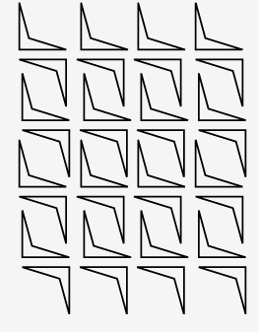
7 Experiment with different ways of using the direct selection tools and the shapes and create your own new shapes.

Create some basic shapes and use some of the reshaping tools

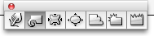

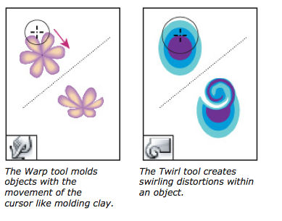
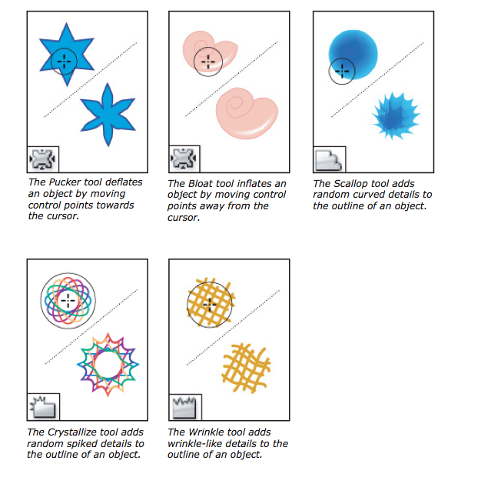

Select the ellipse tool and create a perfect circle

Now use the warp tool to create the following shapes

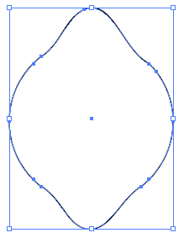
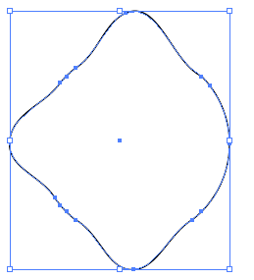
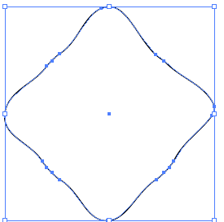
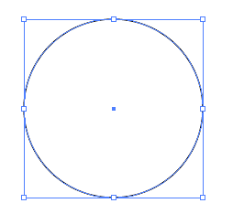
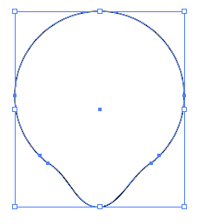

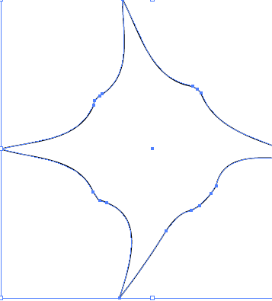

The following shapes were made based on a circle and which
re-shaping tools?

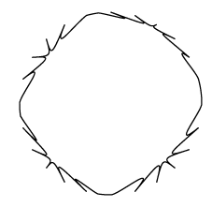
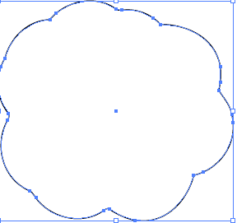

Continue experimenting and see how many other shapes you can make using one shape and one of the reshaping tools

