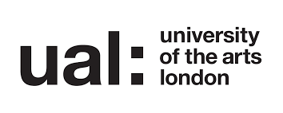

UAL Awarding Body Level 1 Award and Diploma in Art, Design & Media

Assignment Brief: “Impact”

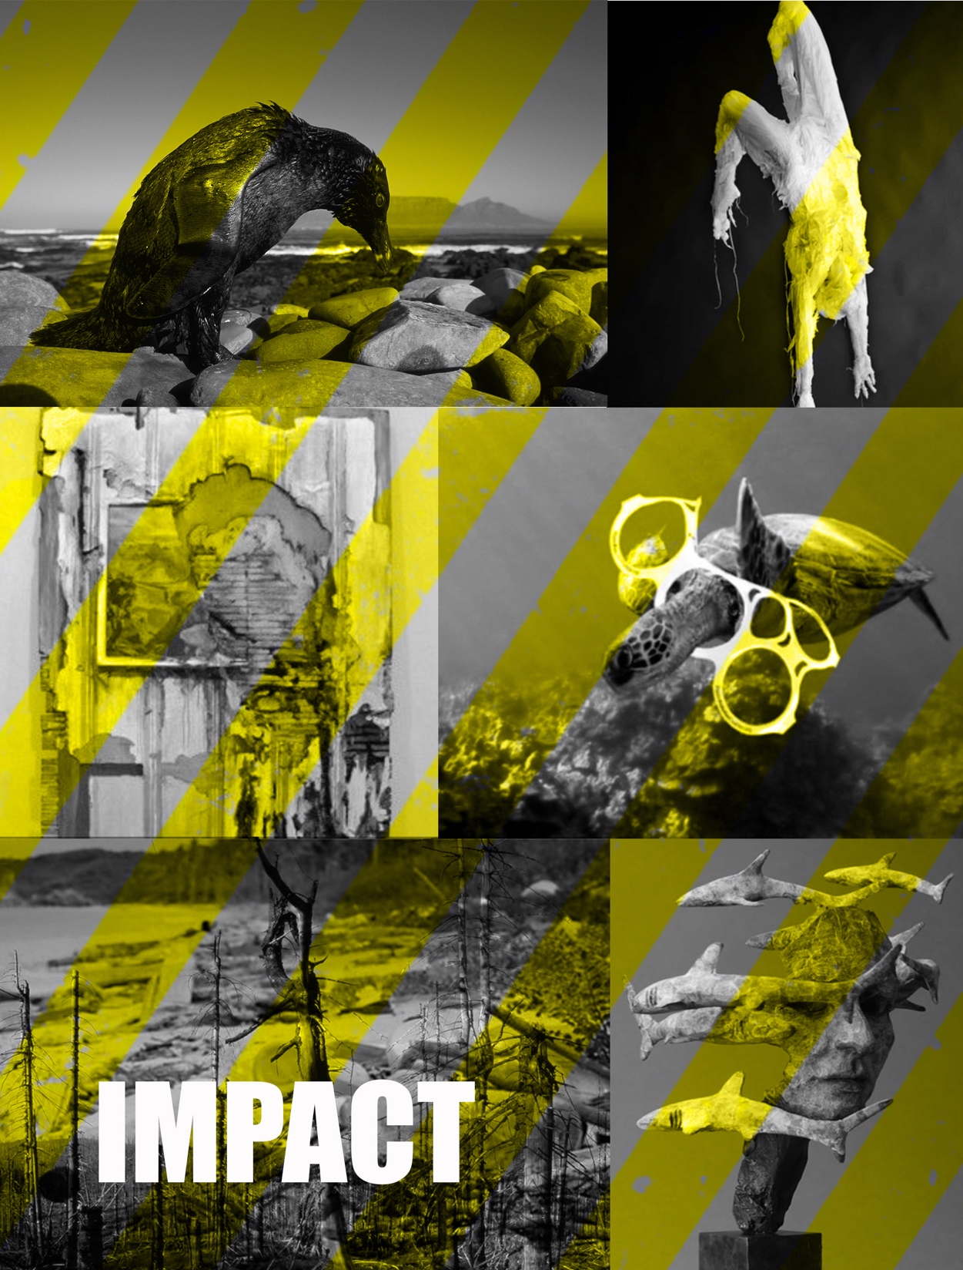Student Name:

|  |  |  |  |  |
| --- | --- | --- | --- | --- |
|  | UAL Awarding Body | | | |
| LEVEL 1 Award and Diploma in Art, Design & Media | | | | | |
| Assignment Brief | | | | | |
| Assignment Title | Impact | | | |
| Unit No & Title | **Unit 5­: Solving 3D creative problems**  **Unit 3: Introduction to communication skills in art, design and media** | | | |
| Level & Credit Value | Level: 1 & Credits 9 | | | |
| Assignment Leader | Alexia Grantham | | | |
| Assignment Verifier | E Riggs | | | |
| Start Date | 09h December 2019 | | | |
| Formative Assessment Date | 20th January 2020 | Deadline Date | 31st January 2020 |
| Learning Outcomes | Objectives: At the end of the units the learner will | | | | | |
| **Unit 5­: Solving 3D creative problems**  Outcome 1 Be able to use materials processes and skills in 3D art, design and media  Assessment criteria  1.1 Use Materials, processes and skills to support the development of a solution to a 3D creative problem  Outcome 2 Be able to use 3D contextual research  Assessment criteria  2.1 Use contextual awareness to support the development of a solution to a 3D creative problem  Outcome 3 Be able to use 3D communication skills  3.1 Present solutions to a 3D creative problem  3.2 Describe the effectiveness of solutions to a 3D creative problem | | | | | |
|  | | | | | |

|  |
| --- |
| Learning Outcomes | Objectives: At the end of the units the learner will |
| **Unit 3: Introduction to communication skills in art, design and media**  Outcome 1 Understand a variety of communication methods and skills.  1.1 Compare communication methods and skills to support a creative activity  Outcome 2 Be able to use 2D communication methods and skills  Assessment criteria  2.1 Use a variety of communication methods to present ideas  2.2 Describe the effectiveness of chosen methods and skills to communicate ideas |
|  |

|  |  |  |  |  |
| --- | --- | --- | --- | --- |
| |  | | --- | | **Vocational Context | Project Description** | | **HUMAN IMPACT on the environment can take many forms here are a few as example.**   * Oil Spills * Acid Rain * Radioactivity * Plastic * Fossil fuels * Smog * C02 (carbon dioxide) * Sewage * Space junk * Deforestation * Land fills   **TASK:**  You will research human impact on the environment and on your lifestyle.  You will choose one particular form of impact that you feel strongly about and investigate ways in which you can promote awareness of it through the use of sculpture as an art form.  In order to do this, you need to explore a range of 3D materials, processes and techniques before you decide what to use to make your final outcome. You will need to research 3D and environmental artists and explore how they have used a range of 3D materials, processes and techniques - producing a range of samples/experiments influenced by their work.  At the end of this unit you and your class mates will develop an art installation which will be shown downstairs in the lobby. This installation will promote awareness of environmental pollution to an audience of college students and staff.  You will work as team to produce and show the installation and present your selves and art work to other people at the college. |  |  | | --- | | What you should aim to produce | | **What you must produce for assessment**   * Design Development Cycle * Mind maps * At least 3 forms of environmental impact researched with images and presented in your sketchbook * At least 3 artists/sculptors researched with images of their work discussing materials and processes used * Drawings of ideas for your 3D work in your sketchbook with annotation * At least 3 different 3D art forms * All work must be photographed and presented on A1 boards - with annotations and evaluations discussing the materials, formal elements and using formal language * 1 X Final outcome (your sculpture) * Contribute to an installation promoting environmental impact * Health and safety notes * Final evaluation | |

|  |  |
| --- | --- |
| **Suggested Research** This is not exhaustive-you will need to independently source additional avenues of research | |
| MOSI  Manchester Museum  Manchester Art Gallery  Manchester City Centre  Charity shops  Galleries  Tutors  Peer Group | **Environmental Artists**   * **Andy Goldsworthy** (born 26 July 1956) is a British sculptor * **Alberto Giacometti** 10 October 1901 – 11 January 1966) was a Swiss sculptor, * **Sir Antony Mark David Gormley**, OBE (born 30 August 1950), sculptor. * **Christo Vladimirov Javacheff and Jeanne-Claude** * **Kathrine Hamnet** Designer Clothing * **Chris Jordan** is a Seattle-based artist * Alexander **Calder** (1898–1976)   **Sculptors**   * **Auguste Rodin** French **sculptor** * **Alberto Giacometti**was a Swiss sculptor, painter, draftsman and printmaker. * [**Damián Ortega**](https://www.widewalls.ch/artist/damian-ortega/) The Mexican sculptor * **Cornelia** Ann **Parker** OBE, RA (born 1956) * **Naum Gabo** (1890-1977) * **Cornelia** Ann **Parker** OBE, RA (born 1956) * Henry Moor |

|  |  |  |
| --- | --- | --- |
| Week / Date  UNIT 5 | | Activity / Location |
| **Session number** | | **Preparation RESEARCH OF**  Introduction to **IDEA GENERATION | DESIGN CYCLE** |
| Week 1  Session 1  Assessment  Criteria | | Activities:  Experimental Processes, techniques, research and recording  **Unit Breakdown | assignment breakdown**  Locations: Art studios room |
| Week 1  Session 2  Assessment  Criteria | | Activities:  Experimental Processes, techniques, research and recording  **Secondary research environmental systems**  Locations: Art studios room |
| Week 1  Session 3  Assessment  Criteria | | Activities:  Experimental Processes, techniques, research and recording  **Secondary research environmental pollution and artist responses**  Locations: Art studios room2 |
| Week 2  Session 1  Assessment  Criteria  OC 1,2  AC  1.1 2.1 | | **Activities: Making trial 1**  Experimental Processes, techniques and recording  Secondary and Primary Research  Secondary Research Giacometti  3D Making techniques using clay  Locations: Art studios and Graphics room |
| Week 2  Session 2  Assessment  Criteria  OC 1,2,3  AC  1.1 2.1 e | | Activities: Making trial 2  Experimental Processes, techniques and recording  Secondary Research Alexander Caulder wire and shape  Wire sculpture bending cutting and sculpting  Locations: Art studios and Graphics room |
| Week 2  Session 3  Assessment  Criteria  OC 1,2,3  AC  1.1 2.1 3.1 3.2 | | Activities: Final outcome  Experimental Processes, techniques and recording  Primary Research  Secondary Research (Gabo) Art movement constructivism  3D Making techniques using cardboard and structure  Written / audio recording on blog of evaluative reflective annotation  Locations: Art studios and Graphics room |
| Week 3  Session 1  Assessment  Criteria  OC 1,2,3  AC  1.1 2.1 3.1 3.2 | Activities:  Experimental Processes, techniques and recording Class Problem solving activity Experimental Sample 3  Contemporary artist wire and materials  Secondary Research Henry Moor  Balloons plaster and modroc  Written / audio recording on blog of evaluative reflective annotation  Locations: Art studios and Graphics room | |
| Week 3  Session 2  Assessment  Criteria  OC 1,2,3  AC  1.1 2.1 3.1 3.2 | | Activities:  Experimental Processes, techniques and recording Class Problem solving activity Experimental Sample 3  Contemporary artist wire and materials  Chicken wire and Modroc contemporary artists  Balloons plaster and Modroc Henry Moor  Written / audio recording on blog of evaluative reflective annotation  Locations: Art studios and Graphics room |
| Week 3  Session 3  Assessment  Criteria  OC 1,2,3  AC  1.1 2.1 3.1 3.2 | | Activities:  Experimental Processes, techniques and recording Class Problem solving activity Experimental Sample 3  Contemporary artist wire and materials  Chicken wire and Modroc  Chicken wire and Modroc contemporary artists  Balloons plaster and Modroc Henry Moor  Written / audio recording on blog of evaluative reflective annotation  Locations: Art studios and Graphics room |
| Week 4  Session 1 | | Activities:  Experimental Processes, techniques and recording Class Problem solving activity Experimental Sample 3  Contemporary artist wire and materials  Chicken wire and Modroc  Chicken wire and Modroc contemporary artists  Balloons plaster and Modroc Henry Moor |
| Week 4  Session 2 | | Final Outcome  Written / audio recording on blog of evaluative reflective annotation  Locations: Art studios and Graphics room  Evaluation |
| Week 4  Session 3 | | Final Outcome  Written / audio recording on blog of evaluative reflective annotation  Locations: Art studios and Graphics room  Evaluation and show |

|  |  |
| --- | --- |
| **Assessment Guidance: Examples of Evidence for Submission** | |
| PLEASE NOTE:   * When researching artists/designers or practitioners on the web - as well as images - you should include author, title of work, web address and date visited. * When researching from books – as well as images – you should include author title of work and publisher | |
| Assessment Criteria Unit 5 Learning outcome 1 | Some examples of evidence |
| 1 Be able to use materials processes and skills in 3D art, design and media  1.1 Use Materials, processes and skills to support the development of a solution to a 3D creative problem | Use of sketchbooks and work sheets to record and explore own ideas   * Introduction to visual language and drawing * Introduction to a range of tools and techniques used in art, design and media * Annotation in the form of peer and self-assessment   Mark making tools and techniques on different media including:   * Continuous lines, scale modifications proportion Wire * 3D Work Room Techniques, skills and processes   Wire, plaster, paper, wood, metal and Perspex Laser Cut   * Computer generated images |
| 2 Be able to use 3D contextual research  2.1 Use contextual awareness to support the development of a solution to a 3D creative problem | * Artist research and information * Annotation reflection in sketchbook and worksheets * Word documents and website |
| 3 Be able to use 3D communication skills  3.1 Present solutions to a 3D creative problem  3.2 Describe the effectiveness of solutions to a 3D creative problem | * Promotion and build of website   Pages to include blog portfolio and evaluation   * Audio files |

|  |
| --- |
| **Submission Guidelines:** |
| Your projects are graded as Pass/Referral until the final project-please take note that you have one opportunity to resubmit work after a referral grade has been awarded-if the work has not been handed in on new assessment date - you are at risk of failing the unit attached to the assignment and will ultimately not be able to pass the course.  **Submission Guidelines:** Assignment work must be submitted during the timetabled lesson on the deadline day to the relevant subject tutor, unless otherwise specified with consent from tutors.  All written work needs to be labelled with all details on including name, unit and assignment.  Any work submitted late will be assessed at the convenience of the tutor and will not receive extensive feedback.  Work that does not fulfil the pass criteria will receive a referral and new submission date-see above.  It is the student’s responsibility to keep a backup copy of all work.  All written work must be referenced; plagiarised work will be returned/will not be accepted as coursework and subject to disciplinary action. |