Using Shapes for Simple Illustration
Preceding Tutorial Vampire Cat
Aim
To use Illustration tools to produce pre-set shapes in Adobe Illustrator to make illustrate jewellery.
To use the direct, Indirect and pathfinder tools to transform shapes Into simple objects such as rings.
Objectives
To be aware of the following tools and panels
- Making a new document
- The Direct Selection Tool
- The Indirect Selection Tool
- Using the path finder tool to create shapes
- To make and save a gradient
- To apply colour using the swatch panel
- Saving a document correctly

The Finished Illustration you are working to
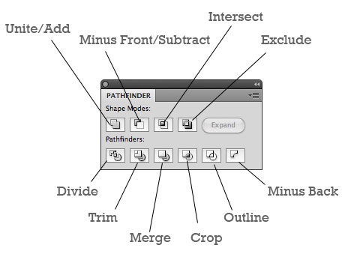
Explanation of the Pathfinder Panel
Building the Shape

- File New Document A4

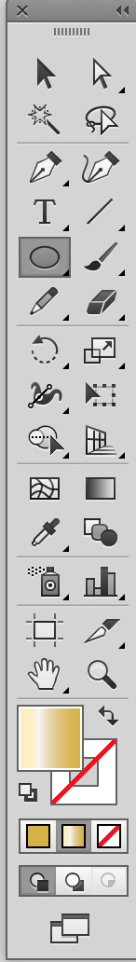
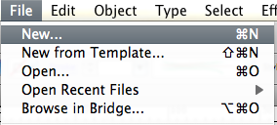

- Draw an elipse
Ellipse Tool
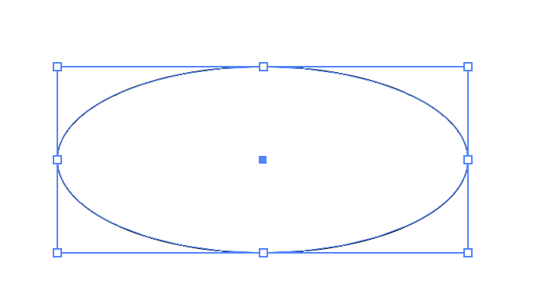

- Select direct selection tool
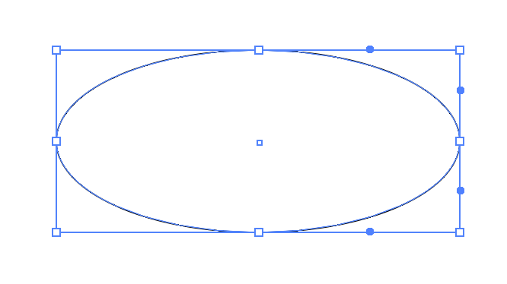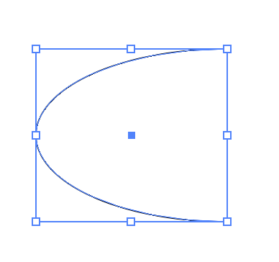
- Drag over the right hand side so you can select the right anchor only and Press backspace
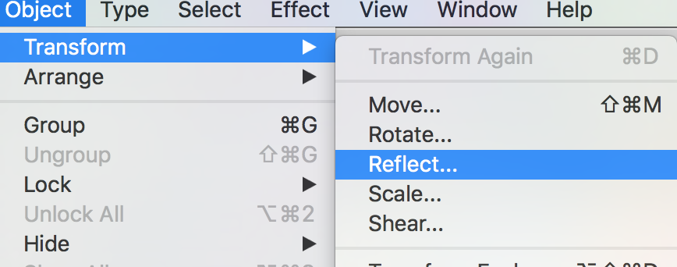
- Object Transform Reflect

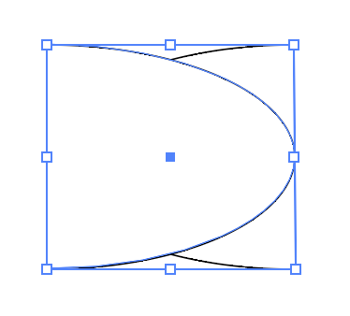
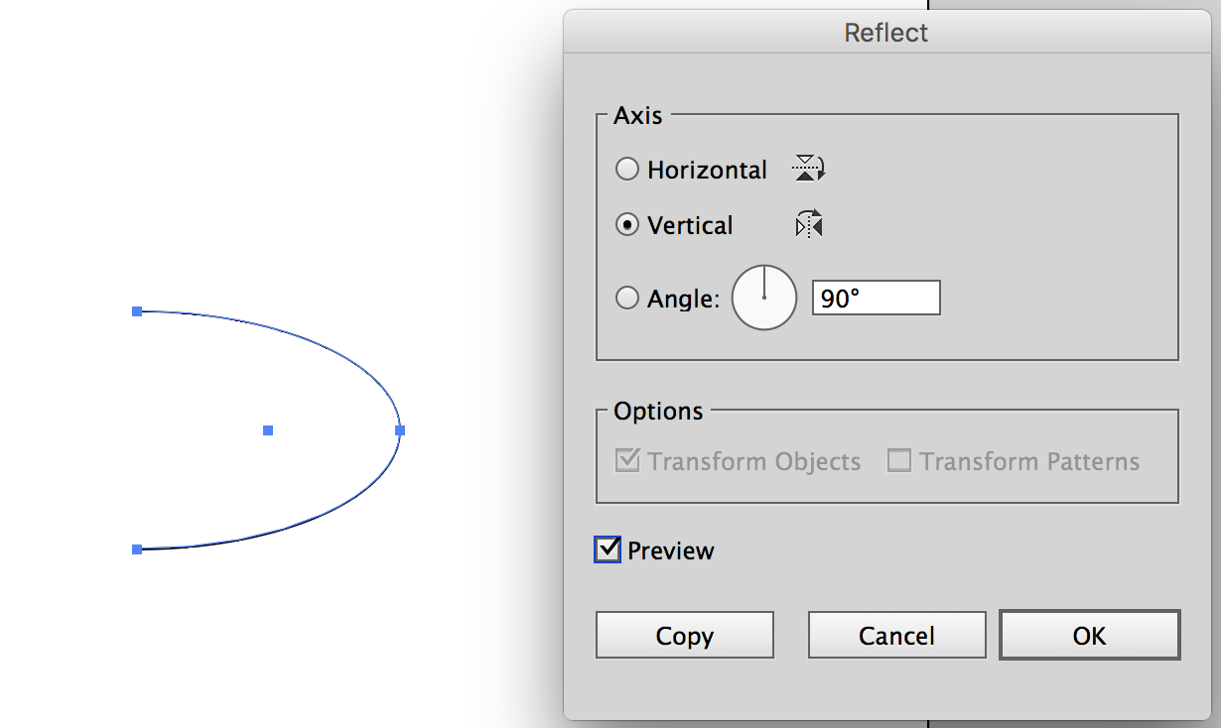

- Click preview and copy
- Notice you now have 2 half ellipses

- Move the right one to the side of the left

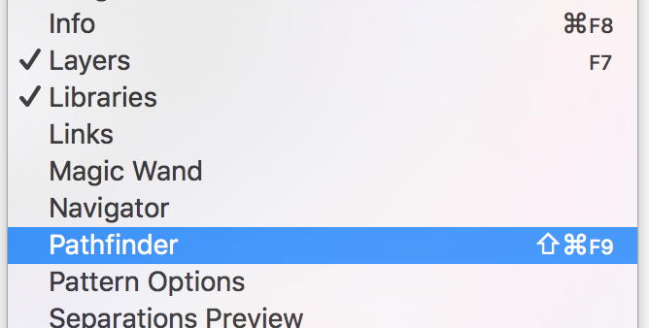
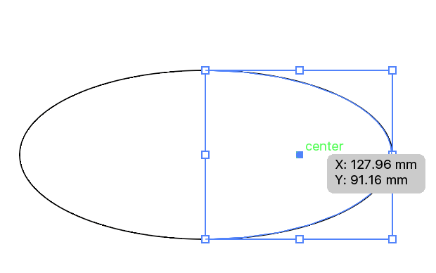

- Go Window Pathfinder and move the pathfinder panel closer to your work
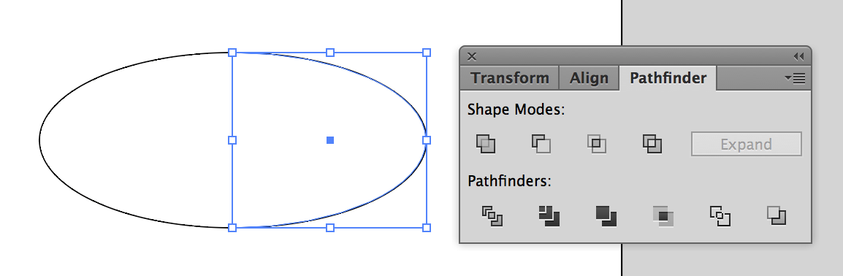

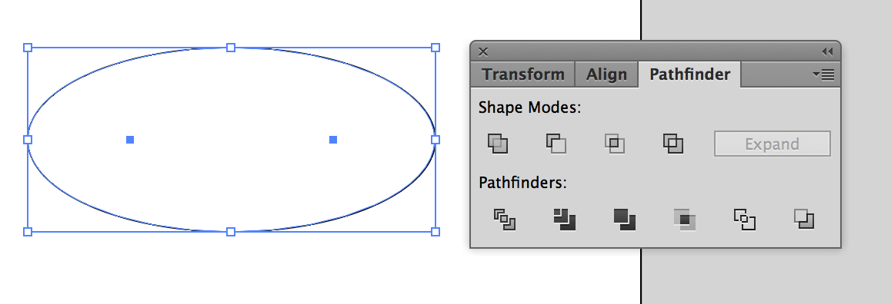
- Select both shapes

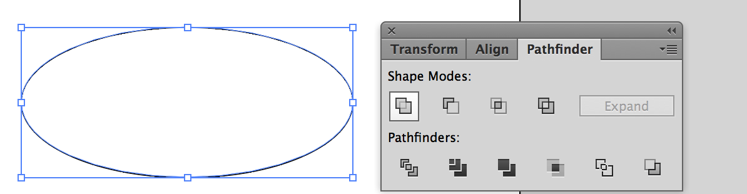
- Select unit icon
- You now have one identical shape

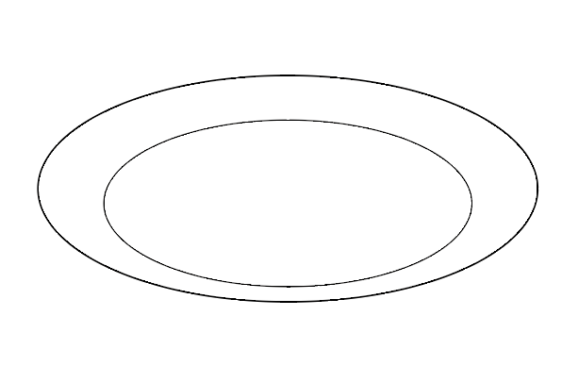
- Select the shape

- Copy and paste the shape and move into position

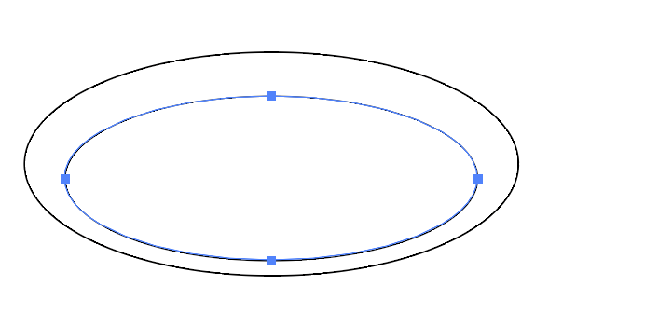
- Edit the shape to make more lifelike by… Select the side transform handle using the Move tool
- Pull the right hand side transform
handle whilst holding alt this will equally scale the object
- Now pull down the top transform handle to flatten the shape a little
- Roughly move this into position as shown

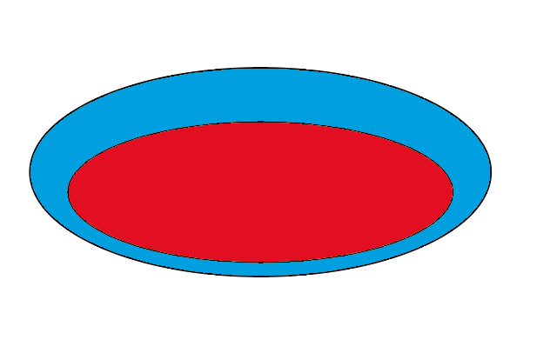
- Select each object and change the colour so you can see what you are doing
- COPY the last shape you made (the smaller one) paste this at the side of your work, make another copy FOR use later on, move this one out of the way and colour this a new colour

- Now click the second icon Minus Front on the pathfinder panel you will now have a ring like shape as shown
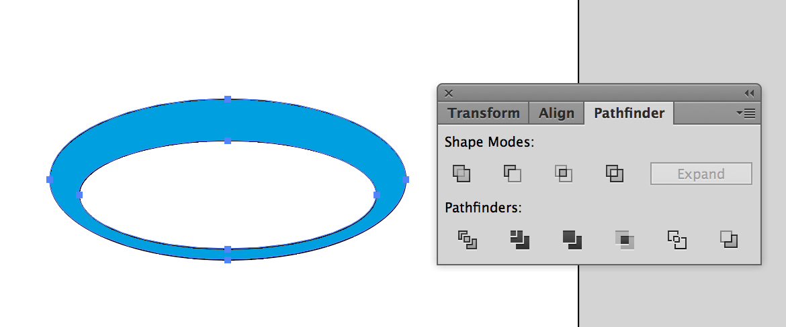
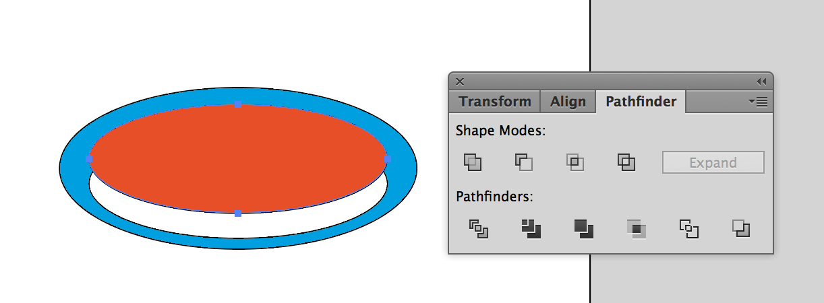

- Drag the copy of the shape you made earlier and place this as shown

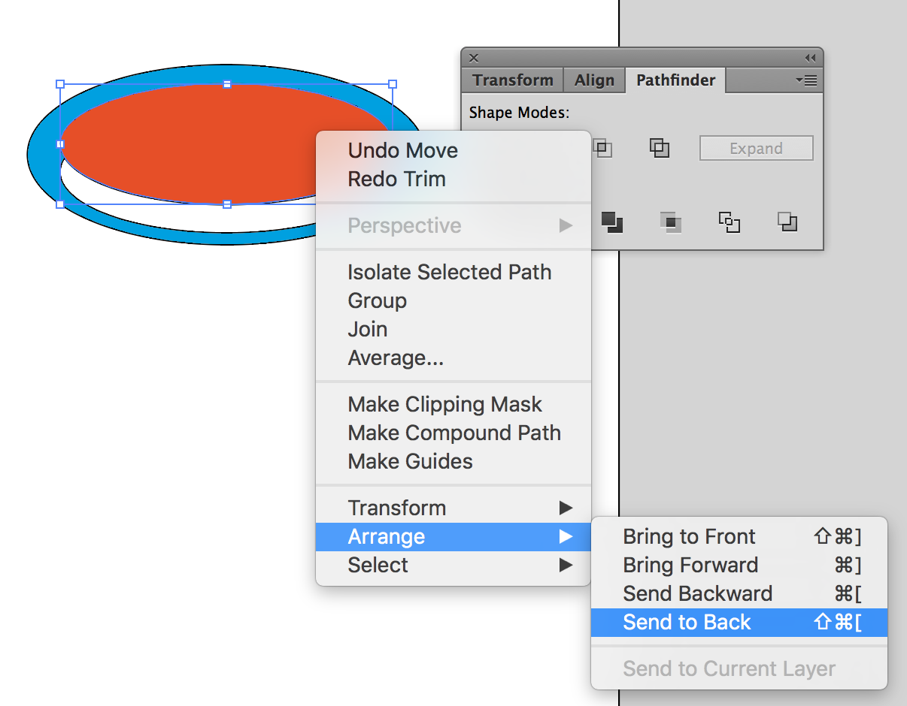

- And right click arrange and send to the back
- Select both on your path finder panel select trim
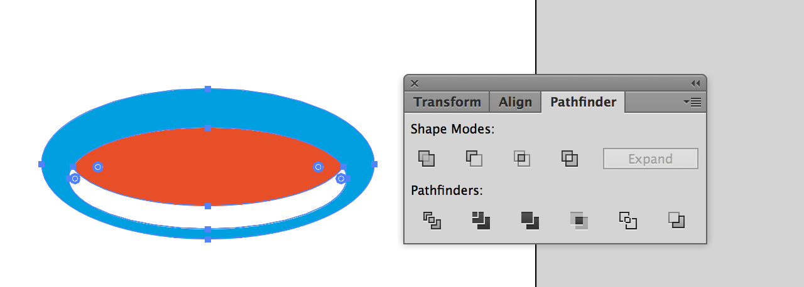
- Click on white space
- SELECT the white direct selection tool
- And select the middle object and press backspace
- It will look as though the whole shape has disappeared but it has not
- Select your direct select and hover over the shape you should now see a line select this
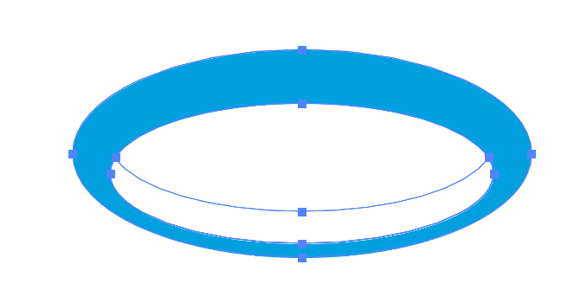

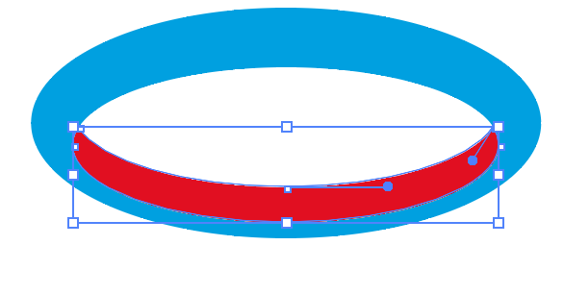
- Highlight the shape by clicking it and select a colour just to make sure

Part 2 Gradients

- Select all objects

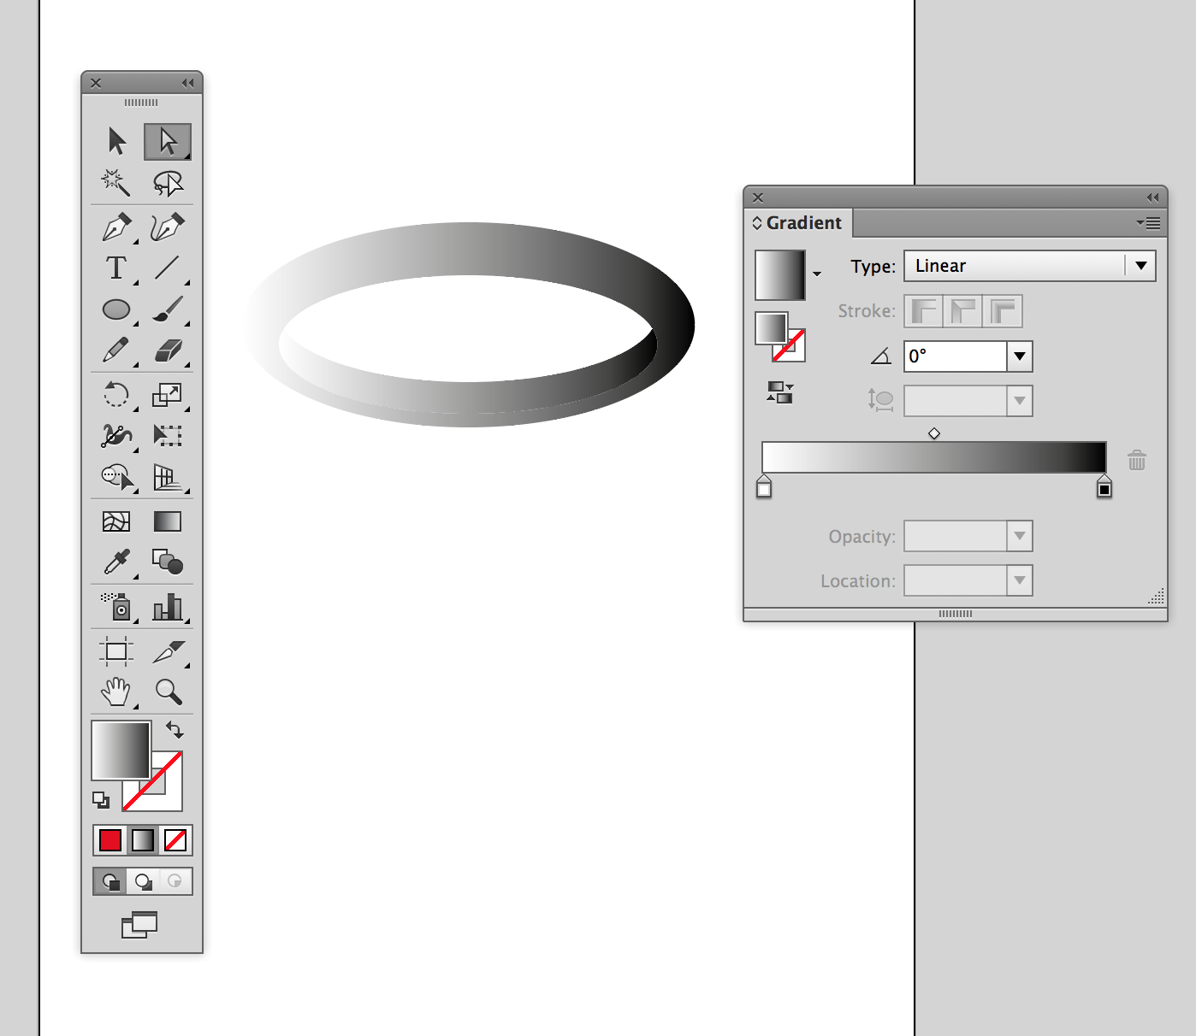
- Select the gradient icon at the bottom of the tool panel

- Open the gradient panel and place next to your work
- You can add paint pots by clicking under the gradient bar
You can remove them by pulling them off by selecting and dragging them off
To add colour select a pot and drag a colour from your swatch panel and put it on the paint pot

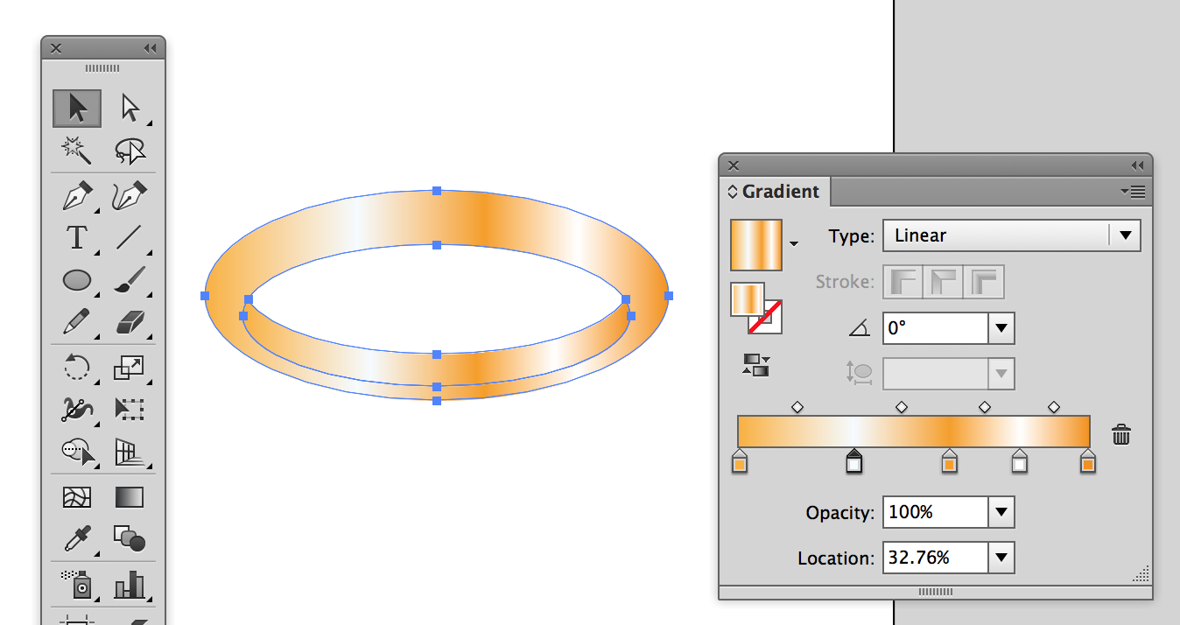

Experiment with different shapes and colours. Try putting in a shadow
Effect > Stylize > Drop Shadow

