Cara Codd
Jewellery and Contemporary Crafts HND – Year 1
Unit 7: Computer Aided Design (CAD)
Part 1: Task 1

The Use of CAD and CAM in
Contemporary Jewellery Design
and Manufacture.

Evolution of Contemporary Jewellery Design 3
Handmade Jewellery: Pre-industrialisation Jewellery 4
Ancient World Jewellery 4
Medieval Jewellery 1200-1500 4
Renaissance Jewellery 5
17th Century Jewellery 5
18th Century Jewellery 5
19th Century Jewellery 6
Manufacturing: Industrialisation 7
The Arts and Crafts movement 9
Art and Craft Jewellery 10
The Modern World: Jewellery Manufacture and Materials 11
Plastics 11
CAD and CAM Processes 12
How might I use of CAD for my own Project 16
Conclusion: The impact that CAD has had on the contemporary design crafts industry 17
Bibliography 19

Evolution of Contemporary Jewellery Design
The relevance of Computer Aided Design (CAD) and Computer Aided Manufacture (CAM) within Jewellery and Contemporary Crafts has and continues to be a heated debate. Although it is widely used within mass produced Jewellery, the applications are now being taught as part of Formal Education Jewellery and Craft courses. The development of CAD and CAM jewellery is still in its infancy and is still shunned by many traditionally trained gold and silversmiths. Why is this and does Computer Aided Design and Manufacture have a long-term place within Contemporary Jewellery and Craft Market or is it a short-lived fad and does it threaten the lively hoods of traditionally trained jewellery artisans and creative individuality? To answer this question, we must explore how jewellers’ skills and jewellery design has evolved through history and how it might continue to evolve in the future.

Handmade Jewellery: Pre-industrialisation Jewellery

Ancient World Jewellery
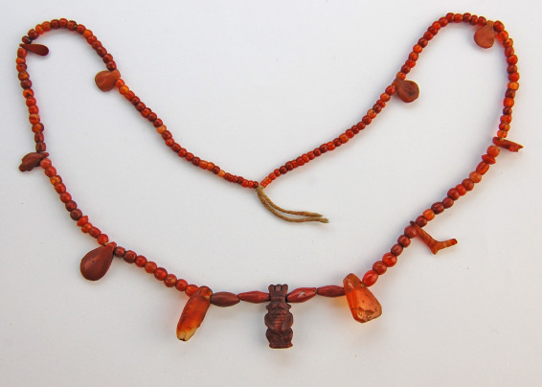
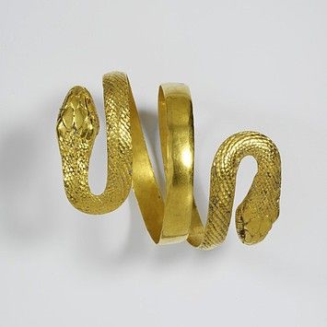
Wearing Jewellery has always been a part of human culture. Even in Ancient times with minimal resources, skilled craftspeople could reshape, and mould materials sourced from nature, such as shells wood, stone, animal skin, gold to create decoration which expressed an individual’s identity, sexuality, social standing, religious and social beliefs. Jewellery was not just decorative but could be worn as a talisman to warn of evil or a magic position to bring a wish. Often jewellery was also used to show allegiance to a leader or tribe or used in worship of a God. Egypt, India and China were at the forefront of Jewellery manufacture, creating tools and methods in which to shape metal and gemstones. Jewellery was often simple in design using the nature, unrefined resources found locally. Jewellery was often buried with the wearer to allow them safe passage to the afterlife.

Medieval Jewellery 1200-1500
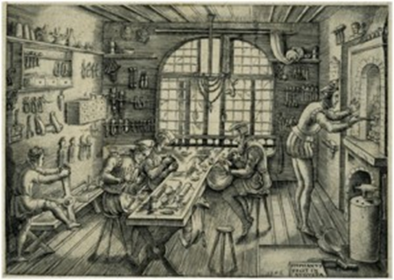
Jewellery was often worn by Royalty and nobility to show Social Status, Wealth, Loyalty to the Crown or Political Persuasion. Law decreed that gold could be worn by nobility only. Silver became popular, wood & base metals with Gold Leaf gilding. Jewellery embellished with polished gemstones, glass, enamelling, metal punching and hammer forming designs.

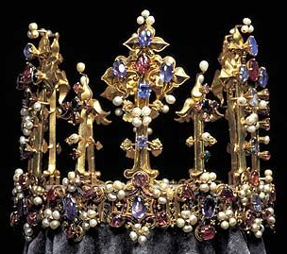

Renaissance Jewellery
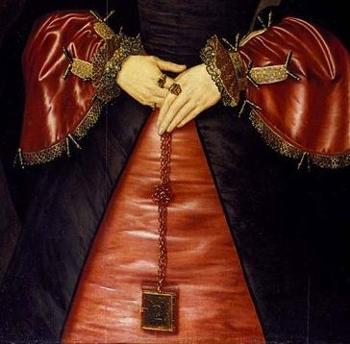
Jewellery was both functional and decorative. Jewellery was heavily influenced by Catholism, The Reformation and Italian fashion. Rosary beads were popular with Catholics during the Reformation period. pomanders, miniature poetry and bibles, decorative belts and girdles were popular items and allowed to be worn by the lower classes. Jewellery was worn for a purpose and to enhance the natural beauty of the wearer. Jewellery of the nobility explored the cutting and polishing of gemstones and often included portraits or carved scenes.

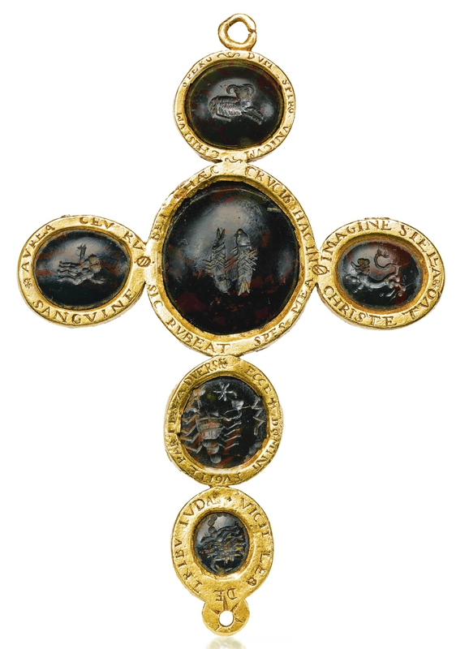

17th Century Jewellery

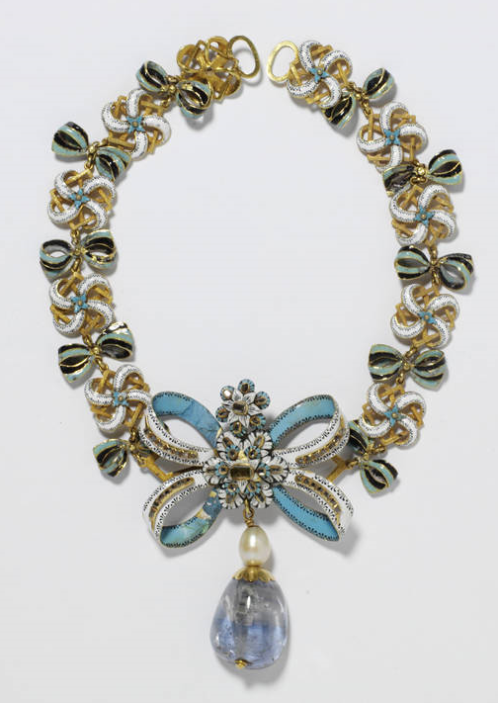
With journeys across the New World, fashions changed. Jewellery was used to decorate dress, ornamental brocade New stones from Spain and The Americas, brought pastel colours to jewellery. New gemstone polishing techniques allowed jewellery to sparkle in candle light Jewellery designs were highly decorated with floral designs and painted illustrative pendants, made fashionable in France.

18th Century Jewellery
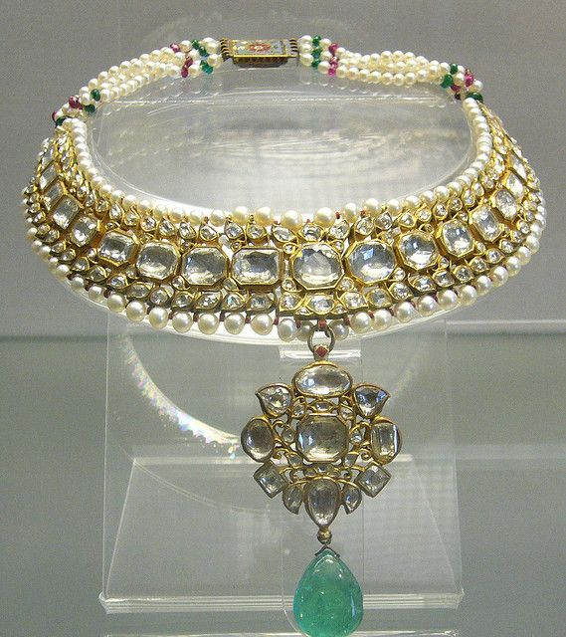
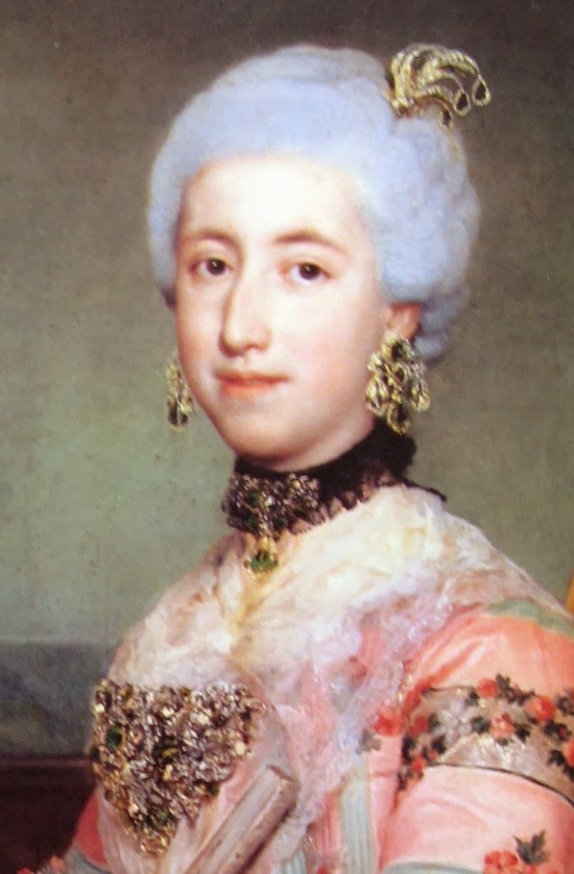
Brooches became highly popular during this period as did adjustable jewellery, which could be work together or as separate pieces, depending on the occasion. Jewellery was not only for the skin, but used to heavily adorn garments, dresses and worn as button on men’s coats and buckles on men’s shoes. With travel and mining in Brazil and India, came an influx of diamonds to Europe, so jewellery was designed around these stones. The rich flaunted their wealth and following the fashions of Paris, Marie Antoinette and the Ladies of the British Court was of the utmost importance. To be in Society one had to be fashionable.

19th Century Jewellery

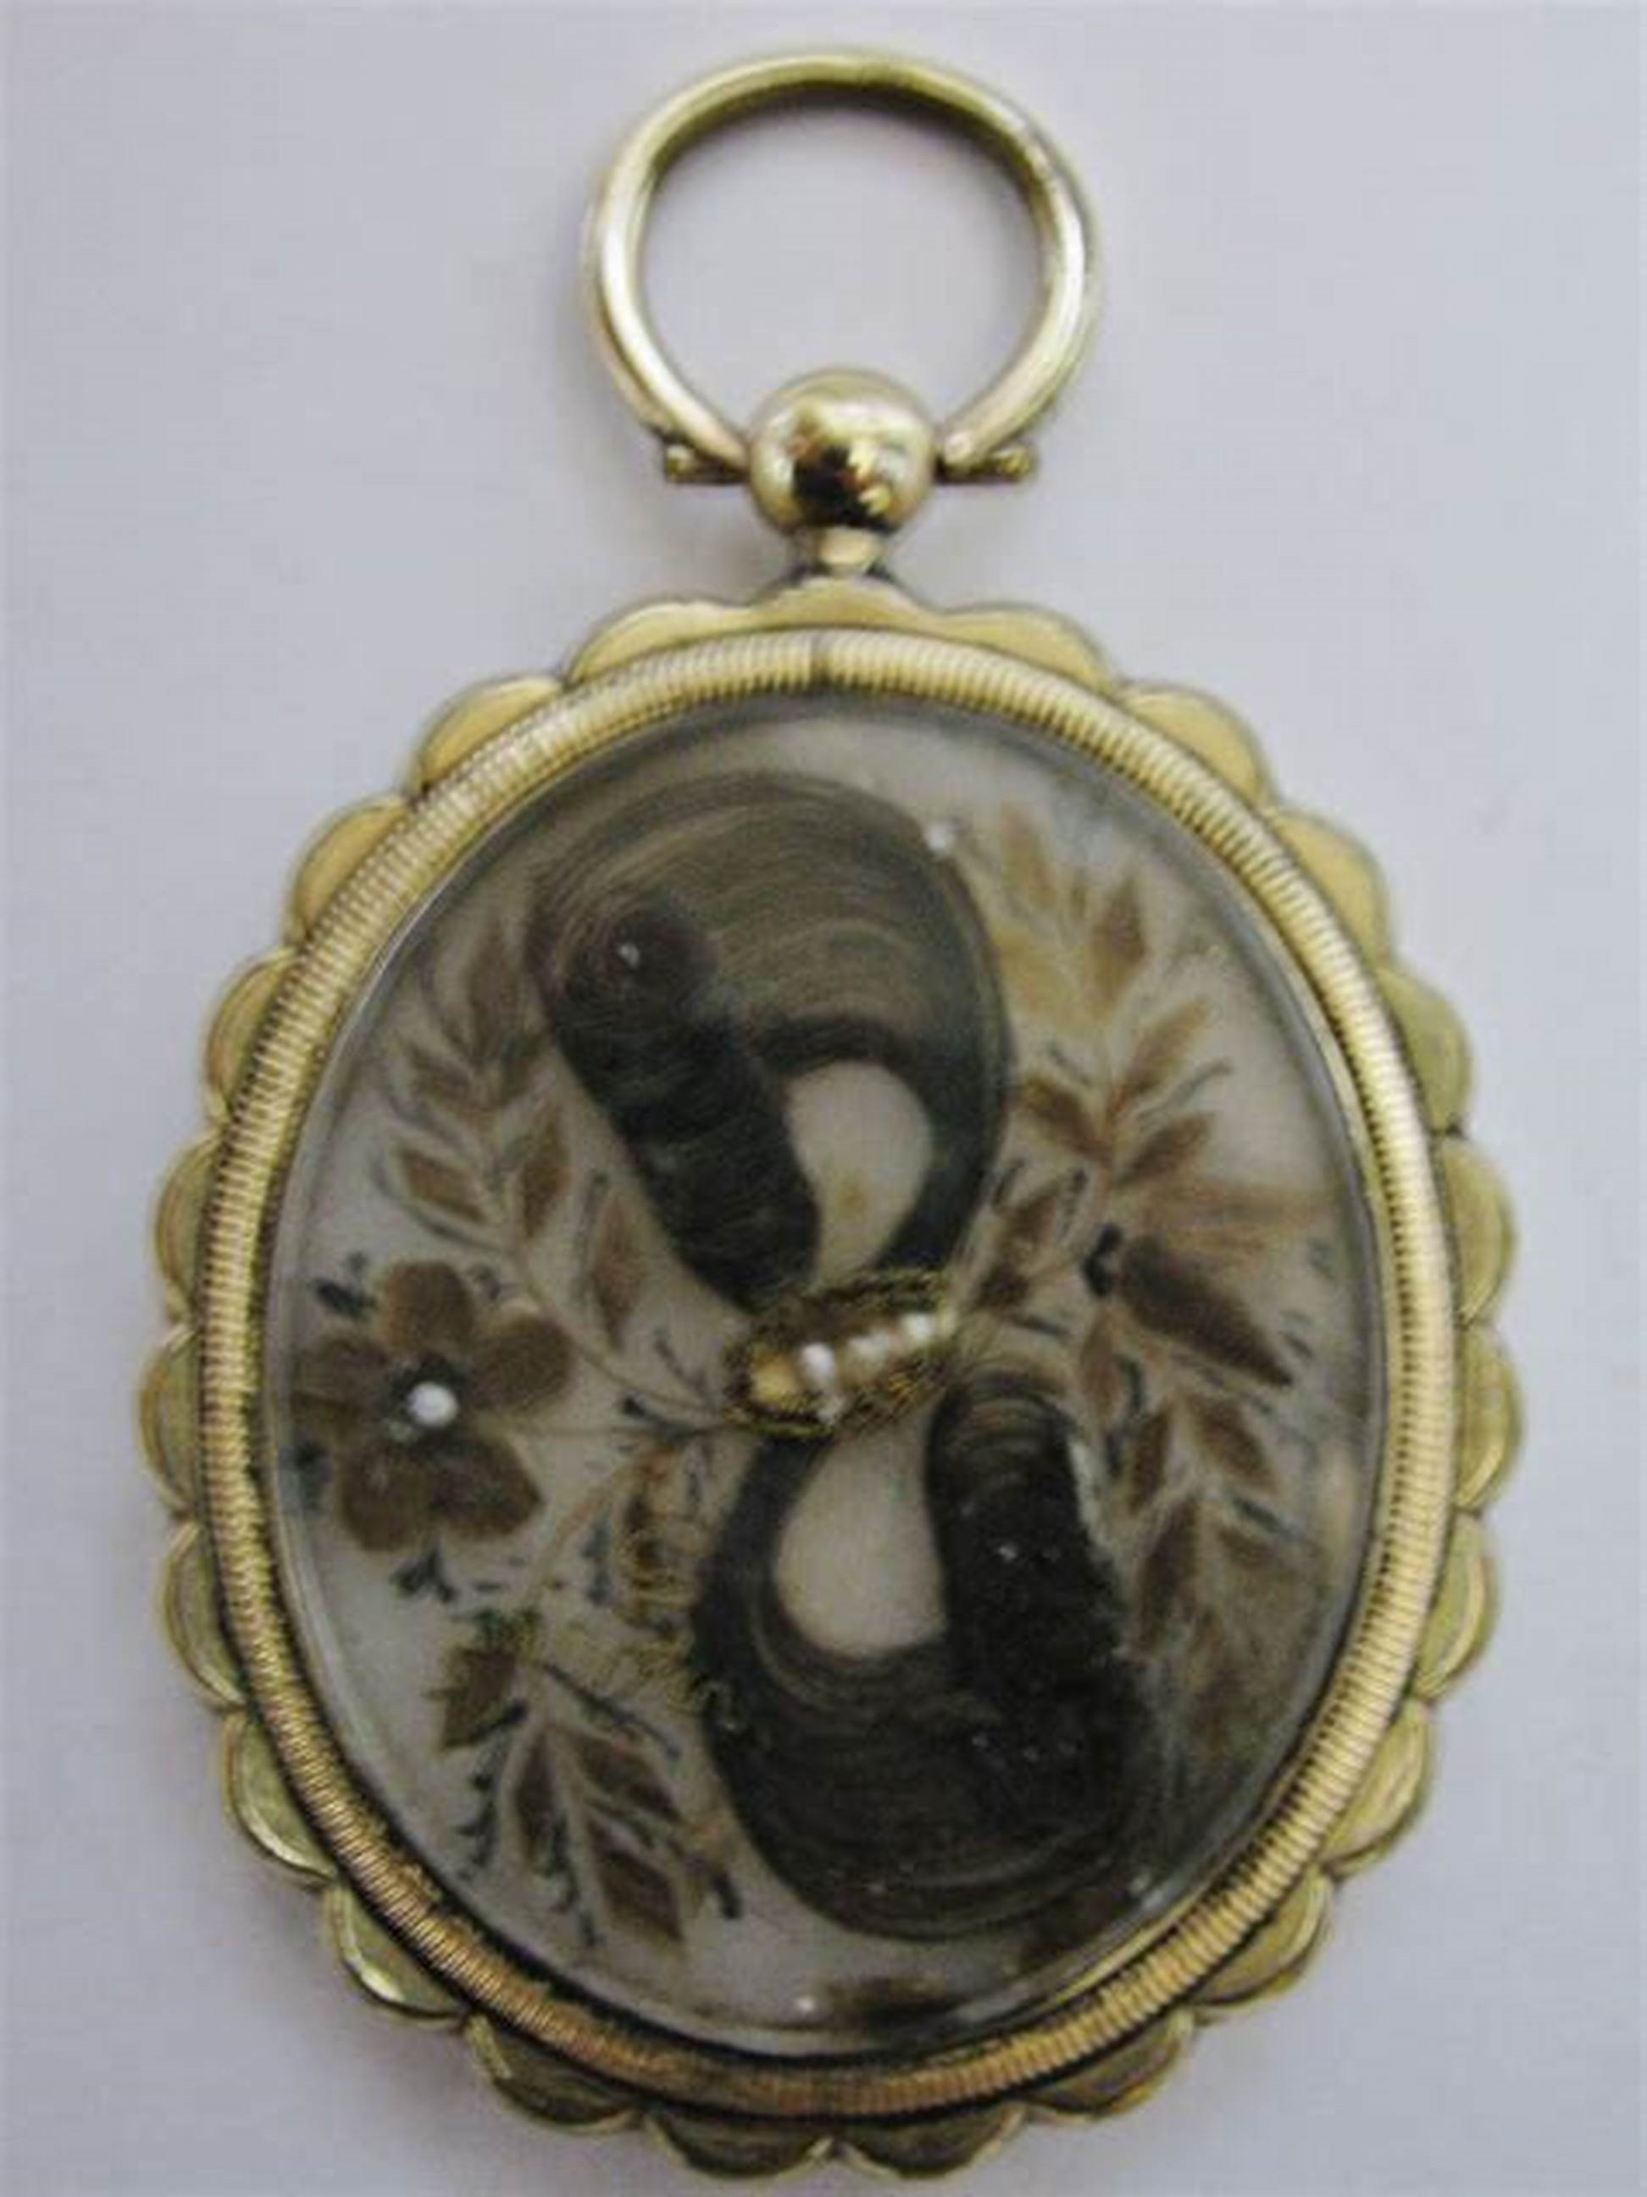
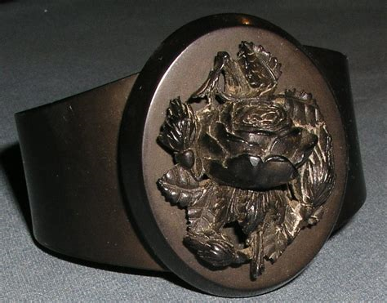
The 19th Century saw massive change, with travel to Europe becoming the norm for people in society. A fusion of styles and materials began to emerge. Cut Steel made some jewellery accessible to lower classes. Cold connections such as rivets and screw were used and through the reign of George IV, Black Jet mourning jewellery was popular. Women would wear pieces of hair, love notes and pressed flowers in lockets or keepsake jewellery. Nature and floral designs were popular again and often given as gifts of love. Jewellery became romantic and sentimental. Influenced by romantic poets Byron and Shelly and Pre-Raphaelite artists. The Great Exhibition, 1851 bought art and invention from around the world, India, China, Europe and Egypt. With that wider travel, and new materials moving into the dawn of industrialism.

Manufacturing: Industrialisation

“An economic organization of society built largely on mechanized industry rather than agriculture, craftsmanship, or commerce.”

Rain, Steam, and Speed - The Great Western Railway
1844, Joseph Mallord William Turner, The National Gallery, London.

Industrialism started in the late 18th Century, in Great Britain, spreading to Europe and further. We saw a dramatic shift from manual rural work to industrial labour. Mainly used by crafts sectors, such as textiles and pottery and largely bypassed the service industries. By the middle of the 19th century Britain accounted for 23% of global industrial production. It introduced the world to new materials such as iron, steel, nylon, cotton, plastic and new ways of production – machines operated by people, factories and railways powered by steam.

Artists working during the period of Industrialism, such as JWM Turner (known for working within the Romanticism art movement and painting the natural landscape), started to document the new industrial world around them. In this painting,’ Rain, Steam, and Speed - The Great Western Railway’, 1844 he depicts the new age of steam railways, as something almost heavenly, exciting and romantic with an impressionistic style light and expressive brush strokes depicting movement and billows of steam. The world was becoming an exciting, yet scary and unknown place. The introduction of lots of new technology in a small amount of time opened a totally new era of opportunities for all classes. I imagine it must have been hard to trust the new Industrial Age and its machinery as it was such an unknown beast, bringing not only excitement, wealth and invention but also negativity, smog, dirt, chaos and poverty.

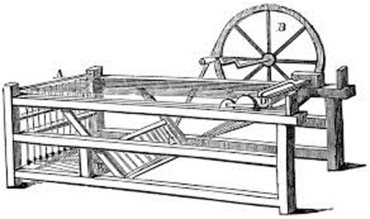

Spinning Jenny, Antisell, T.: “Hand-book of The Useful Arts” (1852)

Great Britain saw the invention of new machines, such as the ‘spinning jenny’ invented by James Hargreaves. 1764 and ‘the power loom’ designed Edmund Cartwright, 1784. This enabled increased production and speed of textile manufacture with less workforce and cost and for the first time, with the invention of steam power, we could transport British goods around the world and bring in new materials and resources from India and China and market them with advances in printing, and later with the invention of electricity, telegraphs, telephones, radio and aeroplanes.

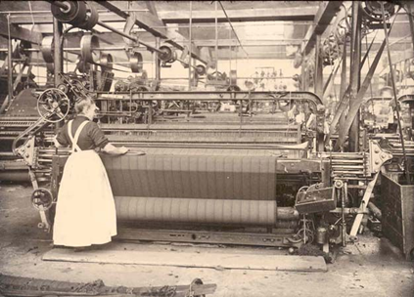

The Power Loom in Action.

The Arts and Crafts movement

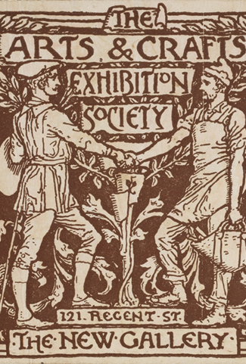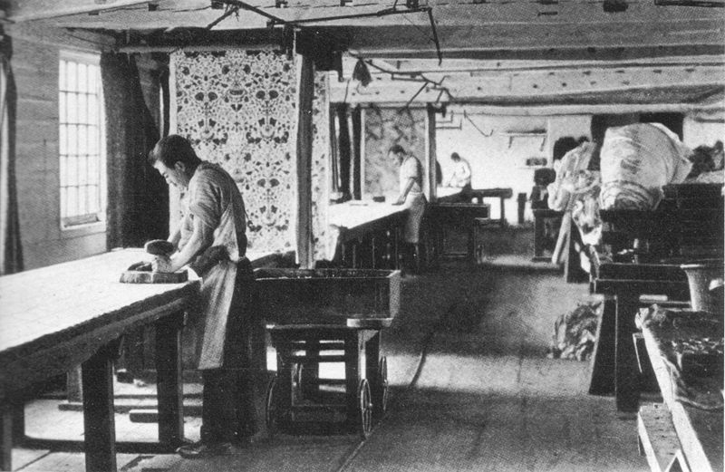
Printed season ticket, Walter Crane, 1890, England. Museum no. E.4164-1915. © Victoria and Albert Museum, London
Printing chintzes at Merton Abbey c. 1890, Morris & Company

“Fine art is that in which the hand, the head, and the heart of man go together.” John Ruskin, 'The Cestus of Aglaia, the Queen of the Air', 1870

The Arts and Crafts Movement was formed in the late 19th century Britain in reaction to mass production and effects of industrialisation on artisans and crafts people. Initiated by designer William Morris, who tried to educate consumers about the worth of handmade decorative arts and skills of the artisan maker as opposed to mass produced mill and factory goods – craftsmanship over productivity and profit. This group of makers formed ‘The Art Workers' Guild’, 1881, bringing together architects, artists, designers and makers. The products created were based on simple forms, natural materials and the use of nature as the source of pattern. William Morris created natural inspired patterns, reproducing them into limited edition textiles, wall papers, home furnishings, embroidery, murals and writings. His designs were also influenced by Medieval and Gothic Art, and like the Pre-Raphaelite artists, established a ‘from scratch’ approach to the creative process. Book Arts were highly valued and “The Private Press Movement” was formed in 1891 and spread worldwide. May Morris daughter of William, was a pioneer, bringing together leading female makers for the first time, forming ‘The Womens’ Guild of Arts’ 1907. Thus, reflecting the changes in society for women during the industrial age. Both movements reformed the design and manufacture of everything from buildings to jewellery.
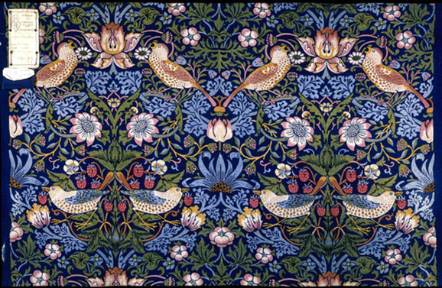
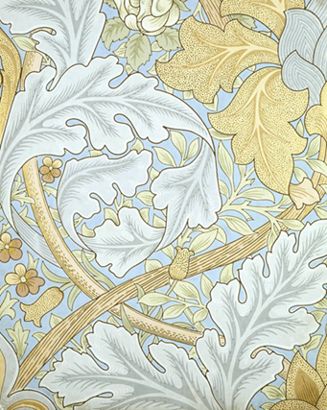

St James's wallpaper, designed by William Morris, manufactured by Jeffrey & Co., 1881, England. Museum no. E.528-1919. © Victoria and Albert Museum, London
Strawberry Thief, furnishing fabric, designed by William Morris, made by Morris & Co., 1883, England. Museum no. T.586-1919. © Victoria and Albert Museum, London
“I do not want art for a few; any more than education for a few; or freedom for a few….” William Morris

William Morris built a strong legacy for the handmade arts and his designs (via Morris & Co) still thrive today - reproducing his designs on limited productions of widely used products. The Art Workers Guild has also continued to influence the teaching of art, craft and design in Britain and introduced the idea of Home Art Industries.

The ethos of the Art and Craft Movement is still strong today. Entrepreneurship, Self-employment in creative industries is thriving. Consumers are now making an informed choice, (they are environmentally and socially aware of the full cost of mass-produced international products) and they are again moving towards handcrafted, unique and sustainable products. Maybe that’s why online sites such as Amazon Handmade, Etsy, Big Cartel, Folksy and Not on your High Street are increasingly popular.

Art and Craft Jewellery

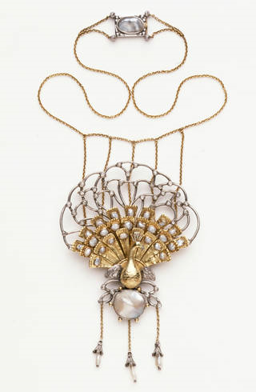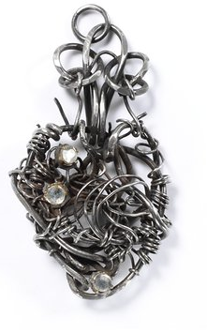
Hand-wrought iron wire and glass, 1890, Sir Alfred Gilbert, The V&A Museum Collection.
Silver, set with amazonite, williamsite, seed pearls and lapis lazuli, May Morris, 1903, The V&A Museum Collection.
Silver and gold, set with blister pearls, diamond sparks and a demantoid garnet for the eye, with three pendent pearls. Ashbee, Charles Robert, 1901, The V&A Museum Collection.

Arts and Crafts Jewellery moved away from the dark, gemstone set mourning jewellery created for the upper classes and moved to a more decorative design. experimenting with colour, enamel, bright cabochons, natural unfaceted stones (pearls, semi-precious cabochons) and non-traditional jewellery materials such as silver, copper, iron, wire and aluminium. Designs were inspired by Medieval art and decorative arts from the Far East, Japan and India.

Although this Jewellery followed the same philopshy as other Art & Craft artforms, of one maker creating a piece from start to finish. Liberty & Co, London, used mass production means to produce high quality editions of Arts and Crafts jewellery to enable it to appeal to a larger market and thus be more realistically priced to sell. A compromise between handmade and mass-produced.

The Modern World: Jewellery Manufacture and Materials

Since the Industrial Revolution and the development of Mass Production, Travel and Computers, we have been able to access manufactured materials. We no longer must use natural products and processes. As manufacturing increases, so does our knowledge of materials and science and how we can exploit these materials and invent more. We no longer need to craft jewellery from the traditional gold metals or natural materials, but we have unmeasurable range of manmade materials to experiment with, from mixed alloys to plastic, resin, concrete, aluminium, titanium etc. Although many materials are made for industry uses, crafts people are always experimenting with the materials around them and reflecting what is happening within modern society and the marketplace.

Plastics

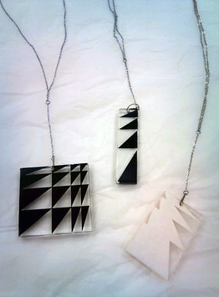
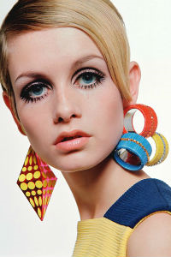
Since the invention of Bakelite by chemist, Leo Baekeland in 1907, New York. Plastic has been continually redefining the way we live our lives. Originally the first plastics were created for household products, radios, telephones, homeware. Jewellery’s and Craftspeople have continually experiment with these modern materials to create jewellery and art. Often being easier and more exciting to work with than traditional silversmith materials. Modern plastics are a popular choice to use in CAD/CAM production, due to its ease of use and low cost (but not to the environment) and nylon is commonly use in the fabrication of 3D printed models and prototypes. Other modern plastics, such as acrylic, Perspex, silicone, latex, epoxy, neoprene and gortex are also popular. Its lightweight, easy to manipulate and cheap to produce and is very long lasting. It can be extruded, moulded, cut, melted, dyed, carved, shaped made into moveable fabric, solid sheets, liquid and within reason recycled to be used again. So, it’s an ideal material to be used for mass manufacture and to experiment with, although with the issue of non – recyclable plastics adding to our landfill and endangering our seas, companies are now experimenting with eco-friendly, bio-degradable plastic and bio-resin, made from plant-based sources.

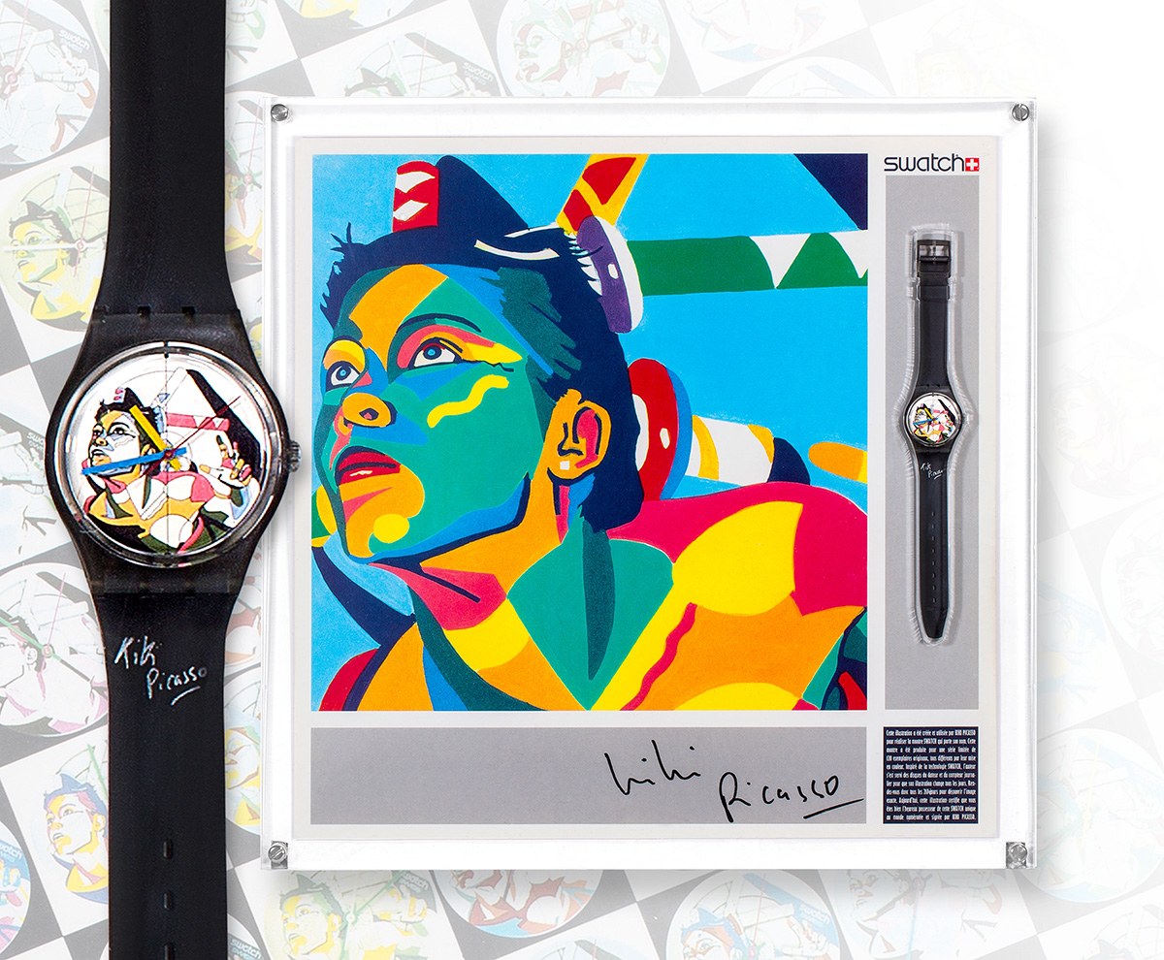
With the introduction of plastic as a material for making jewellery, jewellery has become a widely worn fashion accessory. Designer Jewellery such as Mary Quant was copied across the high street and because of wider international travel and the birth of the package holiday and the space race, our world became vast, we moved quickly with the times, the music, cinema, popular culture and fast throw away fashion. The Youth of the times were making their own decisions and creating their own style and trends and leading the way in consumerism and word of mouth marketing.

French painter Christian Chapiron (aka Kiki Picasso) was the first artist to work with Swatch, in 1985, Swatch Watch, Sotheby’s.
Optic Art Pendant Screen-printed acrylic Perspex and base metal Wendy Ramshaw, 196, The V&A Museum Collection.

CAD and CAM Processes

CAD (Computer Aided Design) and CAM (Computer Aided Manufacture) are modern computer tools/software that enable designers and makers to create 2D & 3D designs, prototypes, models and actual objects. CAD & CAM are new tools in the grand scheme of mass production. Widely used in most industries of the modern world, from architecture, medical applications, car manufacturing to engineering. We can see its influence all around us, from our homes, the way we work, travel, the city infrastructure, what we see and what we wear to the way we communicate, create and consume.

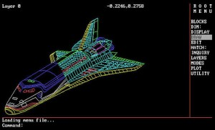 | 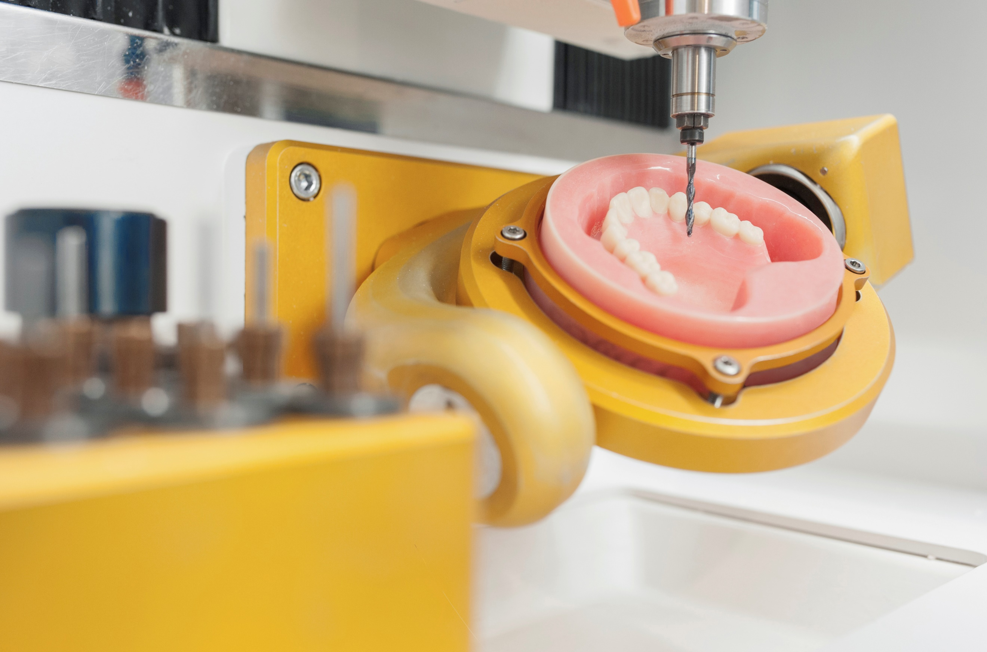

More recently in the past 10-15 years CAD and CAM software has evolved and is much more accessible and even taught in our schools. Creative practitioners, artists, fashion designers, craftspeople and jewellers are now using the software and applications to design and develop work. Jewellers are not only using CAD to custom design jewellery and create intricate details 2D and 3D drawings and designs, but also using CAM to create lost wax prototypes, but also using tools such as Nylon 3D printing to create actual finished jewellery components.

There are many ranges of CAD software for designers to use such as Adobe Illustrator and Photoshop which allow for creative practioners to create 2D drawings, artwork, designs and plans. Many designers use a software called Rhino to create 3D modelling or animations of potential designs and actual products. There is specialist software being developed all the time for specific areas of manufacture and Gemvision Matrix, ArtCAM Jewelsmith and JewelCAD are applications popularly used by Contemporary Jewellers.

 | 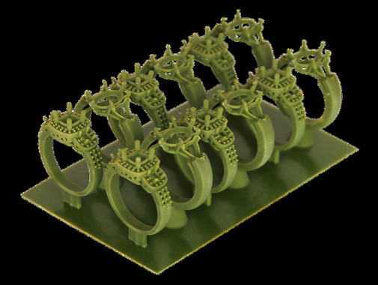 | 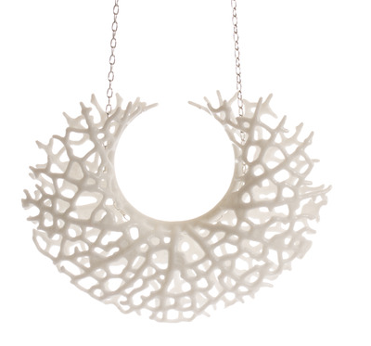

Cost
As with many of the tools a creative practitioner needs to create their designs, CAD & CAM are no different in costing. There is a range of differently priced software depending on your needs and usage, but there are now lots of educational courses out there, which will allow you to use the application and train you in its use, which is often a good starting point for many. You can buy the more popular programmes, such as Adobe Photoshop, Illustrator, Rhino etc via most computer/ electrical stores, such as PC World or Currys or you can purchase software online direct form the manufacturer. Programmes can cost as little as £20 up to £100s, it totally depends on the application you choose, some publishers, like Adobe will allow subscribes to pay monthly £13-20 for use of software, so you could use it for a short period without having to shell out the full programme price. Many companies allow you to download a trial version, so you can try before you buy. You need to ensure that your software is compatible with your computer system and your system may need upgrading if you want to try the latest software, which could be an extra cost you never thought of. There are many free CAD software packages available on the internet, these may not provide you with all the tools you require but will enable you to try out the basics.

Advantages
- Once skilled and trained in the use of CAD/CAM programmes and processes you have a lifelong skill, which you could use to develop employment further in this area. (teaching CAD/CAM or specialising in becoming a CAD specific designer).
- Expands availability of materials and range of processes. You can try new ideas and work with an entire palette of materials without is costing too much time or money.
- CAD & CAM offers new and exciting techniques for creative practitioners to use to create totally unique work and ground-breaking designs and processes.
- Quicker & Easier to make jewellery ranges & duplicates of jewellery and to transfer/translate those designs into other mediums. For example, duplicate part of a jewellery design into a design for laser cutting fabric for a dress or etching into large glass panels for a home.
- With CAD & CAM, practitioners can create accurate prototypes, with precise measurements, allowing for bespoke design and fitting. Also, it allows for makers to make quick adjustments of a design where necessary.
- Using CAD/CAM and 3D printing allows for creative practitioners to visualise their designs in detail, before manufacture or to make prototypes to show potential stockist, funders or customers. It allows for the maker to realise their product and tweak any design elements prior to a costly manufacture of the final item.
- CAD/CAM allows you to perfect your design and use of materials, which in the long run is more cost effective and results in less wastage.
- CAD/CAM software and process are accessible to all makers. So even if you are unable to physically create jewellery with manual tools, you can use the accessibility settings to create a design via CAD and have the item made by a third party via CAM.

Disadvantages
- Fear of the unknow – with all new inventions there is always a sector of society who will not accept the new, and you may find your audience is not open to processes and the CAD/ CAM aesthetic. Traditional Jewellery makers may feel threatened by the new processes and your creations may not be excepted by some audiences.
- Expensive for equipment and consumables, but as software is developed and becomes more popular, cost decreases and becomes more readily available.
- In order to use CAD & CAM software, people need to be trained in how to use the software and hardware and this can be initially, costly.
- Initial set up and layout for equipment and software is expensive as you would have to have all the tools you need at once to use.
- Upkeep and maintenance of equipment and renew of software licences is an added extra cost on top of other tools you might use. Computer related hardware and software can be temperamental and open to viruses and hackers.
- The addition of electrical and computer equipment will increase your computer bills and your business/ house insurance. As if damaged your equipment and software can be expensive to replace.
- Technology is a fast-developing sector. As new software and hardware is developed, users will have to upgrade their knowledge and learning and sometimes this can be costly and time consuming.
- Using CAD and CAM as a creative practitioner is a new development and already there is debate over the validness of using the applications to create something that is normally handmade and whether this devalues the work being created.
- As with all new tools and manufacturing processes there is a danger that makers work could become diluted, over manufactured and no longer unique and there is a danger that work could be more easily replicated, devaluing the original design.

Aesthetics of CAD CAM
Computer aided design and manufacture has become increasing popular with Contemporary Jewellery Makers over the past few years. As new jewellers are trained in the use of CAD and CAM as part of their academic jewellery training, I imagined it will become much more the norm for jewellers to incorporate the process of CAD/CAM as part of the development of their craft. Most of the current jewellery created with CAD and 3D printers seems to be quite mathematical in design, geometric shapes and repetitive designs, layered and intricately cut out. Lots of laser cutting, seamless pierced work. The work is very clean, crisp and precise and much of the designs seem too intricate to be created by hand. Most of the jewellery is either plastic/nylon 3D printed jewellery which often has the laser (linear) texture throughout or is cast in metals. Some laser cut acrylic jewellery is created like a jigsaw, to allow smaller parts to fit into bigger pieces. The possibilities are only limited by the imagination of the maker and the knowledge he or she has of the software and equipment being used.

CAD & CAM Contemporary Jewellery Designs

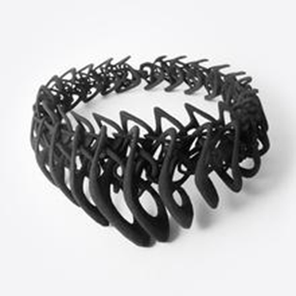 | Neckpiece – Jenny Wu, 2018, Laser Sintering, Binder jetting technology & Wax pattern 3D printing.  This Neckpiece is very intricate, layered and intertwined curved organic shapes. This structure would be very hard to create by hand.
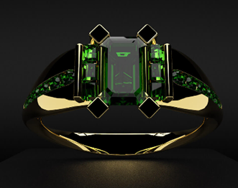 | Ring – Victoria Barter CAD design, traditional goldsmith techniques. Tradition meets Technology.  Victoria Barker used CAD design to develop bespoke Precious gemstone and gold jewellery, creating wax prototypes which are cast and then stone set and finished by hand. Although much of this work could be created by hand, using CAD enables the maker to create bespoke to fit the wearer, making size changes etc when needed and allowing the customer to see a 3D computer design, before manufacturing.
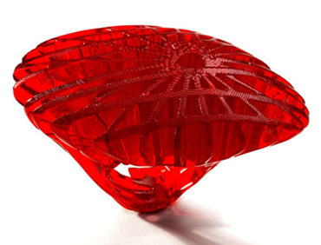 | Crystal 11 Ring- Stefania Luchetta, 3D printed, cast bio compatible resin.  This ring would be near impossible to make in resin my hand due to its complex design CAD enables a complex mould to be made and the ring than cast and hand finished.
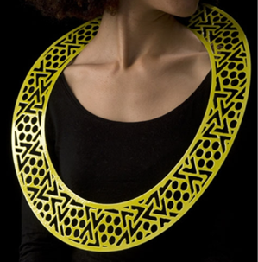 | Necklace - Stephen Bottomley  Yellow Drape, Drape series, 2007  Steel, enamel, CAD design. The maker has used CAD to design this detailed geometric necklace and have it manufactured in steel, probably laser cut, so multiples could be made in a thinner metal sheet that would be difficult to work by hand.
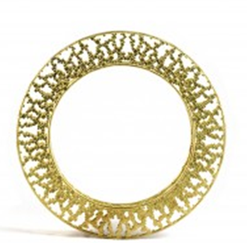 | Bracelet - Jo Hayes-Ward, 3D Printing & traditional gold casting  The use of 3D printing has enabled this bracelet to be printed in a less expensive material than gold, a cast made and then the final design cast. To pierce this design from sheet gold would cause a lot of waste of a very expensive material. So, the process allows for less waste, and a cheaper cost to produce.
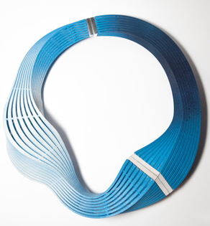 | Neckpiece - Eve Balashova 2018 3D Printed Nylon, Dyed  The processes used by Eve, allow her to create experiment printed pieces that she can curve and bend, which would be very difficult to do in other materials and would be very expensive experimenting with the materials as she does. Eve combines nylon with silver to elevate the design and can create a multitude of these designs in an array of colours as she spray paints the result.

How might I use of CAD for my own Project

I am currently learning how to use Adobe Illustrator to design laser cut and etched jewellery, although my skills are limited, I can also see the possibilities that CAD and CAM applications provide in helping me develop my own work. In a current brief, I have been asked to design a necklace inspired by a charity and to raise money for that charity. In this instance the use of CAD has enabled me to use the charity’s’ branding and logo, copying from the internet and then using sketching and illustrator scamps to play with the logo, add my own elements and create several designs interpreting the set brief. Using Adobe Illustrator, I have mapped out my final chosen design and set this ready for laser cutting and assembling ready to display and sell. I have documented the entire process on my website blog caracoddjewelleryartist.weebly.com

The process of using CAD has enabled me to create a much more precise and detailed design then I would by hand. It has also cut down manufacture time dramatically as to hand pierce the piece from Acrylic sheet would have taken hours and to create a neat unscratched finish would have been near impossible. Using Illustrator has allowed me to create several different designs to try out before production. Allow I do not have extensive skills with the computer design programme, with my limited knowledge, I still managed to create a modern contemporary design, that could be repeated or adapted to make co-ordinating jewellery and accessories. I could choose to make a total range of jewellery using the same design or multiples of it and create a multitude of colours. The possibilities are endless and manufacture time minimal. I do not have the skills yet, to use the laser print package, but I emailed it to someone who manufactured it on my behalf within the hour. I can see how CAD, could become addictive as it makes the design process quicker, accurate, easily duplicated and allows easy adaptation and experimentation.

Conclusion: The impact that CAD has had on the contemporary design crafts industry

Tools Change, But Workflow Doesn’t
Table illustrating two different manufacturing processes for Jewellers side by side:
Traditional Handmade Design Process | CAD/CAM Design Process
Commission is taken from client  Design is hand-drawn, and shown to client  Approved design is made in metal, either with wax carving or direct fabrication  Any parts made in wax are cast into metal  Design is finished by hand, and set  Design is given to client | Commission is taken from client  Design is hand-drawn, and shown to client  Approved design is made using CAD and printed into wax  Wax is cast into metal  Design is assembled and finished by hand, and set  Design is given to client

CAD & CAM software and processes in the end are just tools, which can be used by creative practitioners to further develop their designs and product. Just as a pencil, piercing saw or anvil are used to create handmade crafts, so is technological software and hardware. As in the industrial age, machines were the new tools, computers are the contemporary tools of choice. Even though CAD is being used to create contemporary jewellery, humans have had to design every element of this new technology and software, we must operate it, create it. We design the software and the interface, the hardware and the way we use the technology. So indeed, we have handmade every element of the technology, that is often deemed automated.

There is an expectation or association that craftspeople, work with their hands and create because they love what they do and that what they create is one off and unique. However, a crafts person is a skilled maker and is entitled like other designers, such as fashion designers and car designers to be able to take advantage of how technology can improve their place in the global market and market themselves as product designers as well as skilled craft people. You are still a skilled maker if you use CAD and CAM processes. CAD is a tool which can be exploited to enable the crafts person to develop their unique and original ideas into reality, through a series of processes, using tools and hands. These contemporary technological processes help the creative practitioner to make more detailed work, quicker, in multiples, with modern materials and create prototypes for clients so that they too can visualise the craftsperson’s vision. It has introduced jewellers to a whole new market place, manufacturing and audience. Jewellers can no choose to have part of their creation mass manufactured allowing time to be concentrated on the more creative elements of their work. There is also possibility for practitioners to work collaboratively using CAD & CAM to combine ideas from artists and manufactures (globally), for a common product. This has been demonstrated successfully, when artists and designers have worked with High Street Stores to create limited ranges. Creating a new and wider audience for that makers work, such as the collaboration between Habitat and northern lighting designer Claire Norcross.

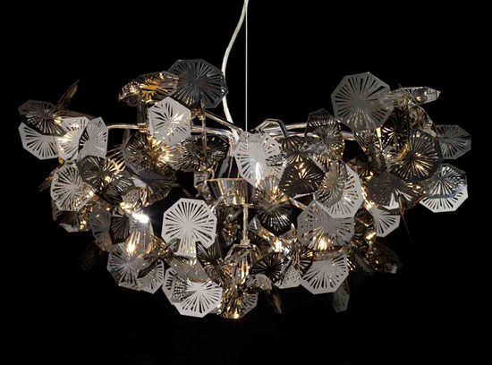

CAD & CAM are new processes, so we don’t yet know the full extent of their creative possibilities. Its and exciting time and as intelligent human beings we are constantly evolving in all areas of technology and society. We can choose to accept or reject technology, but if we want to remain relevant, contemporary and financially successful in the modern market place than we must try to embrace it and use it to advance Contemporary Craft and Jewellery Design and manufacturing, otherwise we will be left behind, and handmade skill will die out.

Bibliography

Phillips, Claire (2008). Jewels & Jewellery. London: V & A Publications. 7-109.
Tait, Hugh (1986). 700 Years of Jewellery. 8th ed. London: The British Museum Press. 138-149
Tait, Hugh (1986). 700 Years of Jewellery. 8th ed. London: The British Museum Press. 150-166.
Tait, Hugh (1986). 700 Years of Jewellery. 8th ed. London: The British Museum Press. 183-193.
https://www.timetoast.com/timelines/spinning-machines-through-the-industrial-revolution
https://geopolicraticus.wordpress.com/2010/08/28/anonymization/
https://www.dictionary.com/browse/industrialism
https://en.wikipedia.org/wiki/Industrialisation
https://www.historytoday.com/stephen-clarke/industrial-revolution-why-britain-got-there-first
https://www.britannica.com/event/Industrial-Revolution
https://www.nationalgallery.org.uk/paintings/joseph-mallord-william-turner-rain-steam-and-speed-the-great-western-railway
https://www.vam.ac.uk/articles/arts-and-crafts-an-introduction
https://commons.wikimedia.org/wiki/File:Morris_and_Company_Textile_Printing_Merton_Abbey.jpg
http://www.artsandcraftsmuseum.org.uk/Arts_and_Crafts_Movement/The_Arts_and_Crafts_Movement.aspx
http://www.artsandcraftsmuseum.org.uk/Arts_and_Crafts_Movement/The_Arts_and_Crafts_Movement/Arts_and_Crafts_Designers.aspx
http://www.courtbarn.org.uk/current-exhibition
http://www.artsandcraftsmuseum.org.uk/
https://www.vam.ac.uk/collections/arts-and-crafts
http://collections.vam.ac.uk/item/O143081/pendant-gilbert-alfred-sir/
https://www.langantiques.com/university/Arts_%26_Crafts_Era_Jewelry
http://agmlib.cheltenham.gov.uk/Details/collect/7036
https://www.tandfonline.com/eprint/tHneiAkTFHfwD6JSskRp/fullmaymorrisartandlife.co.uk/the-exhibition/
https://www.vam.ac.uk/collections/william-morris
https://www.vam.ac.uk/articles/introducing-william-morris
https://www.salonqp.com/updates/buying/sothebys-to-sell-5800-piece-swatch-collection/
http://collections.vam.ac.uk/item/O1194612/optik-art-jewellery-necklace-ramshaw-wendy/
http://www.liverpoolmuseums.org.uk/wml/collections/antiquities/ancient-egypt/item-474771.aspx
https://www.pinterest.co.uk/pin/150870656237406036/?lp=true
https://thescopeofenamel.wordpress.com/2015/01/14/medieval-jewellery-in-europe-1100-1500/
http://www.vam.ac.uk/content/articles/r/renaissance-womens-jewellery/
http://www.alaintruong.com/archives/2013/11/24/28507759.html
http://colletnecklaces.blogspot.com/2014/01/girandole-earrings-in-18th-century.html
http://19thcenturyartofmourning.com/19th_century_human_hair_jewelry.htm
http://19thcenturyartofmourning.com/19th_century_mourning_jewelry.htm
www.historyofjewelry.net/
https://www.scientificamerican.com/slideshow/9-materials-that-will-change-manufacturing/
http://www.bbc.co.uk/schools/gcsebitesize/design/graphics/materialsandcomponentsrev2.shtml

