Making Basic Op Art in illustrator

Please complete the tutorial making basic shapes first

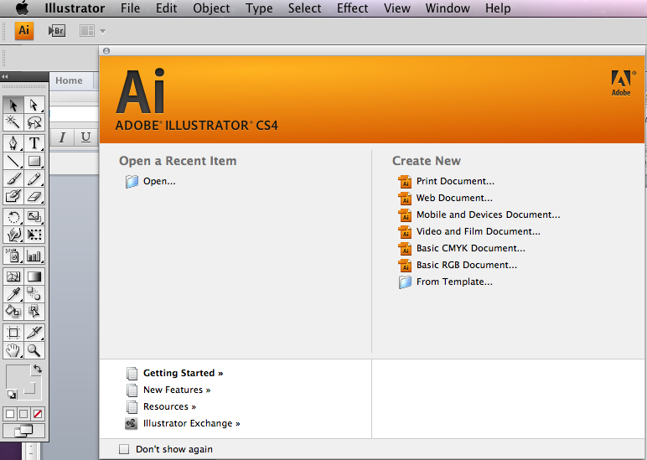
- 1 Open up adobe Illustrator and select new document

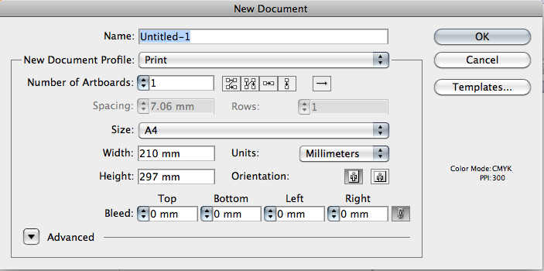
- 2 Select A4 and orientation portrait

The bleed options and margins we will discuss in a later tutorial
3. Go > View > Rulers > Show Rulers
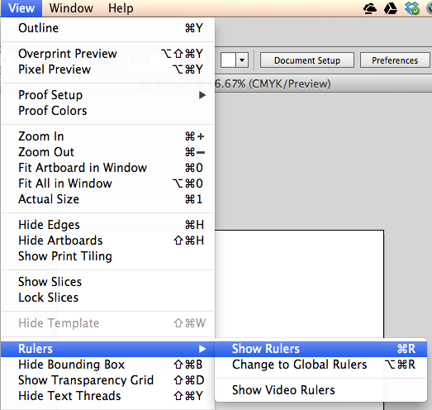

Click and drag down guides from the top and sides of the workspace
- 4. Press and hold down the rectangle tool as shown and you will see a fly out

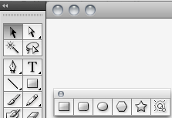

- 5. Select the rectangle and drag out the shape

BY HOLDING DOWN THE SHIFT KEY YOU WILL CONTRAIN THIS SHAPE TO A SQUARE IF NOT YOU WILL GET A RETANGLE

BY HOLDING DOWN THE SHIFT AND ALT KEY YOU WILL CONSTRAIN THE SHAPE FROM THE CENTRE

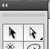
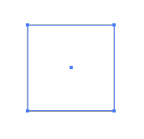

You can now move your shape around the page using the move tool

You can also resize the shape by dragging out the the corners of the shape, remember to hold down shift if you wish the shape to keep the same proportions.

Change the colour of a shape quickly by clicking on the fill block on your toolbox

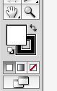
You will now be able to click and select a colour from the colour picker pop up box #FFFFFF = White

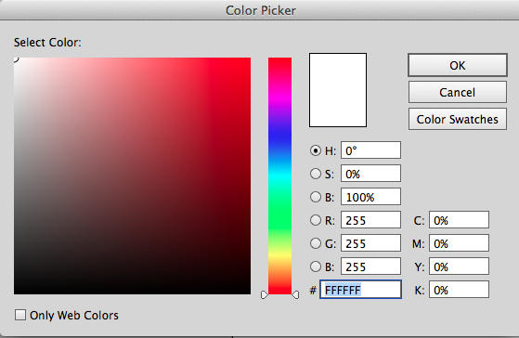

Stoke Colour

This is the square hollow box you can see behind the fill box you will need to select this by clicking on it, and the stroke box comes to the front.

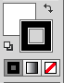

You can change the colour of the stroke by in the same way as the fill

BUT BOTH THE FILL AND STROKE MUST BE SELECTED (AT THE FRONT) TO MODIFY THE SHAPE

Notice now how the bounding stoke box has changed colour

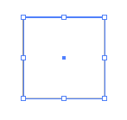

6. Go > Object > Scale

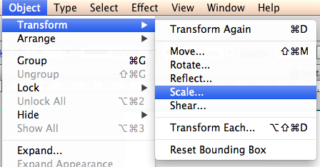
In the following pop up box enter the following

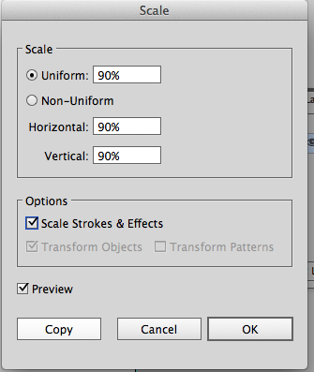

Highlight the 100% and Enter 90%

Tick the Scale strokes and effects box

Tick the Preview box

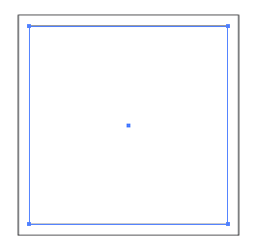
You should now see the following
A smaller box in the original

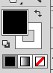
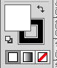
7. Click on the curved arrow so the colours swap

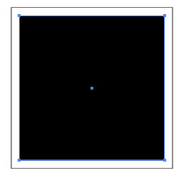
You should now see the following

White square No 1

Black square No 2

8. Now we are going to repeat the process by using a short cut Cmd D

Hold down the Cmd and press D
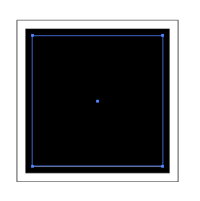
You will now see another square outline by transform handles

White square No 1

Black square No 2

Another black square No 3

9. Switch the fill and stroke colour as follows

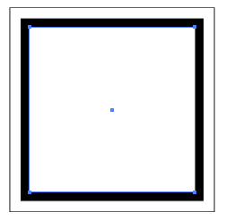
You should now see the following

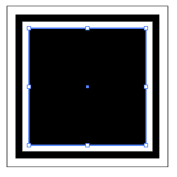
10. Go Cmd D
Switch the stroke and fill

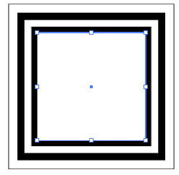
11. Go Cmd D
Switch the stroke and fill

12. Go Cmd D
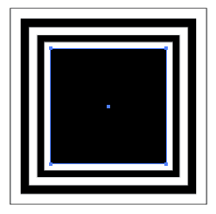
Switch the stroke and fill

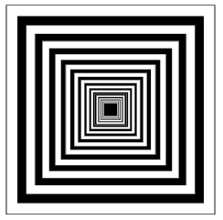
13. Continue until you have the following

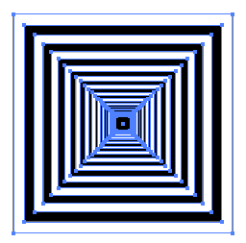
14. Select the move tool and drag and select over
all the squares
You should see all the squares selected

15. Go > Object > Group
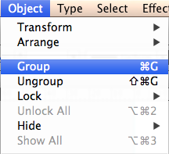
THIS WILL HOLD ALL YOUR SQUARES TOGETHER
You can always undo this afterwards if you wish
By going Object > Ungroup

16. Drag over the shape to select it using the move tool

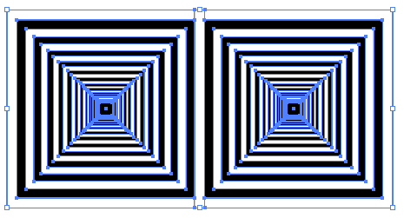
17. By holding down alt drag a copy over and align using the shift to constrain

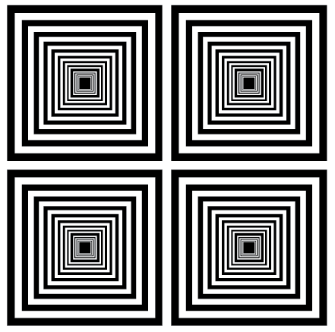
18. Repeat the process

Drag the first row down to make another row

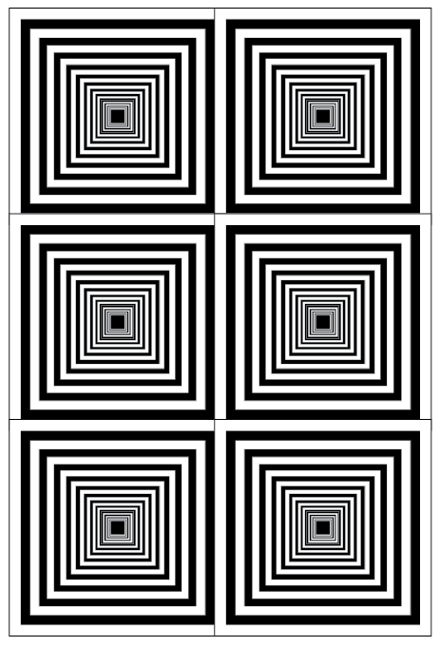
Drag the second row down to make another row

You should now have 6 squares

Highlight all the squares and select the stroke turning of the colour to none

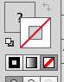

Repeat the above steps as many times as you like and make variations

