An introduction to making shapes and direct selection in illustrator using Constructivism as an example
(Please complete the tutorial stage 1 creating shapes first)

Stage 2 Buildings

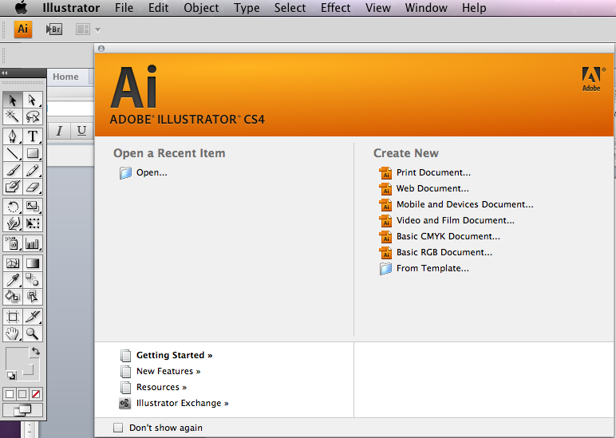
1. Open the application illustrator and make a new document in Portrait mode A4
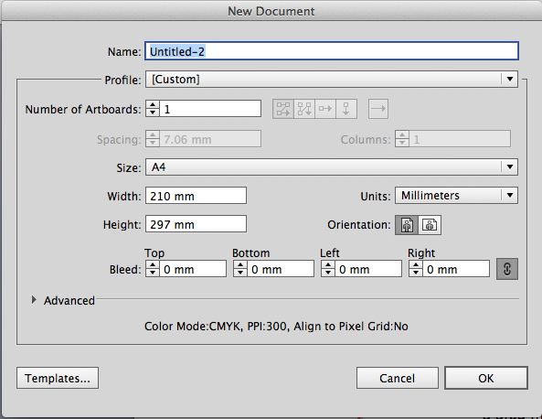

2. Go to the tool panel and hold down the shape tool until you see the following fly out

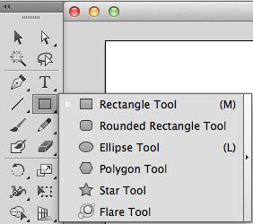
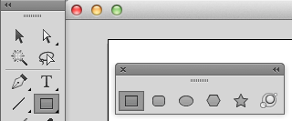
3. Hold down the little black triangle and drag the tear of strip out of the tool panel.

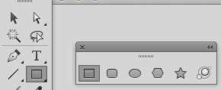
4. Select the rectangle tool by clicking on it

5. Create a window
Set your fill to black and stroke to white and drag out a rectangle remembering to constrain the shape to a square whilst holding down shift at the same time

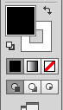

6. Create copies of the windows
Hold down alt on the keyboard and drag out another square, remember to hold down and press shift to keep the squares perfectly aligned
Tower Block repeating pattern

7. Repeat the process until you have something similar to below

8. Select the first row by dragging over the shapes and repeating step 6

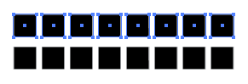

9. To copy the row again repeat the above steps or just press Cmd and D
TRY AND RECREATE THIS PATTERN
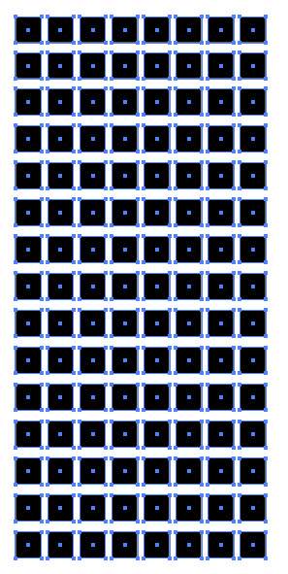
10. Select all the squares

11. Group the shapes so
now the squares can be selected as one

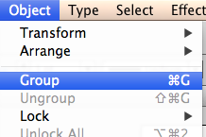

13. Deselect the squares (windows) and drag out a new rectangle that covers all the windows

14. Select the gradient swatch by default it will be what ever the colour was which was last used.
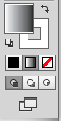

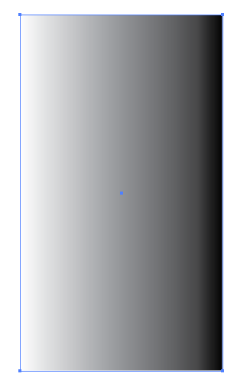
15. The rectangle will now have a gradient in (it may not be the same as shown) this does not matter

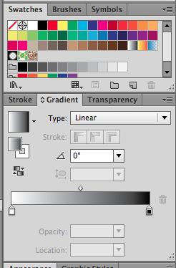
15. Now select the Gradient Panel

16. Go to the swatches and drag a dark brown colour down on the left hand side of the gradient

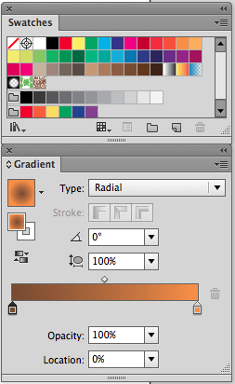

17. Drag the orange colour down the right hand side of the slider

18. Make sure the Type is set to Radial

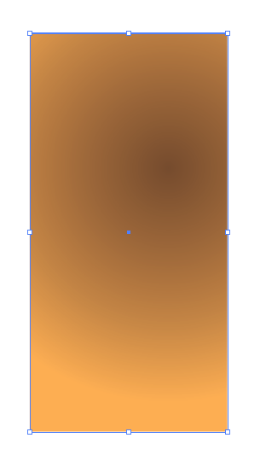

19. The rectangle should now resemble something like shown

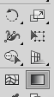
20. Select the gradient tool
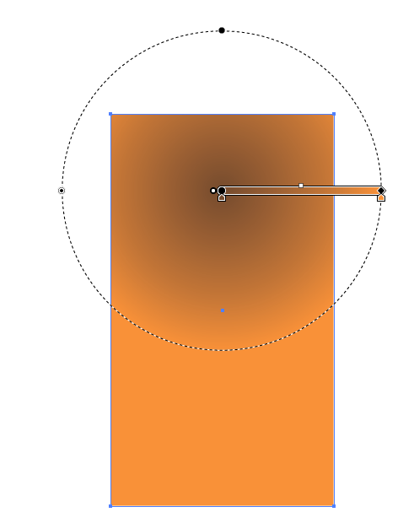
21. You will see a circle and a slide bar just for now grab the gradient and drag up the towards the top of the rectangle

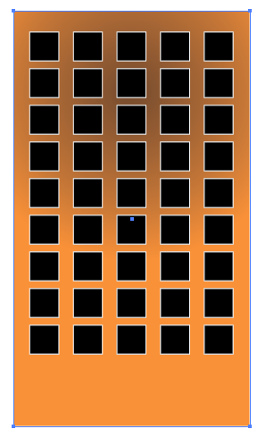
22. Ordering of shapes
Send this shape backwards by going Object > Arrange Send to the back

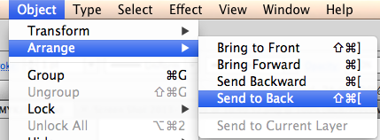

23. Select all the shapes and group them

COPY THIS SHAPE AND JUST LEAVE IT TO THE SIDE FOR THE MOMENT

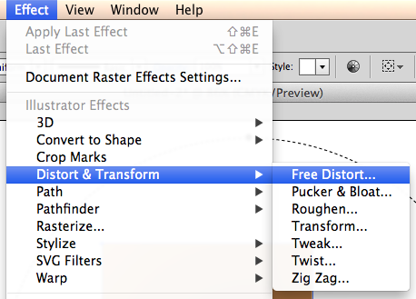
24. Change and distorting shapes
Go > Effect > distort and transform > Free Transform

A pop up box called Free Distort will appear
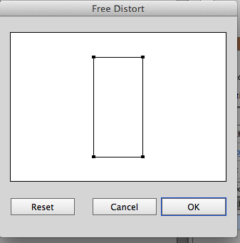
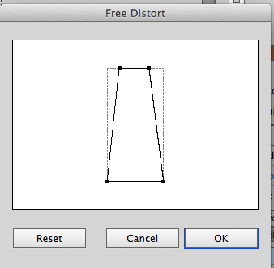
Click the left hand side of the point and drag in and repeat this for the right hand side

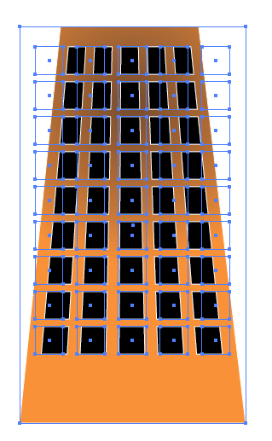

The building should now resemble as shown

For the next stage we need to need to make the building into one shape so we need to expand its appearance
See overleaf.

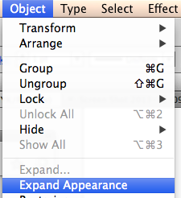
25. Expand the appearance of the shape so it becomes one shape
Go > Object > Expand Appearance

Your shape should now resemble as shown
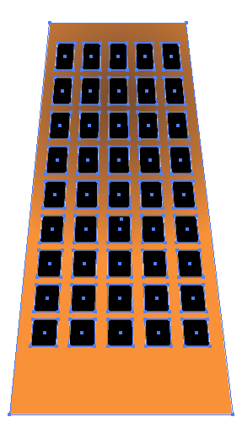
26. Using the move tool rotate the building so it’s just of the corner of the document, you can resize it or rotate it more depending on how you would like it to look

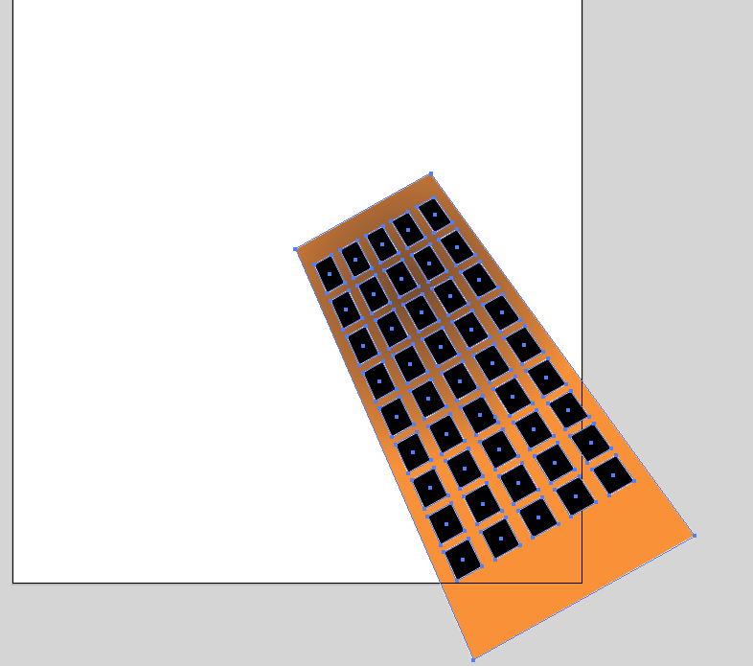

The image is not yet complete so we will make a few more building for the general effect

