An Introduction Photoshop Montages using Layer Masks

Techniques used
- Basic Layer Masks
- Basic Layer Blending Modes
- Basic Selections Techniques
- Basic Layer Adjustments

Part 1Building the Structure

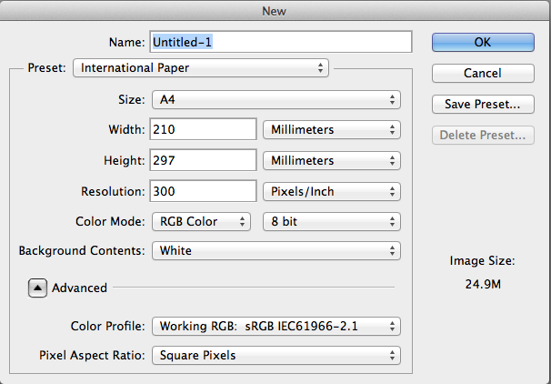
1. File open New Document

Make sure your document is in Portrait mode

2. GO > File open > statue_to_use.jpg

3. Select the entire image GO > Select all

You will now see a selection around the image than is called running ants, they look like little flashing dots

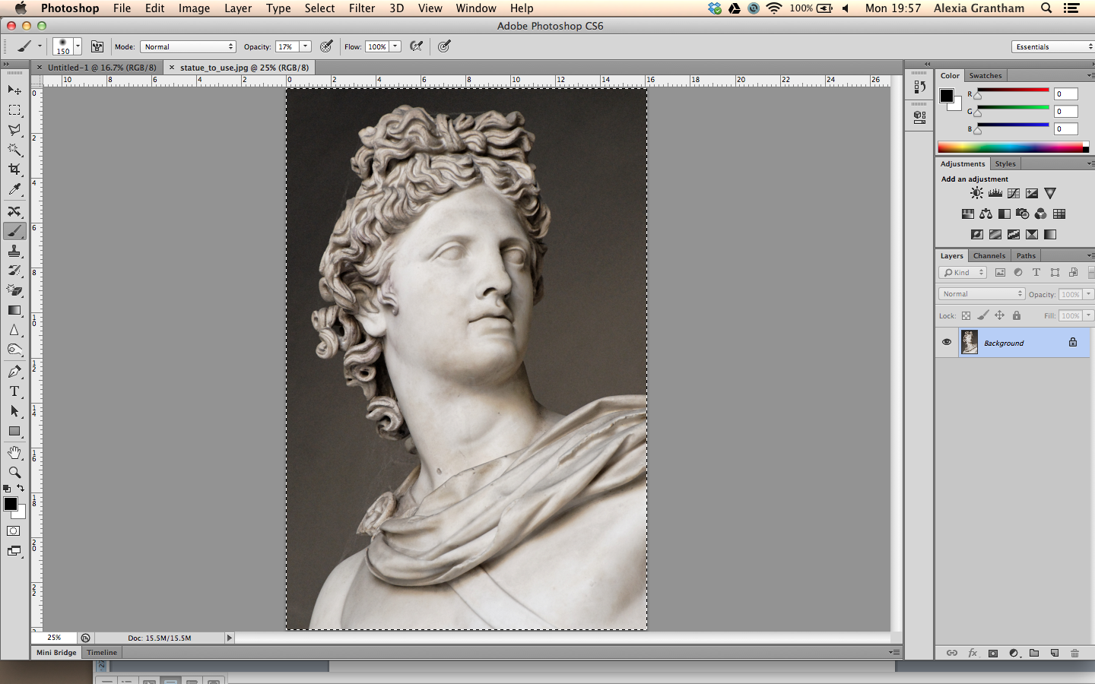

4. Copy the image
Go > Edit Copy or cmd C

5. Navigate to the new image you created earlier
You will find this by looking for the tab showing Unentitled document on your window bar

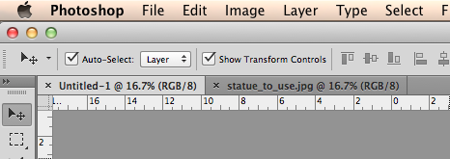
6. Paste the image
Go > Edit Paste or cmd

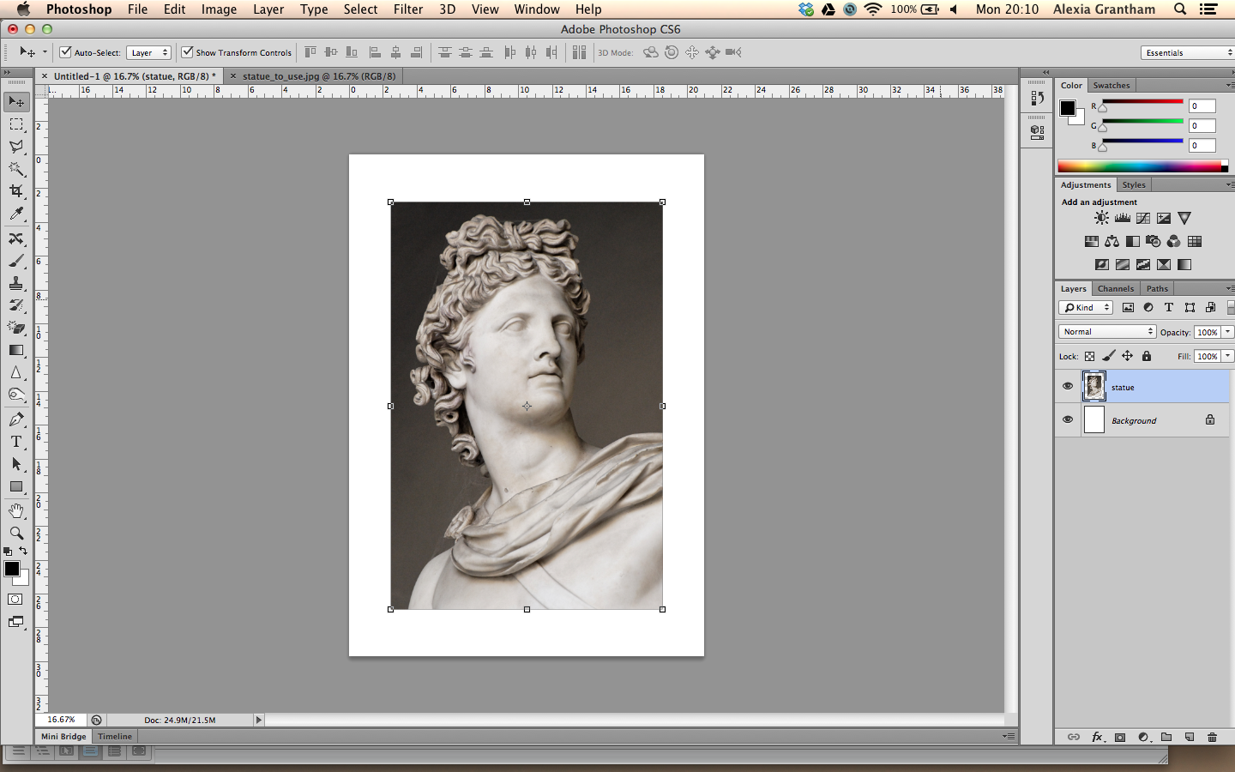
7. Make sure transform selections are selected
Click and drag the transform handles to resize the image to fit the size of the document maintaining aspect ratio

Name the your new layer statue

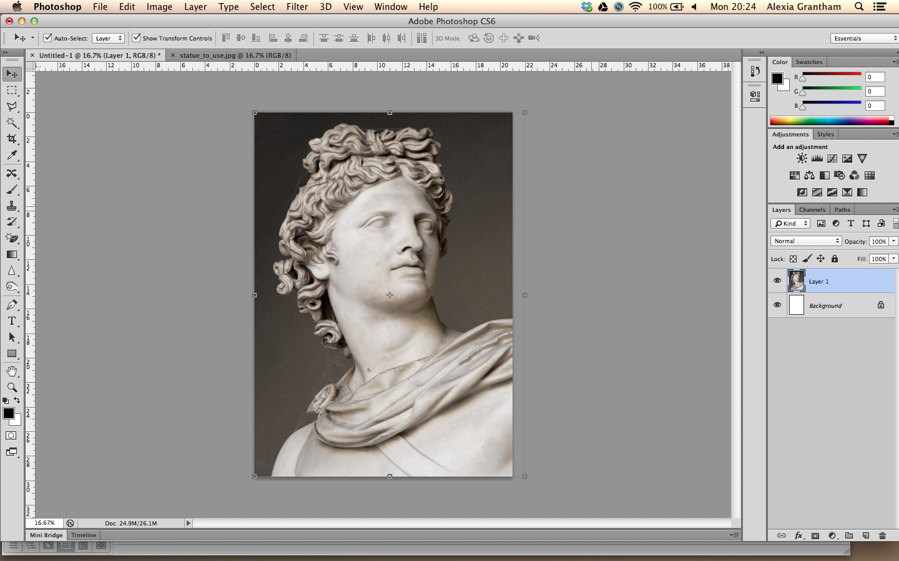
8. Double click to apply the transformation

9. KEEPING A COPY OF A LAYER SAFE
Select the layer Statue
Copy this layer by dragging it
down to the new layer icon

ABOVE THIS LAYER YOU NOW GET A NEW LAYER CALLED STATUE COPY

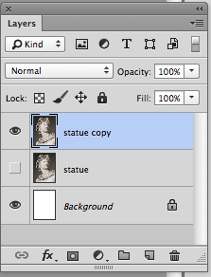

10. Turn of the layer visibility for the layer statue it is not needed yet

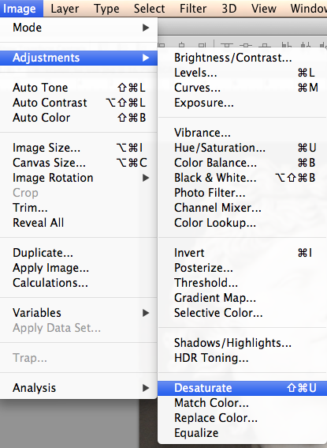

9. Making the image black and white
GO > Layer > Adjustments > Desaturate

10. Open the document called white_paper.png

Repeat previous steps 4 5 6 and 7
Select > Select All = cmd A
Edit > Copy = cmd C
Edit > Paste = cmd V

Size your image so it covers the whole document

You will need to rotate the paper layer so it’s in portrait
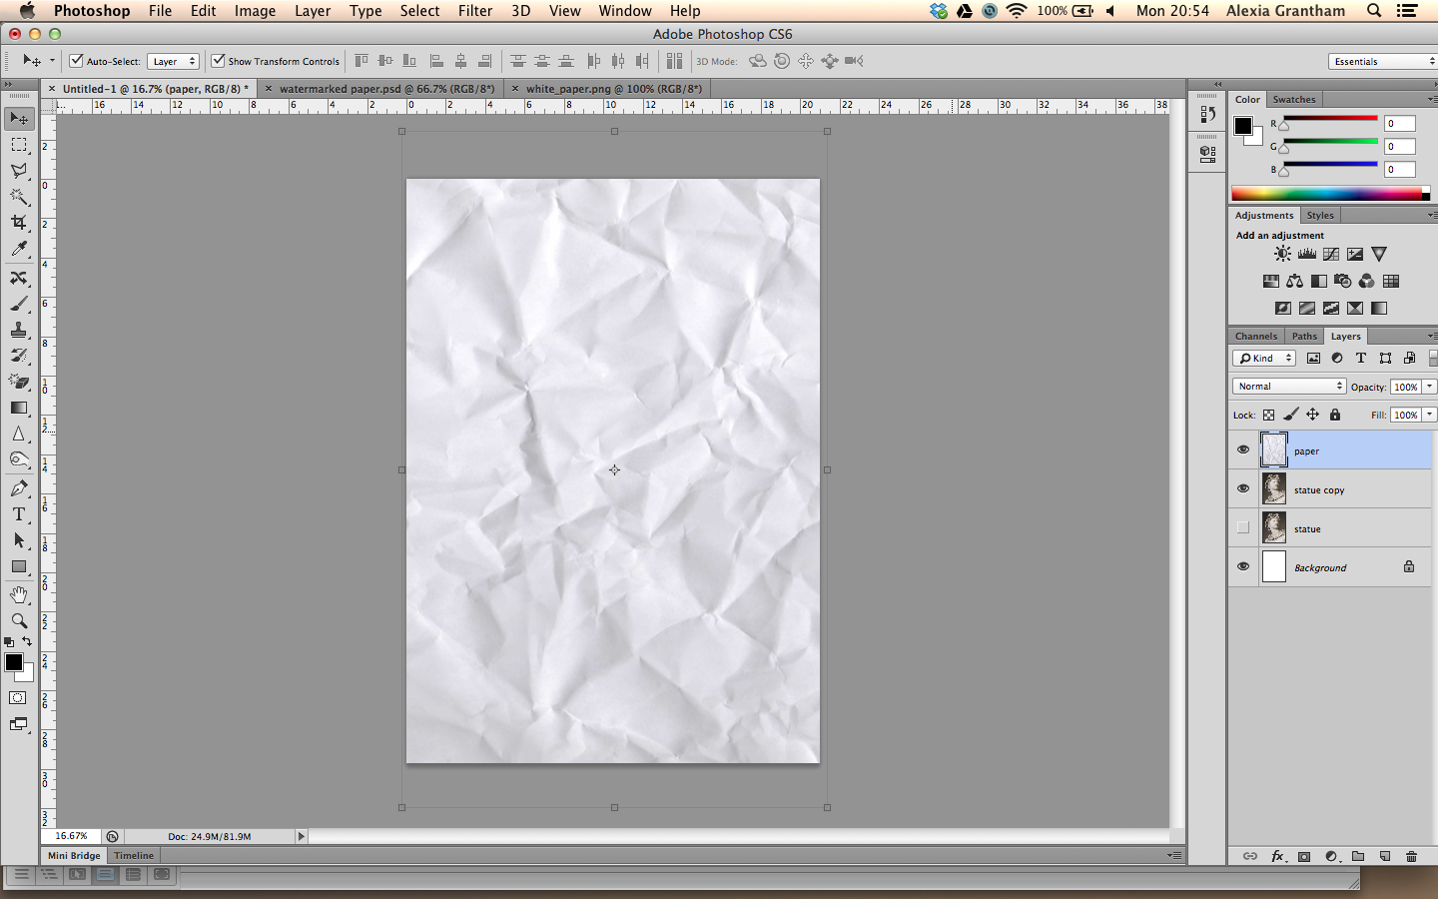
DON’T FORGET NAME YOUR LAYER = PAPER

Move on to Part 2 over leaf

Part 2 Using Layer Blends

Please see additional tutorial for using blending modes in
Photoshop essential blends modes for photo editing Stage 1

Quite simply, layer blend modes give us different ways for a layer to interact with, or "blend" with, the layer or layers below it. Without layer blend modes, the only real way we have of blending layers together is by reducing the opacity (or fill) of a layer, which usually doesn't give us very interesting results. But with blend modes, not only do they unlock a world of creative possibilities, especially when we combine them with layer masks, they can also be extremely helpful when it comes to editing, retouching and restoring photos, and they can save us a whole lot of time!
Adjust the layer opacity of statue copy to 40%
either drag the slider or highlight the number and input the value
11. Press and hold down the
the layer blending mode
drop down box and
select Multiply for the
layer Statue copy
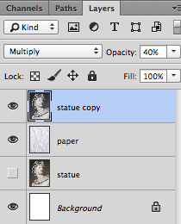
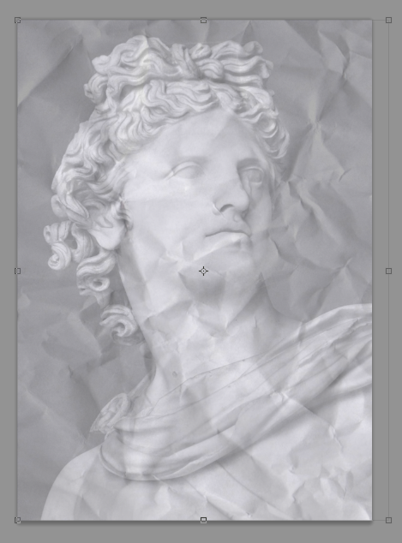

Observe your background layer the paper is now partially visible

NOTICE YOUR IMAGE LOOKS ALL RATHER GREY
This is remedied in the next section

Part 3 Using None Destructive Technique Masks

A layer mask is something that you apply to a given layer to control the transparency of that layer. Where layer opacity controls the transparency of the entire layer at once, a mask gives you more precise controls over very specific areas. If you want the entire layer to be at 30%, you would lower the opacity, if you want just the left side of a layer to be at 30%, you would use a mask.

12. RECAP
Name and move your
layers as shown if they have moved

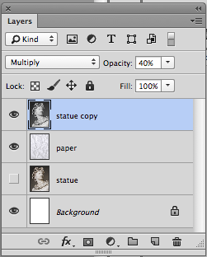

Statue copy
Is at the top

Paper
Is in the middle

Statue
Is at the bottom and the layer visibility is turned of

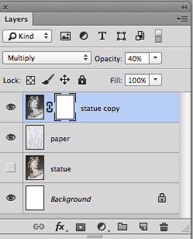
13.Click on the icon at
the bottom of the layer
panel called add layer
mask

There now is a separate window next to the layer window showing the fire

14. Press D on the
keyboard to make the
foreground and
background colour
default to black and
white

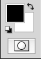
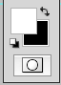
Click the small rounded arrow to reverse the colours arrow and make sure foreground is set to black and background is set to white

Getting the effect right of the next stage is personal but the feel of the image is to generally show less of the sculpture and generally take out the intensity of the hair

15. Select the brush tool and roughly follow the setting below
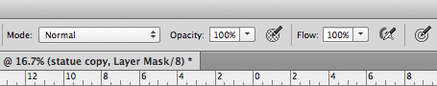
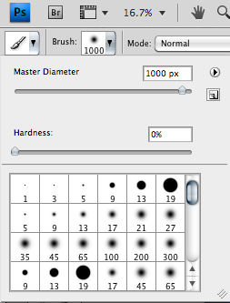
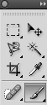
Soft Brush size 1000 px
Opacity 100 %

16. Using a Mask

With the brush selected as shown gently brush over the darkest part of the image, you will see black appearing on your layer mask window

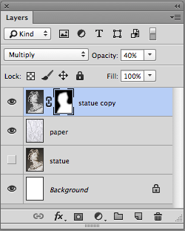
When brushing with black selected you are masking out the layer you are applying the brush too

You are applying transparency to your layer
BUT in a none destructive way

Try now switching the colours in your tool panel to Black
The image is being revealed

This is the power of a none destructive technique

PAINT WITH BLACK TO BRUSH OFF THE IMAGE
PAINT WITH WHITE TO BRUSH ON THE IMAGE

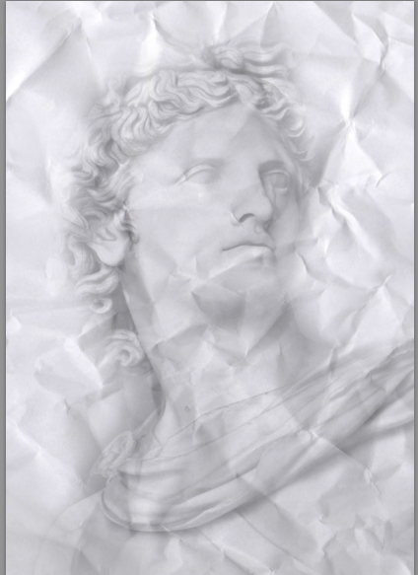
Reveal the background of the paper

Note what is happening to the mask on the layer, there is a solid black silhouette of a the statue showing how you have revealed the paper background

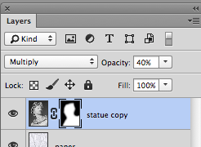

17. It is now time to blend the face in a little it is too prominent
input 40 % into the opacity box, this will soften the brush making
it less opaque
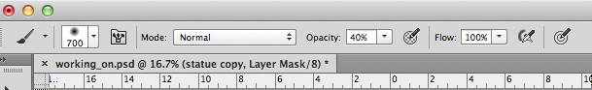
It is like using a rubber gently to erase a small amount of
pigment (pixels) instead of using it harshly and removing all the
pigment (pixels)

Before After

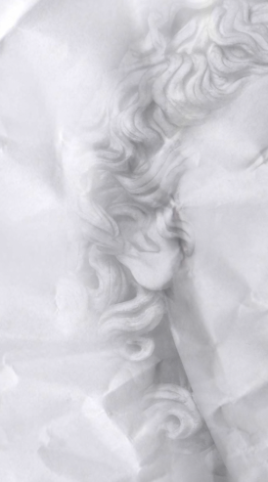
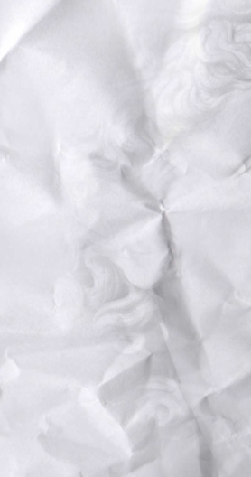

Continue gently revealing the paper background until you have a nice impression of the statue on the paper
18. Open the document called old_paper.jpg

GO > Select all = cmd A
GO > Edit Copy = cmd B
GO > Edit Paste = cmd V

Into the other document with the statue on

PHOTOSHOP PASTES THE NEW ITEM ABOVE WHICH EVER LAYER YOU HAD SELECTED

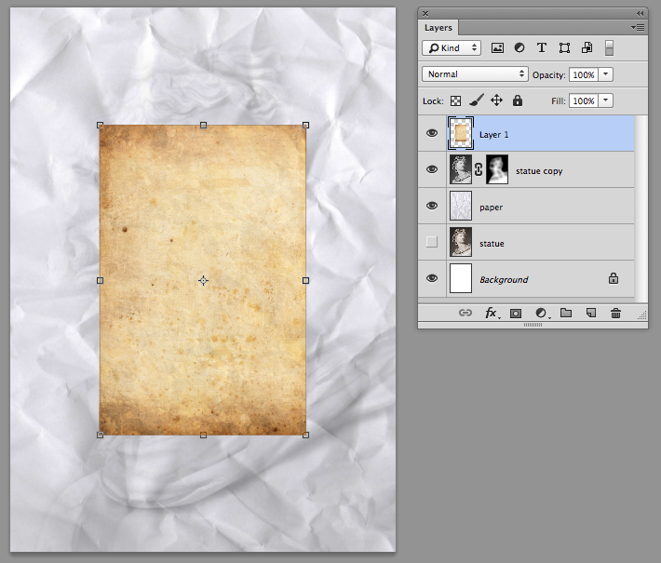

Notice the old_paper is smaller and needs its size adjusting

19. Adjust the size of the old paper

Using the move tool drag out the corner of the transform handle whilst holding down alt and shift, this drags out the image from the centre

Before After
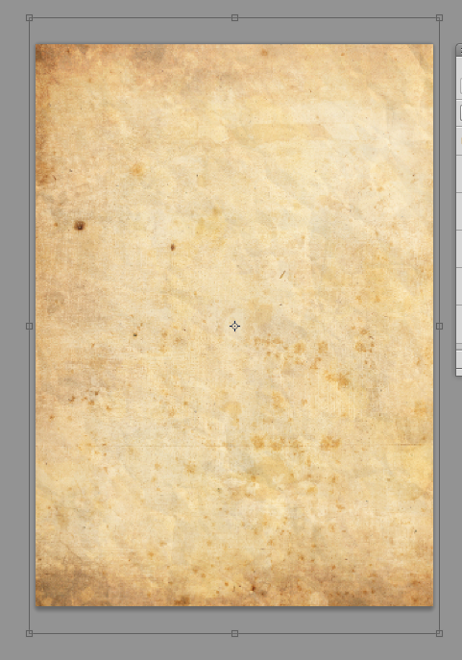
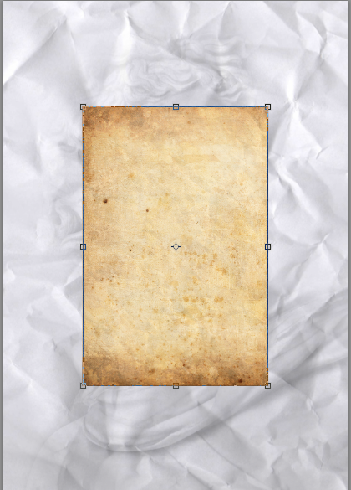

20. Using layer order and layer blending modes

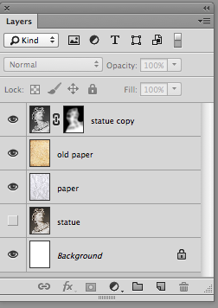

Move the layer old paper to below the statue copy layer

Make sure your layer panel resembles the one as shown

21. Adjusting the layer blending mode of the old paper

This is a matter of personal choice there is an example of two below
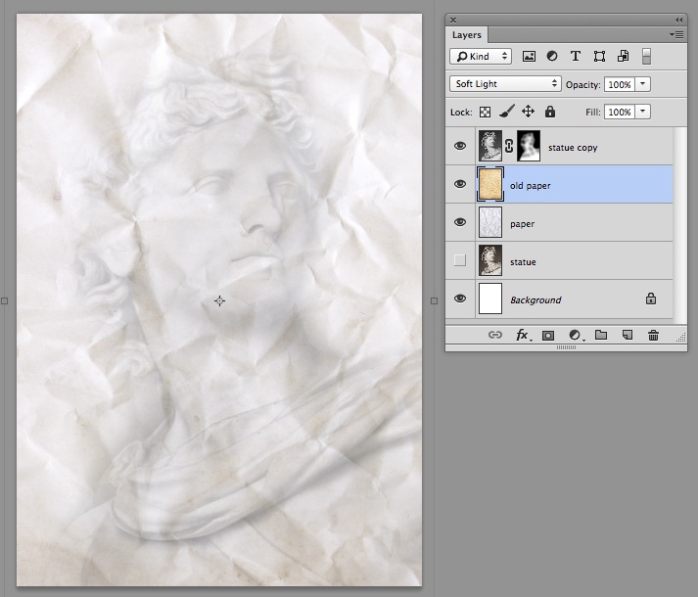
A. First example old paper set with a blending mode of soft light

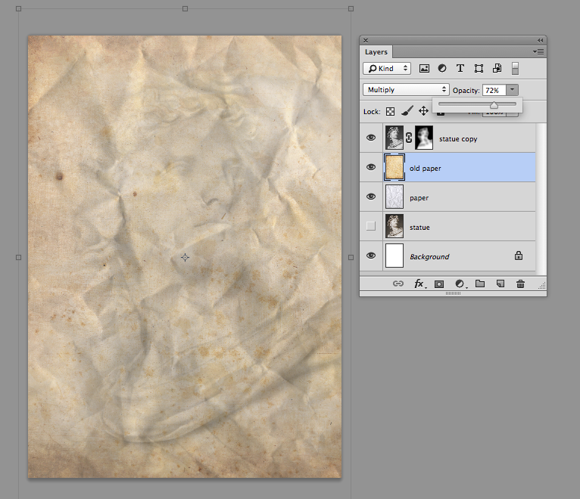
B. Second example old paper set with a blending mode of multiply BUT the opacity of that layer turned down to about 70%

NOTE FOR THE PURPOSES OF THIS TUTORIAL EXAMPLE A WAS CHOSEN
Part 4 Using Basic Layer Adjustments

Simply put, an adjustment layer is a layer we can adjust either on the specific layer it is clipped to or the document as a whole. This is a none destructive technique which is editable once the file has been closed and saved as a .psd
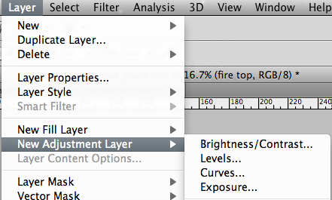
22. Make sure the layer
statue copy is
highlighted

> Click layer
> New Adjustment layer > Curves

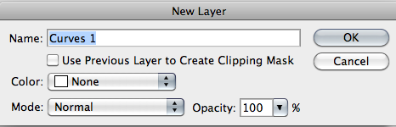
23. A new layer pop up
box is displayed
Click ok

We will not click use previous layer to crate clipping mask at the moment because we want our adjustment layer to affect all the layers underneath it.

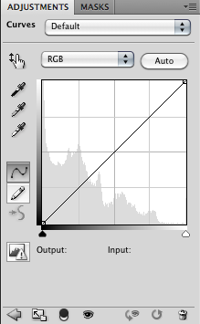
24. A new layer panel will be seen

This is the panel which allows the image to be brightened up without permanently destroying the layers beneath it.

In the future you can select the layer adjustment window on the layer and alter this to personal preference

25. Drag the curve downward (depending on your image and layer blending mode you chose)

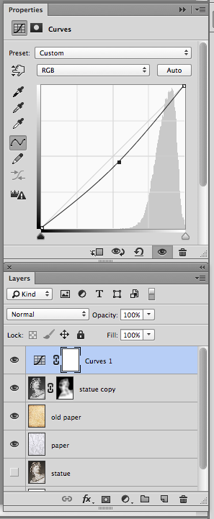
Notice your image appears Darker

Now have a look what the layer panel looks like

Notice this adjustment layer over the statue copy layer?

THIS IS A NONE DESTRUCTIVE TECHNIQUE
Which at any time allows you to alter the tone of your picture say if you change your mind

Experimentation with the finished image using differing layer blending modes and opacities

Layer = Old paper  Layer blending mode = soft light  Opacity = 100% | Layer = Old paper  Layer blending mode = Multiply  Opacity = 40%
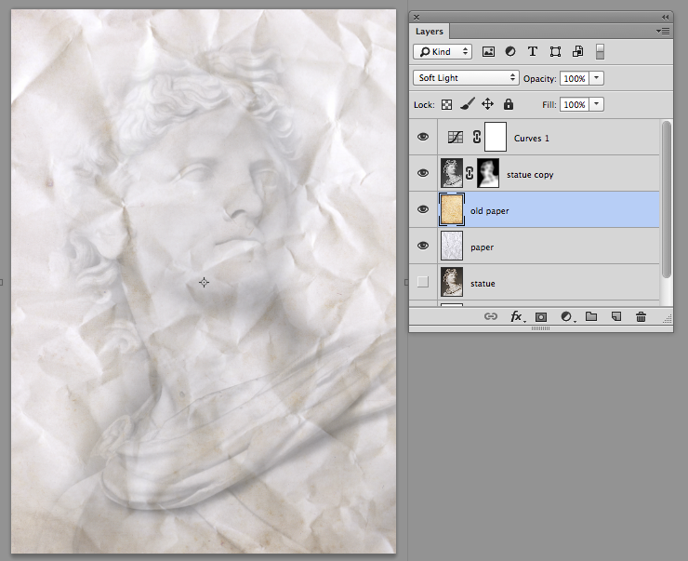 | 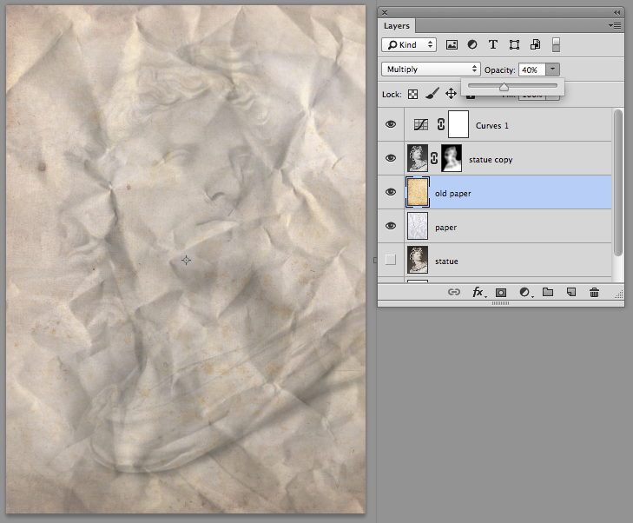
Layer = statue copy  Layer blending mode = multiply  Opacity = 70% | Layer = statue copy  Layer blending mode = Luminosity  Opacity = 50%
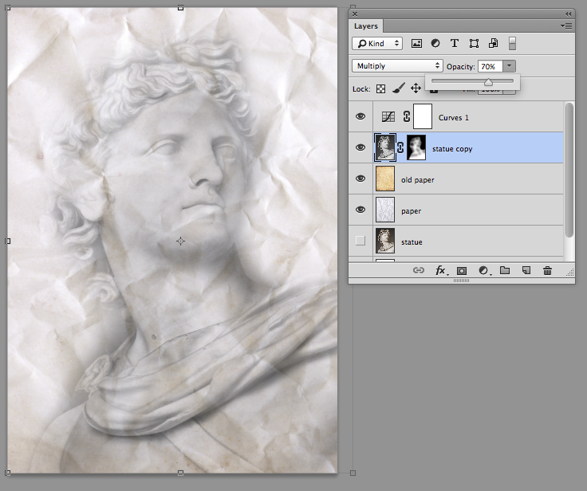 | 