A Basic Introduction Photoshop Montages using Layer Masks

Techniques used
- Basic Layer Masks
- Basic Layer Blending Modes

Part 1Building the Structure

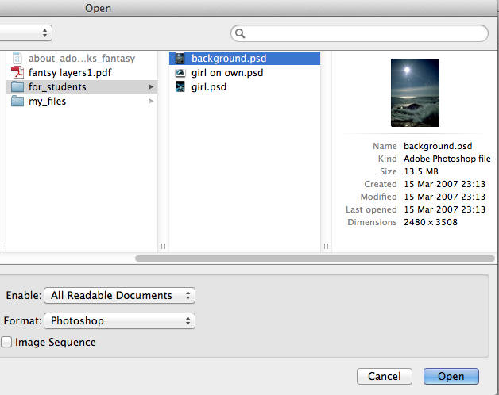
1. File open the document
background.psd

2. GO > File open > statue_to_use.jpg

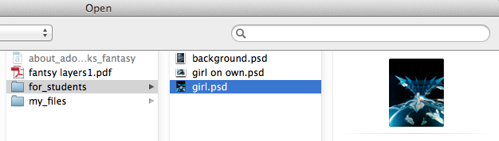
3. Select the entire image GO > Select all

4. You will now see a selection around the image than is called
running ants, they look like little flashing dots

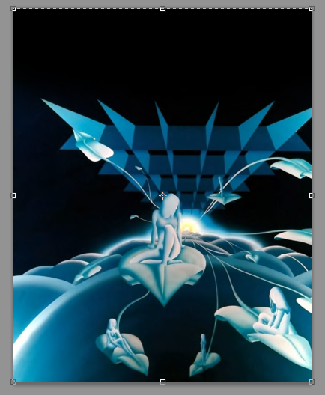

5. Copy the image
Go > Edit Copy or cmd C

6. Navigate to the new image you opened earlier
You will find this by looking for the tab showing Unentitled document on your window bar
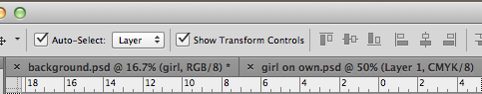
7. Paste the image
Go > Edit Paste or cmd V

8. Make sure transform controls are selected using the move tool
follow step 9

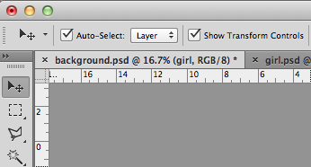

10. Transform the girl layer so it mostly covers the background
layer
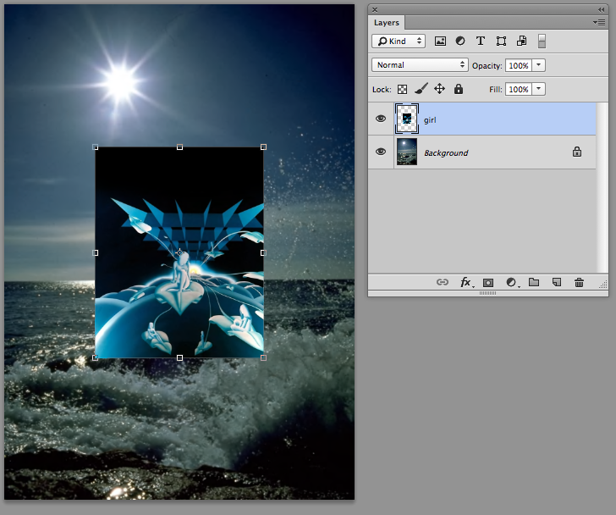

Name the your new layer girl
Click and drag the transform handles to resize the image to fit the size of the document maintaining aspect ratio

11. Double click to apply the transformation
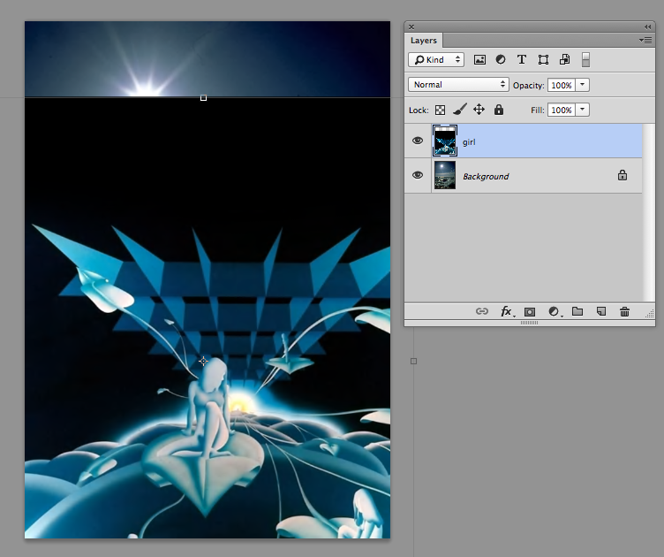

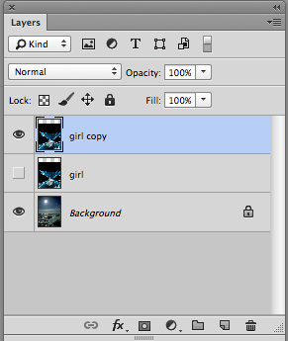
12. KEEPING A COPY OF A LAYER SAFE
Select the layer girl
Copy this layer by dragging it
down to the new layer icon

ABOVE THIS LAYER YOU NOW GET A NEW LAYER CALLED GIRL COPY

13. Turn of the layer visibility for the
layer statue it is not needed yet,
that’s the eye

Part 2 Using None Destructive Technique Masks

A layer mask is something that you apply to a given layer to control the transparency of that layer. Where layer opacity controls the transparency of the entire layer at once, a mask gives you more precise controls over very specific areas. If you want the entire layer to be at 30%, you would lower the opacity, if you want just the left side of a layer to be at 30%, you would use a mask.

14. RECAP
Name and move your
layers as shown if they have moved

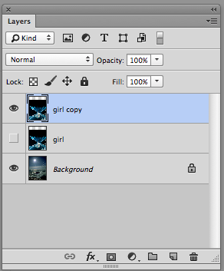

girl copy
Is at the top

girl
Is in the middle visibility is turned of

background
Is at the bottom and the layer

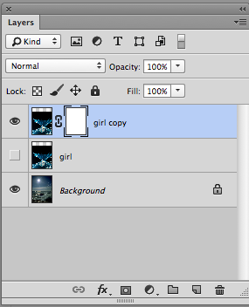
15.Click on the icon at
the bottom of the layer
panel called add layer
mask

There now is a separate window next to the layer window showing the fire

16. Press D on the
keyboard to make the
foreground and
background colour
default to black and
white

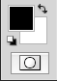
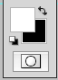
Click the small rounded arrow to reverse the colours arrow and make sure foreground is set to black and background is set to white

17. Select the brush tool and roughly follow the setting below
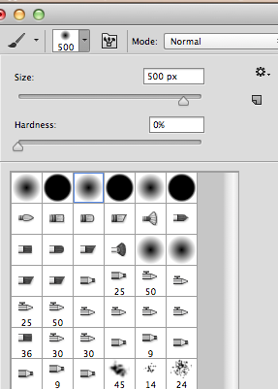
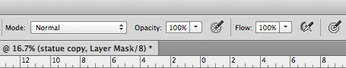
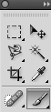
Soft Brush size 1000 px
Opacity 40 %

18. Using a Mask

With the brush selected as shown gently brush over the darkest part of the image, you will see black appearing on your layer mask window

When brushing with black selected you are masking out the layer you are applying the brush too

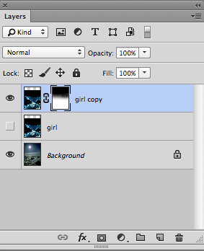
You are applying transparency to your layer
BUT in a none destructive way

Try now switching the colours in your tool panel to Black
The image is being revealed

This is the power of a none destructive technique

PAINT WITH BLACK TO BRUSH OFF THE IMAGE
PAINT WITH WHITE TO BRUSH ON THE IMAGE

19. Reveal the background of the
paper
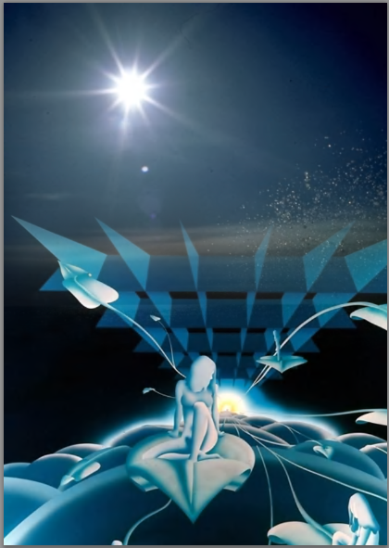

Note what is happening to the mask on the layer, there is a solid black silhouette of a the statue showing how you have revealed the paper background

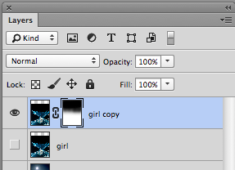

20. It is now time to blend the girl in a little it is too prominent
input 40 % into the opacity box, this will soften the brush making
it less opaque
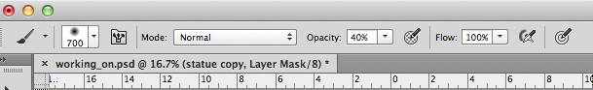
It is like using a rubber gently to erase a small amount of
pigment (pixels) instead of using it harshly and removing all the
pigment (pixels)

Before After

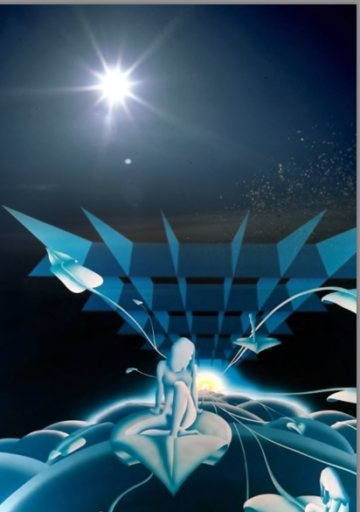

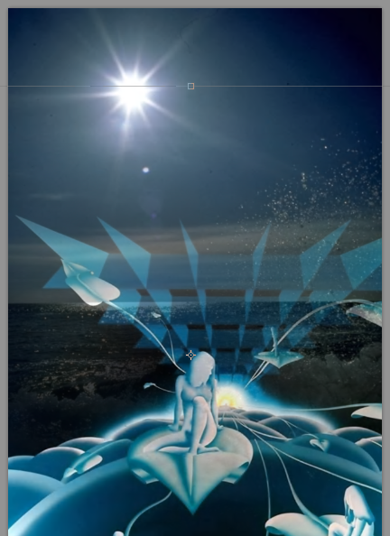

Part 3 Using Layer Blends

Please see additional tutorial for using blending modes in
Photoshop essential blends modes for photo editing Stage 1

Quite simply, layer blend modes give us different ways for a layer to interact with, or "blend" with, the layer or layers below it. Without layer blend modes, the only real way we have of blending layers together is by reducing the opacity (or fill) of a layer, which usually doesn't give us very interesting results. But with blend modes, not only do they unlock a world of creative possibilities, especially when we combine them with layer masks, they can also be extremely helpful when it comes to editing, retouching and restoring photos, and they can save us a whole lot of time!
Keep the layer opacity of girl copy to 100%
Either drag the slider or highlight the number and input the value
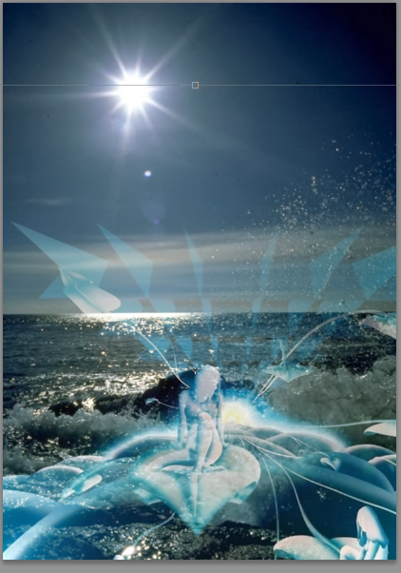
21. Press and hold down the
the layer blending mode
drop down box and
select SCREEN for the
layer Statue copy

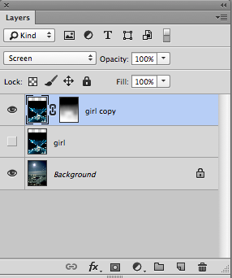

Observe your background layer the SEA is now partially visible

22. Open the image girl_on_own.psd
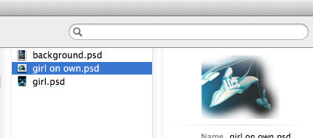

23. Copy the layer 1
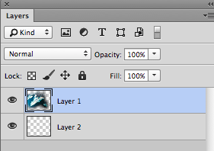

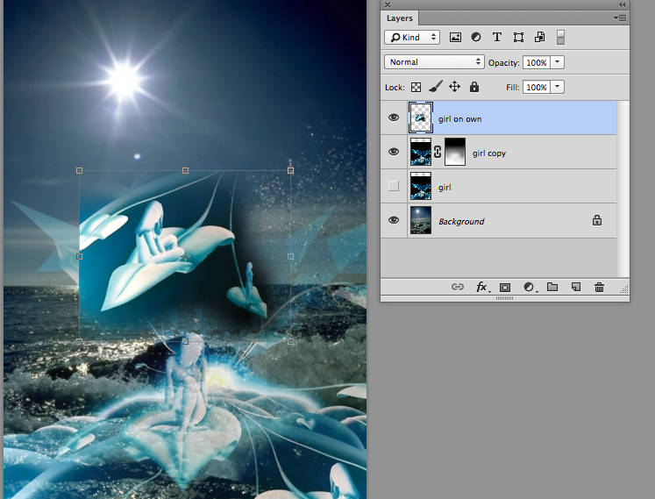
24. And paste into your new
document size and
position at the bottom left
hand side

25.Change the layer blending mode to screen and make as many
copies of the this layer as you want positioning them on the
document

