The world according to Adobe Photoshop

Photoshop is the leading digital image editing application for the Internet, print, and other new media disciplines. It is embraced by millions of graphic artists, print designers, visual communicators, and regular people like you. It's likely that nearly every picture you've seen (such as posters, book covers, magazine pictures, and brochures) has either been created or edited by Photoshop. The powerful tools used to enhance and edit these pictures are also capable for use in the digital world including the infinite possibilities of the Internet.
It is almost impossible to use or even learn all of Photoshop's tools to their maximum benefit. Photoshop has been around since 1982! That's around 25 years of troubleshooting and advancing software. This tutorial will go over the main features of the program so that you will feel confident to explore the remaining features on your own.

Some examples of Photoshop

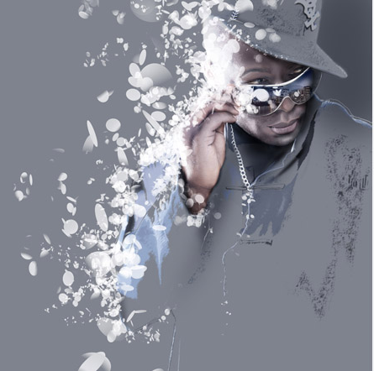

The Workspace

The Photoshop workspace consists of five main components: the Application Bar, the Tools Panel, the Options Bar, the Document Window, and the Panel Dock. One of the nice things about using Photoshop is that its workspace interface is very similar to that of other products in the Adobe Creative Suite, for example InDesign and Illustrator.
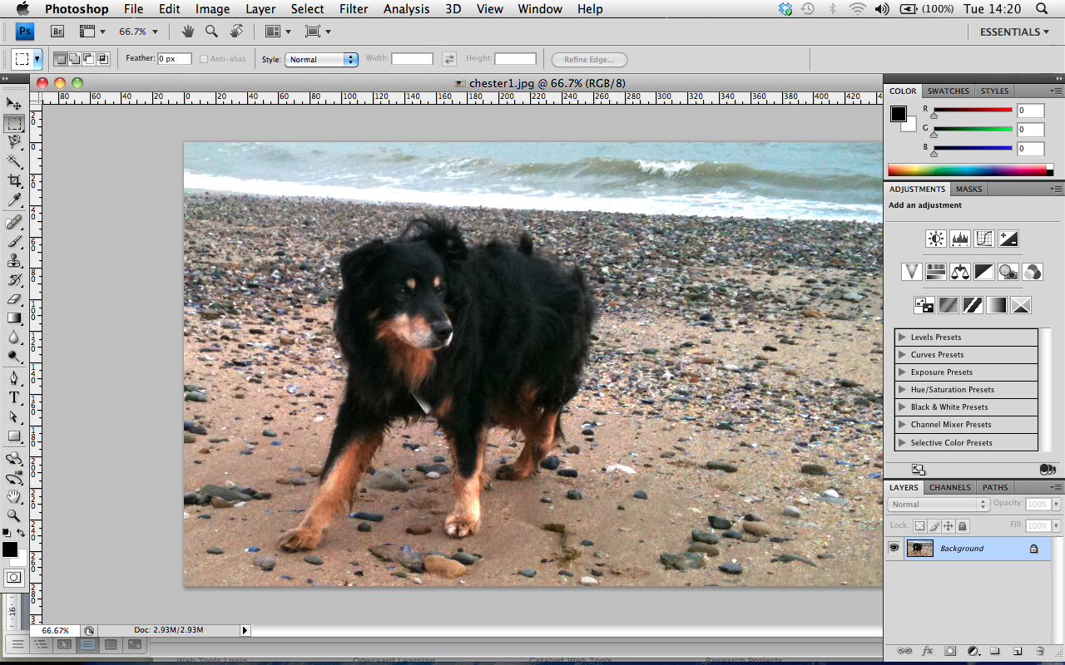

The Application Bar

The Application Bar, new to Photoshop CS4, is located across the top of the screen. It contains the old menu bar, along with a number of other controls, for example a dropdown zoom menu, a button for launching Adobe Bridge, and a button for viewing extras. The menu bar contains controls for managing and editing files, manipulating images, managing layers, and more.

Tools Panel

The familiar Tools Panel contains a collection of tools for creating, selecting, and manipulating images. Tools that have a similar function are grouped together.
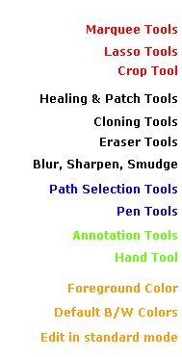
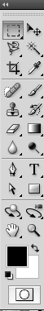
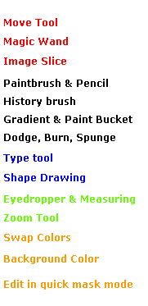

You can access more options for each tool by holding down the mouse on a tool.

Options Bar

The Options Bar is located below the Application Bar. The options change depending on the tool you have selected. For example, when you select the Type tool, options pertaining to text editing will appear across the bar.

Document Window

The Document Window displays the file you're working on.

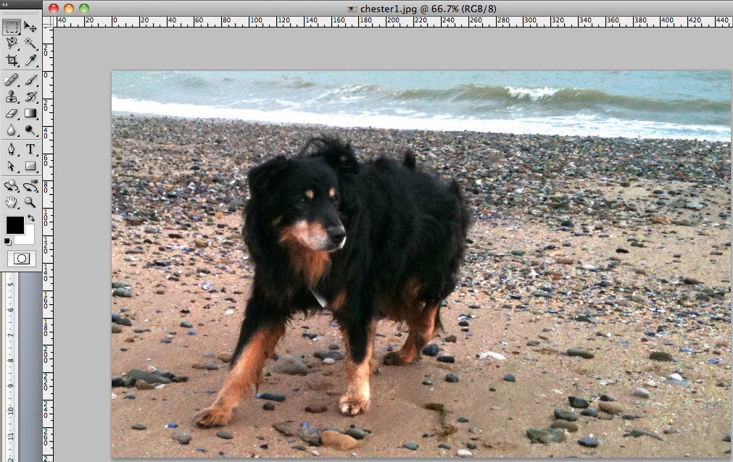

Panel Dock

A vertical dock of panels is located on the right of the workspace. Panels help you manage and edit your images, allowing for quick and easy access to the most common controls for a particular task. By default, three panels will appear when you open Photoshop: the layers, adjustments and styles panels.
To access more panels, click Windows from the Application Bar, and click the panel you want to open. To hide a panel, click Windows from the Application Bar, and click the panel you want to hide.

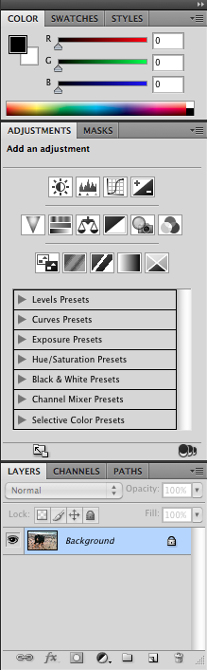

Creating a New Image

- To create a new image, follow these steps:
- Click File from the Application Bar.

- Click New. A dialog box will open, allowing you to define the following elements of your image:

- Name - allows you to name your image.

- Size - allows you to predetermine the width and height of your image. Photoshop offers preset dimensions for sizing your image, or you can customize your own size using many types of measurements including pixels, centimetres, inches, and millimetres.

- Resolution - allows you to set the image resolution. A resolution of 72 ppi (pixels per inch) is generally used for Internet images. If you wish to use your images for print or video, they will need to be a higher resolution of 300 ppi

- Color Mode - allows you to control the colour mode of your image. The standard colour mode is RGB (Red Green Blue). You can also choose to create your image in grayscale, bitmap, and more. Some modes will limit your colour range.

- Background Content - allows you to choose the initial background colour of your image.
- When you are happy with your selections, click OK.
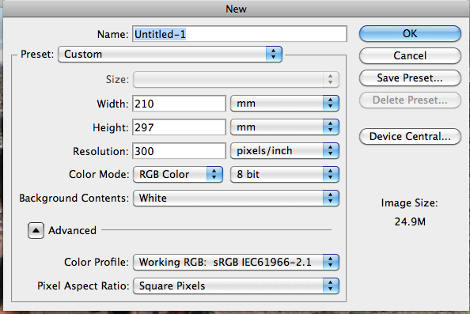

Opening an Existing Image

- To open an existing image, follow these steps:
- Click File from the Application Bar.
- Click Open.
- Navigate to your saved file.
- Click Open.

Saving an Image

- To save an image, click File and then click Save.

