Social Media

MAKE | CHANGE | EXCHANGE | COMMUNICATE

Social media is the collective of online communications channels dedicated to community-based input, interaction, content-sharing and collaboration. Websites and applications dedicated to forums, micro blogging, social networking, social bookmarking, social curation, and wikis are among the different types of social media.
Social media is becoming an integral part of life online as social websites and applications proliferate. Most traditional online media include social components, such as comment fields for users. The term "social media" is likely to lose meaning as the social aspect of the Web becomes increasingly taken for granted.

What are social networking sites?

The computer industry has always loved buzzwords and one of the latest is ’social networking’. This can be fun, as well as useful, and if you fancy getting involved, then this article will point you in the right direction.
There are a lot of myths about social networking. Firstly, Facebook, Twitter and that sort of thing are for kids (actually, Ofcom figures show that over 50% of the people on these networks are aged 35 and over). Secondly, it’s risky and people will steal your personal details (it’s no more risky than any other internet page). And thirdly, it’s difficult and technical (it’s not).

Social networking is a way of using your computer to talk to other people, exchange pictures, whatever you want to do.
Twitter
This is one of the fastest-growing networks. You follow people you know or in whom you’re interested, they follow you, you exchange brief text-only messages. If you say something interesting, one of your followers might ’re-tweet’ it, which means repeating it and saying who said it. So, some of their followers might start to follow you too, and that’s how you meet new people. Great for asking quick questions.

Facebook
Unlike Twitter, you get a page on the web and can use this for longer bits and pieces. You can upload pictures, videos, play games, whatever you want to do. There are Facebook applications for reviewing books, reviewing films, areas for private messages and for more open discussions. This can really be your place on the internet if you want it to be.
LinkedIn
A bit like a Facebook for business. This is a network for contacting and keeping in touch with work colleagues. You may only contact people who are a friend of a friend, or a friend of a friend of a friend, and so forth.
Flickr
There’s less scope for socialising here, but you can upload and share any pictures you want others to see. You can also download and sometimes use pictures on websites, as many people put them up with few copyright restrictions.
Google+
It's still early days for Google's competitor to Facebook and Twitter, but the company is such a behemoth that it's not a good idea to count them out. Google+ lets you put all your acquaintances in separate "circles", so you can post something to your best friends that you might not want sent to your work colleagues.
Reddit

- Is a social news website and forum where stories
- are socially curated and promoted by site
- members. The site is composed of hundreds of sub-communities, known as "subreddits." Each subreddit has a specific topic such as technology, politics or music. Reddit site members, also known as, "redditors," submit content which is then voted upon by other members. The goal is to send well-regarded stories to the top of the site's main thread page.

Pinterest
Is a social curation website for sharing and categorizing images found online. Pinterest requires brief descriptions but the main focus of the site is visual. Clicking on an image will take you to the original source, so, for example, if you click on a picture of a pair of shoes, you might be taken to a site where you can purchase them. An image of blueberry pancakes might take you to the recipe; a picture of a whimsical birdhouse might take you to the instructions.
Check out networks before you post
As a rule, it’s a good idea to have a look at what others are doing before putting your own entries up onto these networks. But once you’re in the swing of it, they can be a great additional resource for finding things out – and who knows, you might have the answer to someone else’s query and be able to help immediately!

What is a "blog"?
"Blog" is an abbreviated version of "weblog," which is a term used to describe web sites that maintain an ongoing chronicle of information. A blog features diary-type commentary and links to articles on other Web sites, usually presented as a list of entries in reverse chronological order. Blogs range from the personal to the political, and can focus on one narrow subject or a whole range of subjects.
Many blogs focus on a particular topic, such as web design, home staging, sports, or mobile technology. Some are more eclectic, presenting links to all types of other sites. And others are more like personal journals, presenting the author's daily life and thoughts.
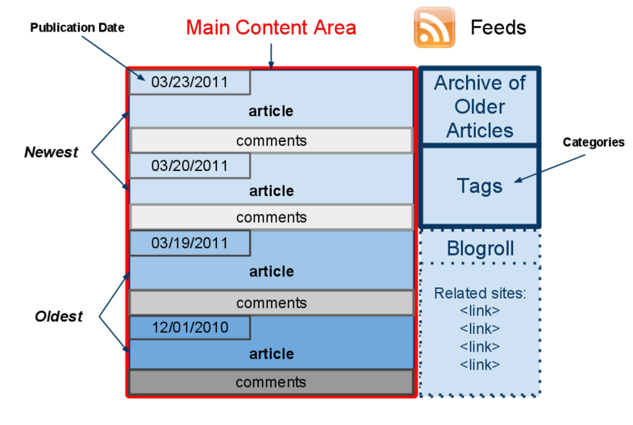
Generally speaking (although there are exceptions), blogs tend to have a few things in common:

- A main content area with articles listed chronologically, newest on top.
- Often, the articles are organized into categories.
- An archive of older articles.
- A way for people to leave comments about the articles.
- A list of links to other related sites, sometimes called a "blogroll".
- One or more "feeds" like RSS, Atom or RDF files.

The Blog Content
Content is the raison d'être for any web site. Retail sites feature a catalog of products. University sites contain information about their campuses, curriculum, and faculty. News sites show the latest news stories. For a personal blog, you might have a bunch of observations, or reviews. Without some sort of updated content, there is little reason to visit a web site more than once.
On a blog, the content consists of articles (also sometimes called "posts" or "entries") that the author(s) writes. Yes, some blogs have multiple authors, each writing his/her own articles. Typically, blog authors compose their articles in a web-based interface, built into the blogging system itself. Some blogging systems also support the ability to use stand-alone "weblog client" software, which allows authors to write articles offline and upload them at a later time.
Comments
Want an interactive website? Wouldn't it be nice if the readers of a website could leave comments, tips or impressions about the site or a specific article? With blogs, they can! Posting comments is one of the most exciting features of blogs.
Most blogs have a method to allow visitors to leave comments. There are also nifty ways for authors of other blogs to leave comments without even visiting the blog! Called "pingbacks" or "trackbacks", they can inform other bloggers whenever they cite an article from another site in their own articles. All this ensures that online conversations can be maintained painlessly among various site users and websites.
A few tips for beginner bloggers

1. Define Your Goals

Before you start a new blog, it's essential that you define your goals for it. Your blog has a greater chance of success if you know from the beginning what you hope to accomplish with it. Are you trying to establish yourself as an expert in your field? Are you trying to promote your business? Are you simply blogging for fun and to share your ideas and opinions? Your short and long term goals for your blog are dependent on the reason why you're starting your blog. Think ahead to what you'd like to gain from your blog in six months, one year and three years. Then design, write and market your blog to meet those goals.

2. Know Your Audience

Your blog's design and content should reflect the expectations of your audience. For example, if your intended audience is teenagers, the design and content would be quite different than a blog targeted to corporate professionals. Your audience will have inherent expectations for your blog. Don't confuse them but rather meet and exceed those expectations to gain reader loyalty.

3. Be Consistent

Your blog is a brand. Just like popular brands such as Coke or Nike, your blog represents a specific message and image to your audience, which is your brand. Your blog's design and content should consistently communicate your blog's overall brand image and message. Being consistent allows you to meet your audience's expectations and create a secure place for them to visit again and again. That consistency will be rewarded with reader loyalty.

4. Be Persistent

A busy blog is a useful blog. Blogs that are not updated frequently are perceived by their audiences as static web pages. The usefulness of blogs comes from their timeliness. While it's important not to publish meaningless posts else you may bore your audience, it's essential that you update your blog frequently. The best way to keep readers coming back is to always have something new (and meaningful) for them to see.

5. Be Inviting

One of the most unique aspects of blogging is its social impact. Therefore, it's essential that your blog welcomes readers and invites them to join a two-way conversation. Ask your readers to leave comments by posing questions than respond to comments from your readers. Doing so will show your readers that you value them, and it will keep the conversation going. Continue the conversation by leaving comments on other blogs inviting new readers to visit your blog for more lively discussions. Your blog's success is partially dependent on your readers' loyalties to it. Make sure they understand how much you appreciate them by involving them and recognizing them through meaningful two-way conversation.

6. Be Visible

Much of your blog's success relies on your efforts outside your blog. Those efforts include finding like-minded bloggers and commenting on their blogs, participating in social bookmarking through sites such as Digg and StumbleUpon, and joining social networking sites such as Facebook and LinkedIn. Blogging is not a demonstration of, "if you build it, they will come." Instead, developing a successful blog requires hard work by creating compelling content on your blog as well as working outside of your blog to promote it and develop a community around it.

7. Take Risks

Beginner bloggers are often afraid of the new blogging tools and features available to them. Don't be afraid to take risks and try new things on your blog. From adding a new plug-in to holding your first blog contest, it's important that you keep your blog fresh by implementing changes that will enhance your blog. Alternatively, don't fall prey to every new bell and whistle that becomes available for your blog. Instead, review each potential enhancement in terms of how it will help you reach your goals for your blog and how your audience will respond to it.

8. Ask for Help

Even the most experienced bloggers understand the blogosphere is an ever-changing place and no one knows everything there is to know about blogging. Most importantly, bloggers are part of a close-knit community, and the majority of bloggers understand that everyone is a beginner at some point. In fact, bloggers are some of the most approachable and helpful people you can find. Don't be afraid to reach out to fellow bloggers for help. Remember, the success of the blogosphere relies on networking, and most bloggers are always willing to expand their networks regardless of whether you're a beginner blogger or seasoned pro.

9. Keep Learning

It seems like everyday there are new tools available to bloggers. The Internet changes quickly, and the blogosphere is not an exception to that rule. As you develop your blog, take the time to research new tools and features, and keep an eye on the latest news from the blogosphere. You never know when a new tool will roll out that can make your life easier or enhance your readers' experiences on your blog.

10. Be Yourself

Remember, your blog is an extension of you and your brand, and your loyal readers will keep coming back to hear what you have to say. Inject your personality into your blog and adapt a consistent tone for your posts. Determine whether your blog and brand will be more effective with a corporate tone, a youthful tone or a snarky tone. Then stay consistent with that tone in all your blog communications. People don't read blogs simply to get the news. They could read a newspaper for news reports. Instead, people read blogs to get bloggers' opinions on the news, the world, life and more. Don't blog like a reporter. Blog like you're having a conversation with each of your readers.

BUT remember you are accountable legally and publically so think before you speak!

Adapted Various online content

