An introduction to making shapes and direct selection in illustrator using Pop Art as an example

Stage 1

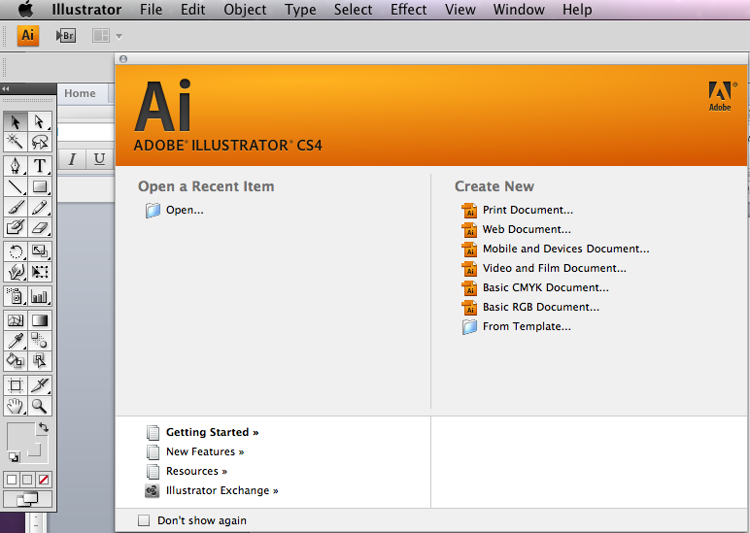
1. Open the application illustrator and make a new document in landscape mode A4

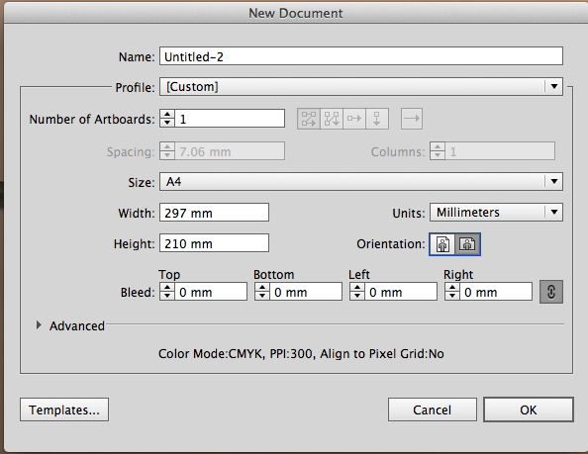

2. Go to the tool panel and hold down the shape tool until you see the following fly out

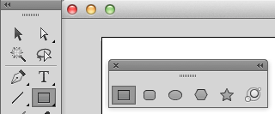
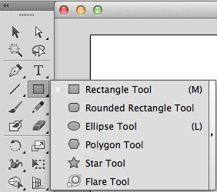
3. Hold down the little black triangle and drag the tear of strip out of the tool panel.

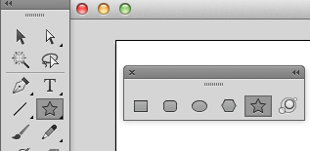
4. Select the star tool by clicking on it

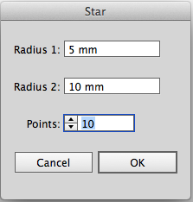
5. Click ONCE on the art board and a pop up box will appear enter the settings as shown

6. Click on the selection tool (black arrow)

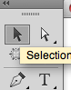

7. Select the star and adjust the shape of the star by pulling in or out the transform handles. Alter the shape of the star until it resembles as shown.

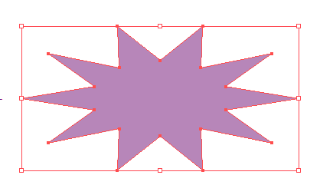
Transform Handles
This is the same on
the right, top and bottom
of the shape

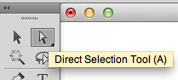
8. Click on the Direct Selection tool (the white one)
This tool allows you to directly edit any shape using the shapes anchor point

These will stay white (they are not Selected)

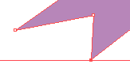
Select the corner anchor using the direct selection tool on the corner anchor and pull out

NOTICE how that anchor has now gone dark blue (mine is just red for demo purposes

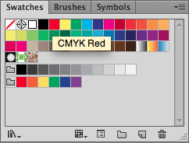
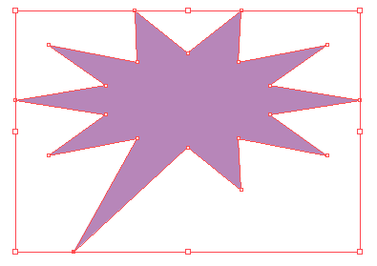
8. Continued Pull out the anchor until your star resembles the one shown

9. Choose any colour from your swatches (see tutorial using colour)

10. Then Go to the top of the menu bar and select Effect
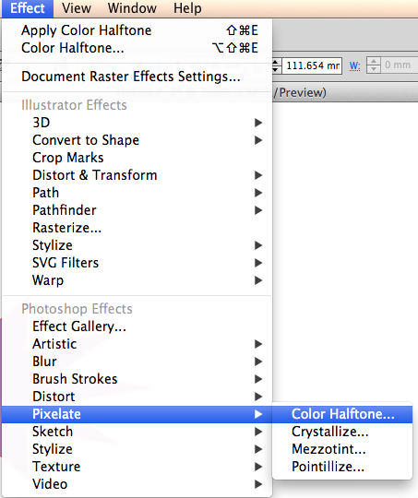
- Click Effect scroll down and
- Click Pixilate then go across and
- Click Colour Halftone

11. A Pop up box will appear called Colour Halftone

KEEP A NOTE OF THESE SETTINGS SO YOU CAN SWITCH BACK LATER

Select the following settings
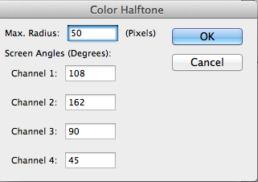
Max. Radius 50

Channel 1 = 108
Channel 2 = 162
Channel 3 = 90
Channel 4 = 45

Do not lose these settings

Click ok

12. You should have something similar to this

13. Select different colours in your swatches and experiment with max radius setting in the colour half tone pop up box

Look at these examples and experiment with stroke weight and max radius settings
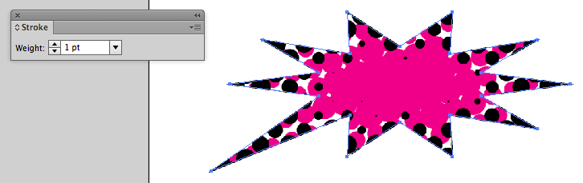

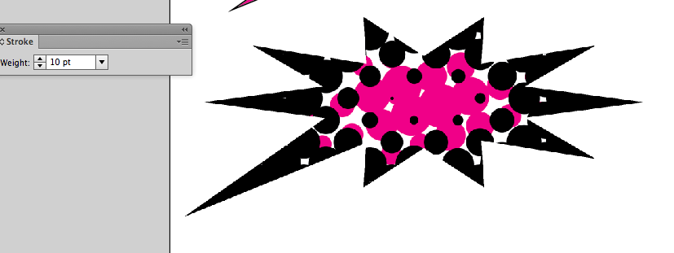
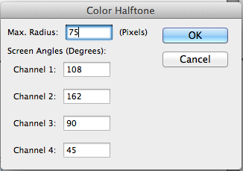
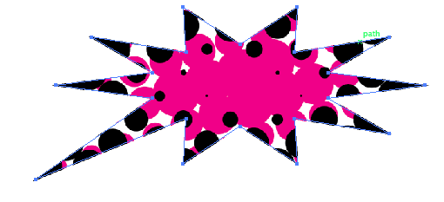

14. Click on the selection tool (black arrow) and select the shape

16. Making a duplicate of the shape
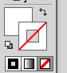
- Copy the shape either by Alt and dragging (see making basic shapes tutorial) or go edit copy and then edit paste
- Select white for the fill
- Select the no stoke for the stroke

- Scale the second star down until it a little smaller than the original
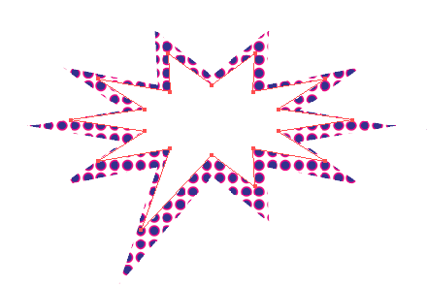
- Position over the top of the original shape

Keeping the second star selected click on the stroke and turn the colour to black

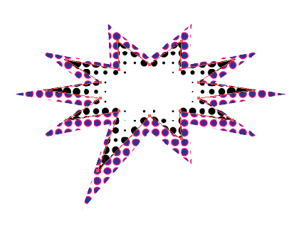
18. Experiment with different colours on the fill and the stroke

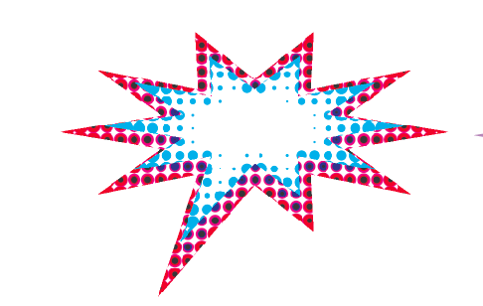
The next stage of the Tutorial shows a different approach to half tone effect where you can set the colours of the spots to just one colour

