An Introduction Photoshop Montages
Techniques used
- Basic Layer Masks
- Basic Layer Blending Modes
- Basic Selections Techniques
- Basic Layer Adjustments

Part 1Building the Structure

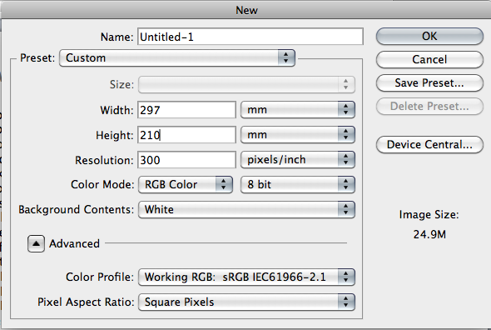
1. File open New Document

Make sure your document is in landscape mode

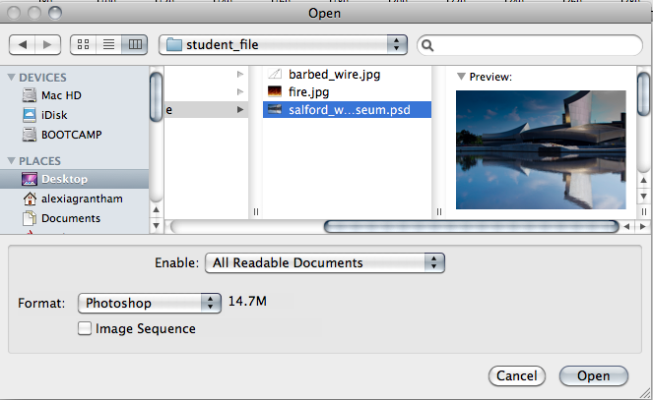
2. File open salford_war_museum.psd

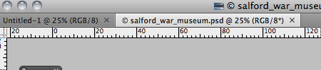
Drag and pull down the tab for the file salford_war_museum if your file is docked to the window

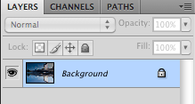
3. Unlock the layer, double clicking on
the background layer, click ok to the
pop up window

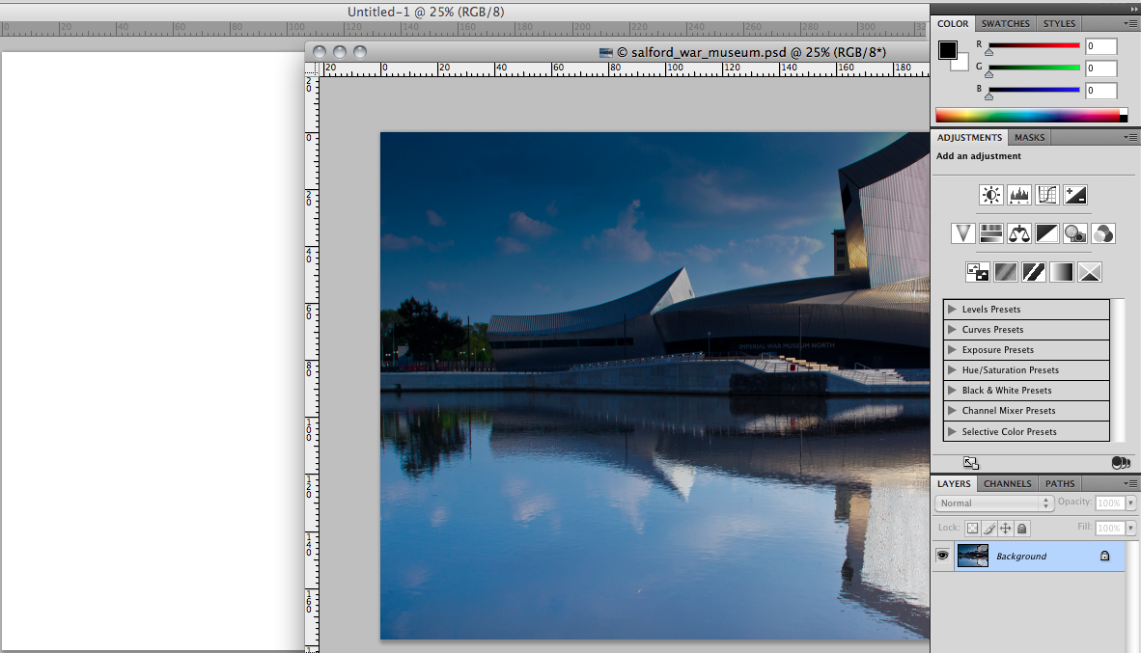
4. Drag over the layer
salford_war_museum
to your new document

Make sure transform selections are selected
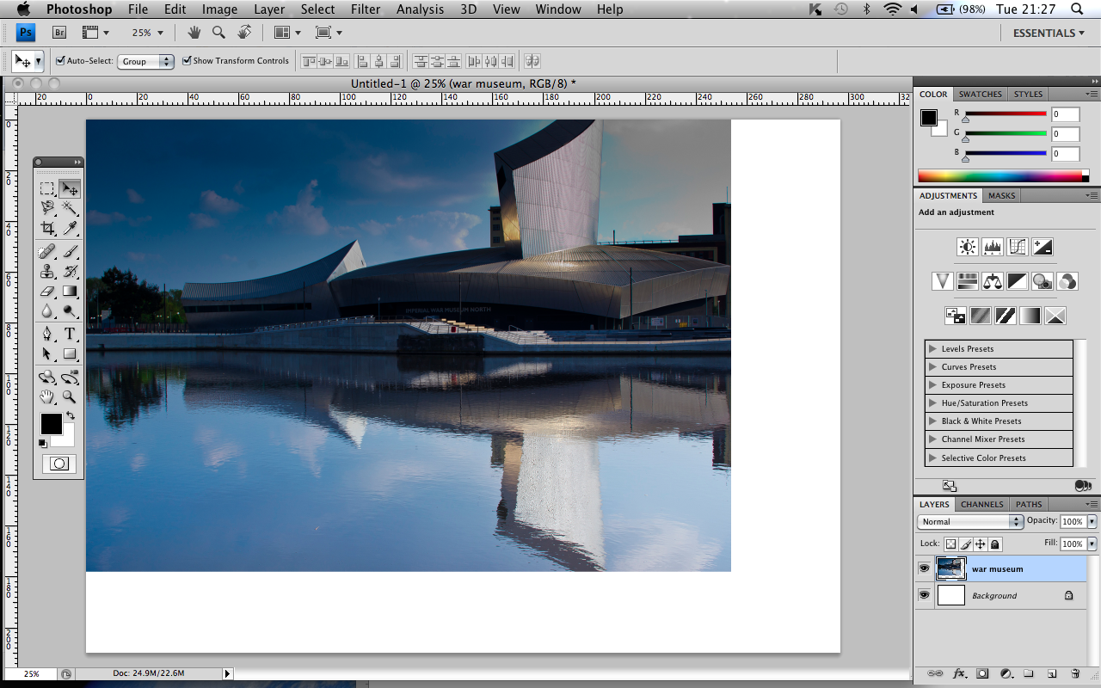
Click and drag the transform handles to resize the image to fit the size of the document maintaining aspect ratio

Name the your new layer war museum

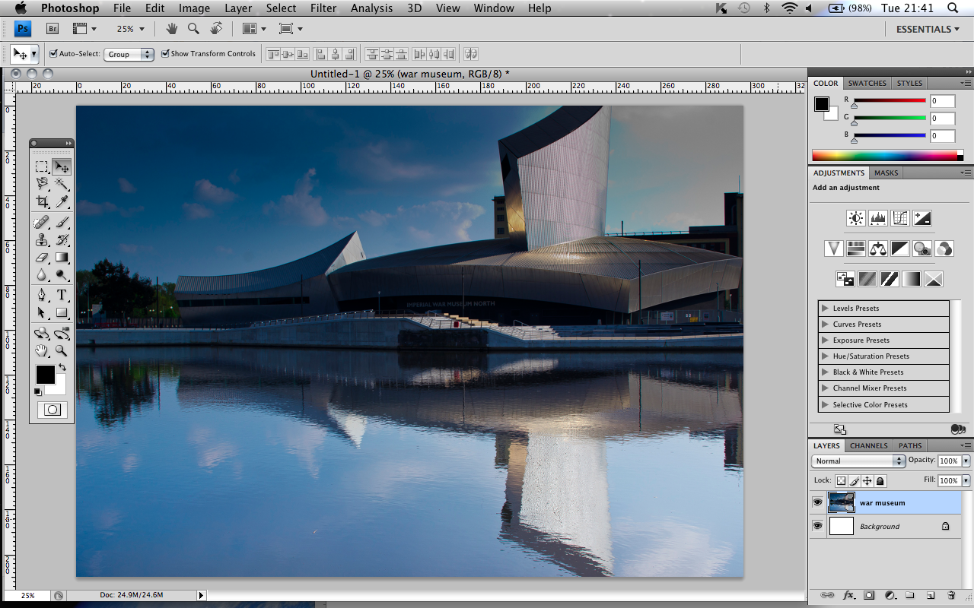
Double click to apply the transformation

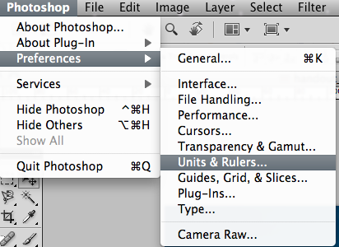
5. Go to preferences units and rulers

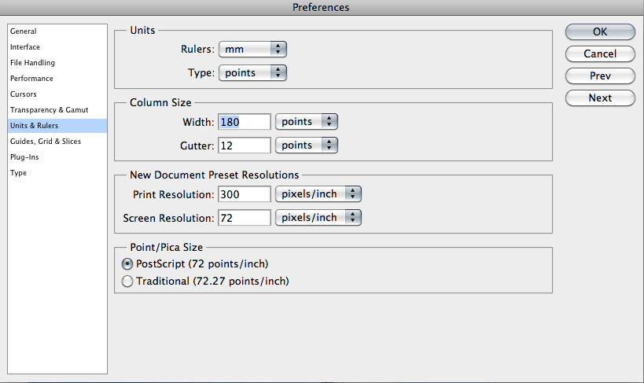
Make sure in the rulers drop down box select mm

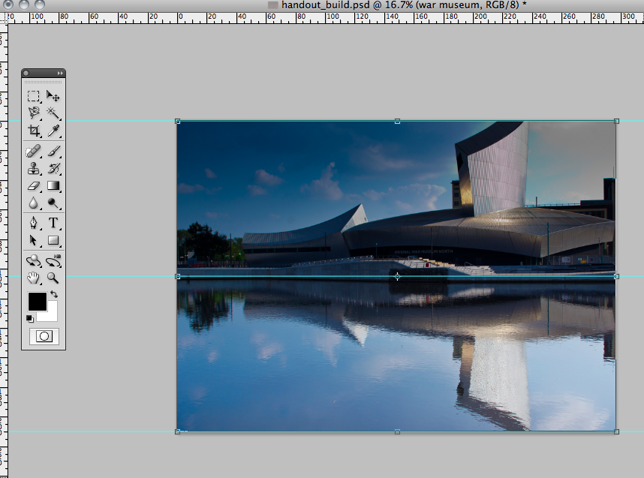
You will now see rulers at the top and side of your document window
Now click on the ruler bar and drag down a guide to the top middle and side of your image

6. Open the fire.jpg image
Repeat the previous step 4
Drag down your document from the docking window
Drag over the layer and name it fire

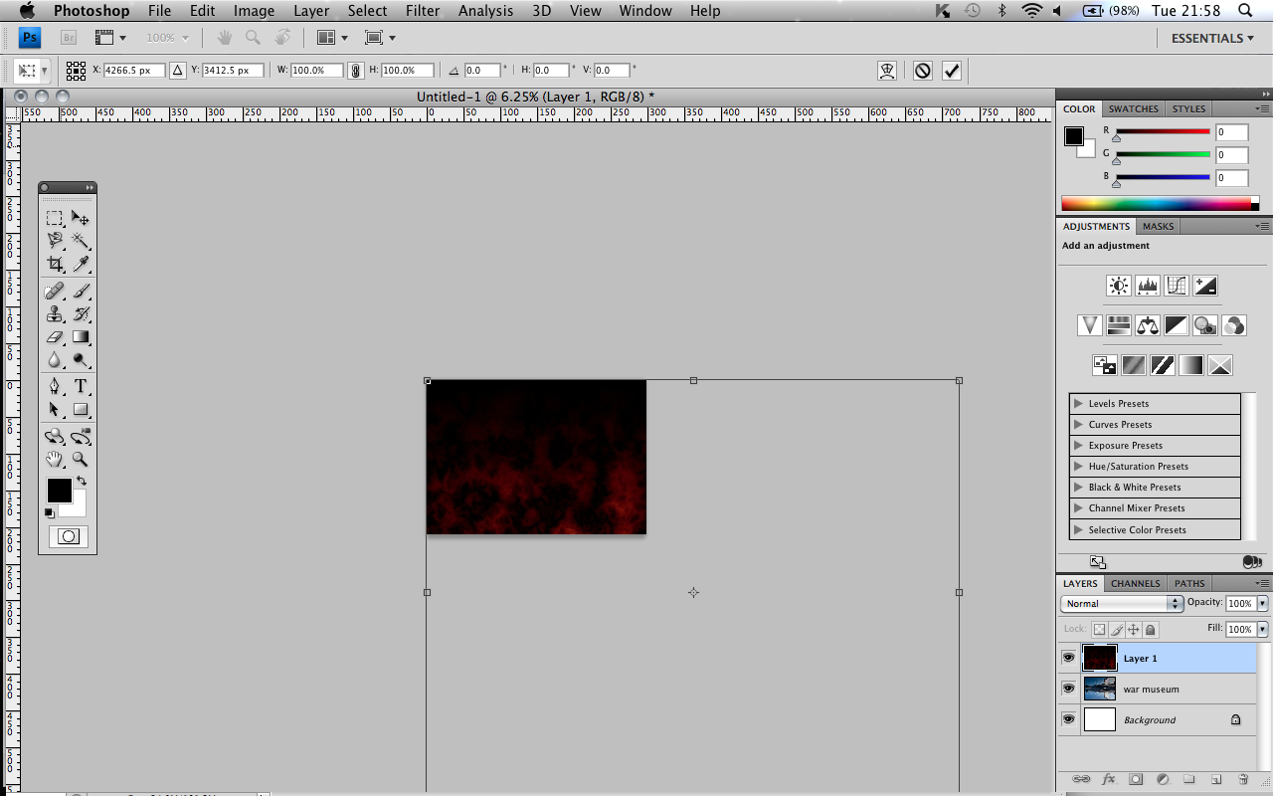
Notice how your fire document is bigger zoom out cmd+ to see the transform handles

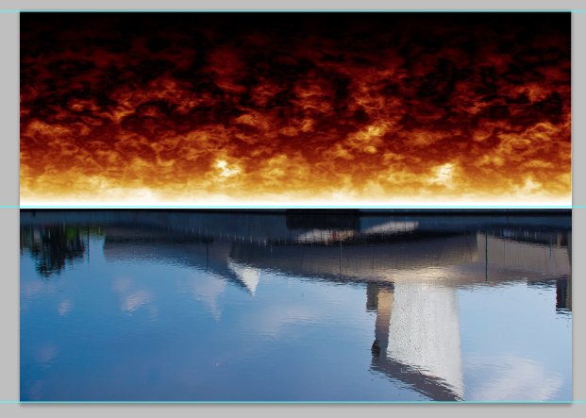
Position and size as shown
Close fire document

Half way ruler

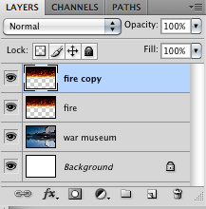

7. Copy this layer by dragging it
down to the new layer icon

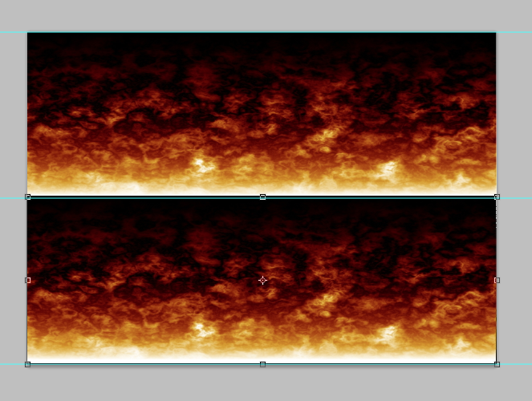
8. Drag down this layer on your
image so it resembles the
example shown

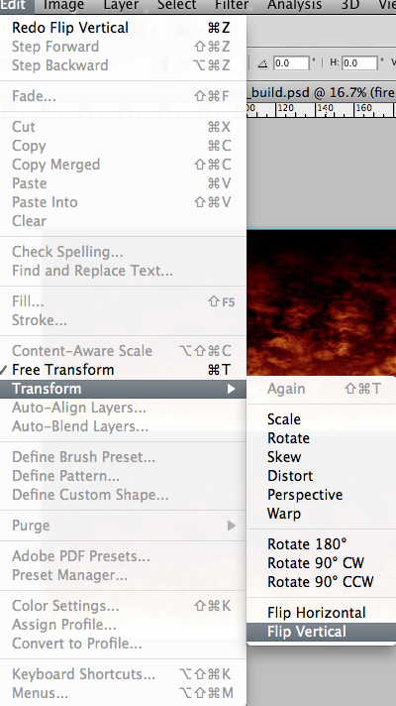
9.Making sure the layer fire copy is selected
Go to Edit Transform Flip Vertical
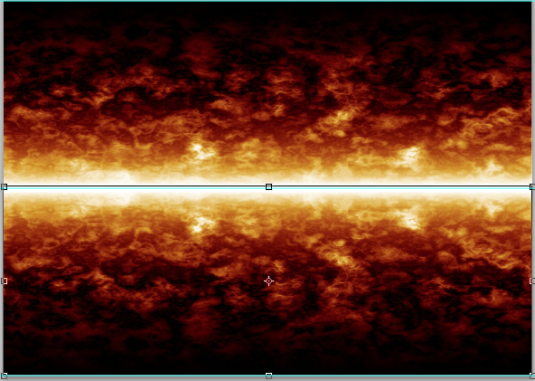

Part 2 Using Layer Blends

Please see additional tutorial for using blending modes in
Photoshop essential blends modes for photo editing Stage 1

Quite simply, layer blend modes give us different ways for a layer to interact with, or "blend" with, the layer or layers below it. Without layer blend modes, the only real way we have of blending layers together is by reducing the opacity (or fill) of a layer, which usually doesn't give us very interesting results. But with blend modes, not only do they unlock a world of creative possibilities, especially when we combine them with layer masks, they can also be extremely helpful when it comes to editing, retouching and restoring photos, and they can save us a whole lot of time!

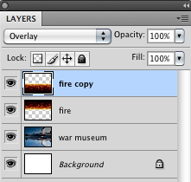
10. Press and hold down the
the layer blending mode
drop down box and
select overlay for both
fire and fire copy
layer
Observe your background layer the war museum is now partially visible

Part 3 Using None Destructive Technique Masks

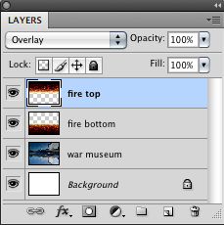
A layer mask is something that you apply to a given layer to control the transparency of that layer. Where layer opacity controls the transparency of the entire layer at once, a mask gives you more precise controls over very specific areas. If you want the entire layer to be at 30%, you would lower the opacity, if you want just the left side of a layer to be at 30%, you would use a mask.

11. Name and move your
layers as shown

Fire top

Fire Bottom

War Museum

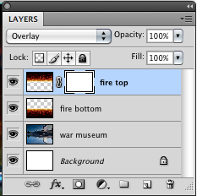
12.Click on the icon at
the bottom of the layer
panel called add layer
mask

There now is a separate window next to the layer window showing the fire

13. Press D on the
keyboard to make the
foreground and
background colour
default to black and
white

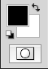
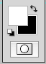
Click the small rounded arrow to reverse the colours arrow and make sure foreground is set to black and background is set to white

Getting the effect right of the next stage is personal but the feel of the image is to generally show flames on the buildings and water, leaving a few on the sky

14. Select the brush tool and roughly follow the setting below
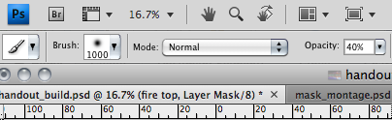
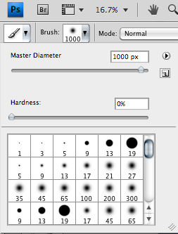
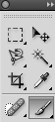
Soft Brush size 1000 px
Opacity 40 %

15. Using a Mask

With the brush selected as shown gently brush over the image of the top sky, you will see black appearing on your layer mask window

When brushing with black selected you are masking out the layer you are applying the brush too
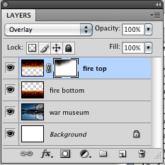
You are applying transparency to your layer
BUT in a none destructive way

Try now switching the colours in your tool panel to white
The image is being revealed

This is the power on a none destructive technique such as discussed in class

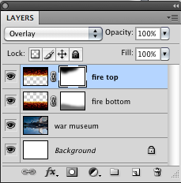
16. Repeat step 15 on the layer fire bottom and create a layer mask
and try to re create the image as shown removing a little fire from
the water

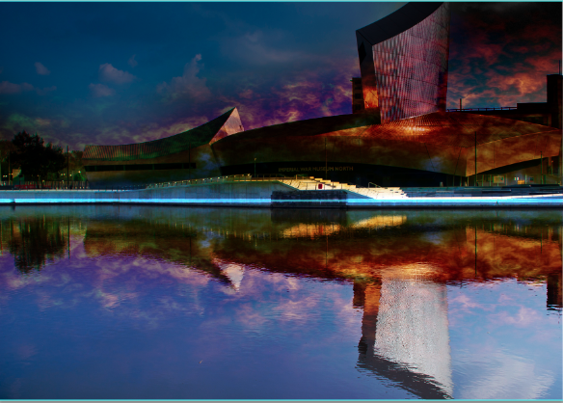
Revealing parts of the layer war museum

Part 4 Using Basic Layer Adjustments
Please see additional tutorial for using Adjustment Layers
Stage 1

Simply put, an adjustment layer is a layer we can adjust either on the specific layer it is clipped to or the document as a whole. This is a none destructive technique which is editable once the file has been closed and saved as a .psd
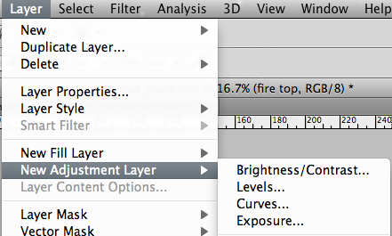
17. Make sure the layer
fire top is highlighted

> Click layer
> New Adjustment layer > Curves

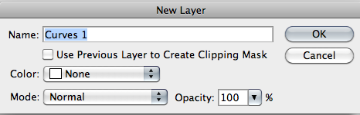
18. A new layer pop up
box is displayed
Click ok

We will not click use previous layer to crate clipping mask at the moment because we want our adjustment layer to affect all the layers underneath it.

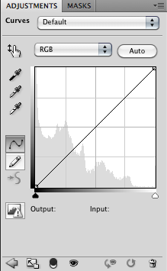
19. A new layer panel will be seen

This is the panel which allows the image to be brightened up without permanently destroying the layers beneath it.

In the future you can select the layer adjustment window on the layer and alter this to personal preference

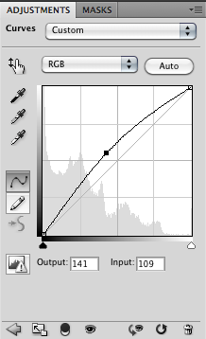
20. Drag the curve upwards
as shown or input the
values

Output 141
Input 109

Notice your image appears brighter

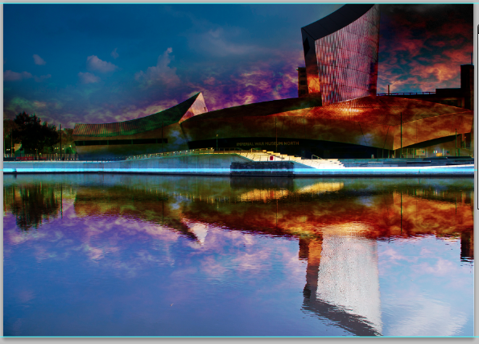
21. Open up the file barbed_wire.jpg

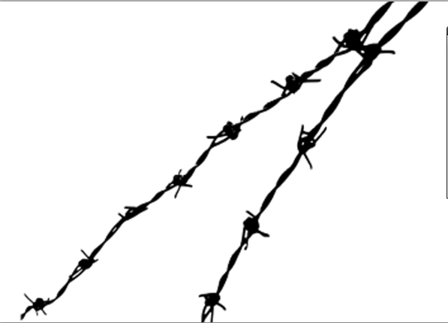
22. Use any selection technique you
you have previously used to
select the barb wire

HINT

Use the magic wand tool and when there is a selection go

Select > Select similar

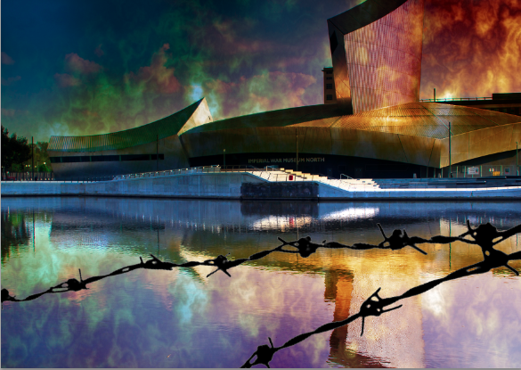
23. Copy and paste this selection
into the war museum document

24. Copy Position and transform the
size of the barb wire so it roughly covers the bottom third of the document.

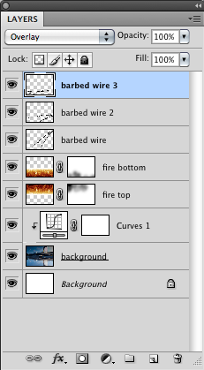
25. Repeat this process so you have 3 barbed wire layers (barbed wire 1, barbed wire 2, & barbed wire 3)

26. Turn each layer of BARBED WIRE
blending mode to OVERLAY

